Chapter 3
Organ systems in Humans
Cells with the same structure and function are grouped into tissues, (such as muscle, nerves, and skin). Groups of different tissues form organs, (such as the heart, lungs, stomach, and liver). Organs work together in organ systems (such as the respiratory system and the digestive system). This arrangement of cells, tissues, organs, and systems form several different levels of organization in living things, as can be seen in the example below.

Organism
(Cat)
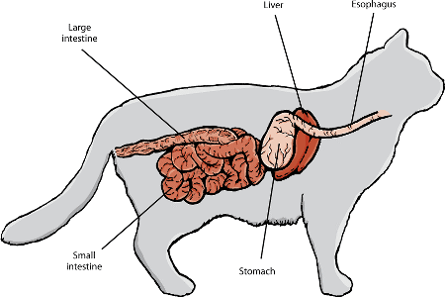
Organ system
(Digestive system)
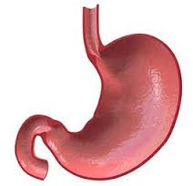
Organ
(Stomach)
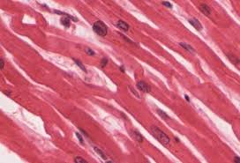
Tissue
(Muscle tissue)
Cell
(Muscle cell)
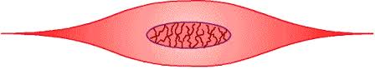

Organ systems
Organs work together just as cells and tissues do. Organs form organ systems to perform activities that help the body function as a whole. For example, your stomach is part of a group of organs that form your digestive system. Other organs in this system include your tongue, pancreas, and small intestine. The role of the digestive system is to digest food and eliminate waste. No organ alone can perform all these functions. There are many different organ systems other than the digestive system in the human body that all work together to keep you alive and thriving; for example: the respiratory, circulatory, excretory, and nervous systems.
Organs
Organs are distinct structures in the body that perform particular functions. Imagine you feel hungry, you see a slice of pizza, and eat it. This simple action would not be possible without your organs. You used your eyes to sense the pizza, your brain to plan and co-ordinate your actions, and your mouth and stomach to start digesting the pizza. Each organ is made of several tissues working together. For example, the stomach is made of 4 main types of tissues: muscle tissue to mix the stomach contents, epithelial tissue which lines the stomach, connective tissue which holds the stomach’s shape, and nerve tissue to co-ordinate the stomach’s activities.
Tissues
Tissues are groups of similar cells. Onion skin is a tissue made of sheets of similar, thin, tightly packed cells. We will look at the structure of onion skin under a microscope. These specialized cells form a layer that covers and protects the onion. The main types of tissues found in animals are: Muscle tissue, epithelial tissue (skin), connective tissue (bone), and nerve tissue.

