Active Transport
Small particles – such as 1)water, 2)carbon 3)dioxide, and 4)oxygen – diffuse freely into and out of cells through small openings in the cell membrane. This process depends only on the 5)concentrations of the particles. It occurs 6)without any use of 7)energy by the cells. This is called 8)passive 9)transport.
However, cells also require certain substances in 10)greater concentrations or in 11)lower concentrations than can be obtained by 12)diffusion alone. For example, cells need large amounts of 13)glucose, which supplies them with 14)energy. To meet this need, glucose particles must move from an area of 15)low concentration (16)outside the cell) to an area of 17)higher concentration (18)inside the cell). This process 19)reverses the usual movement caused by diffusion. Unlike diffusion, this process requires the use of 20)energy by cells – like pushing a car uphill instead of letting it roll down to the bottom as it normally would.
The controlled movement of substances through the cell membrane is carried out by the 21)membrane itself. To understand how it does this, scientists have studied the membrane structure in great detail.
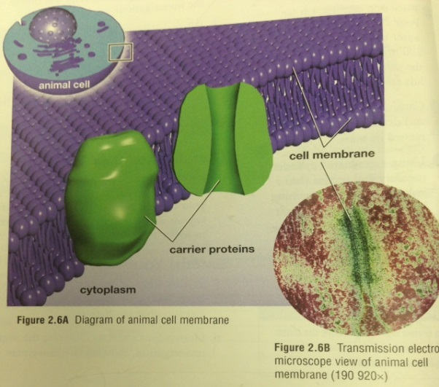
With the help of more powerful 22)microscopes, they discovered large particles called 23)carrier 24)proteins embedded in the membrane. Like gates in a wall, carrier proteins 25)control substances 26)entering or 27)leaving the cell. Each 28)carrier 29)protein attracts particles of a 30)certain 31)particular 32)substance.
The protein 33)attaches to the 34)substance, 35)moves it through the membrane and 36)releases it on the opposite side, as shown in the picture below. This energy-using process is called 37)active 38)transport.
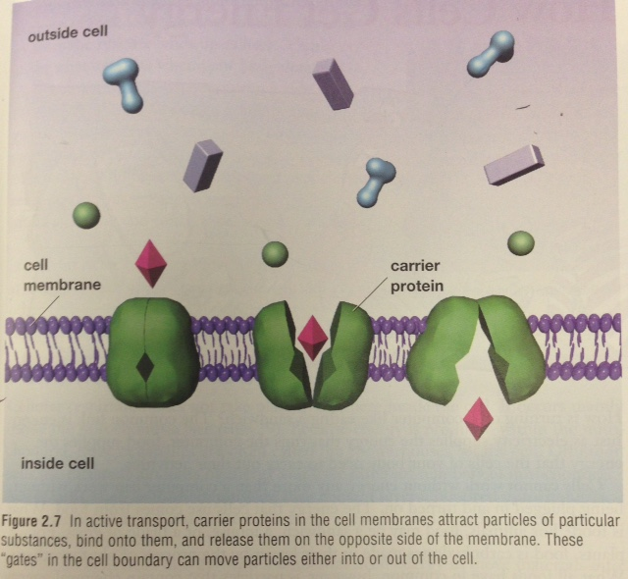
Cells “breathe” and “eat” by controlling the entrance and exit of key substances such as food particles. Active transport is one way this occurs. We will look later at how the food we eat eventually gets turned into energy by your cells.

Remember…
Passive Transport
Small particles, such as water, carbon dioxide, and oxygen, diffuse freely into and out of cells through small openings in the cell membrane. This process depends only on the concentration of small particles. It occurs without any use of energy by the cells.
Examples of passive transport that we have talked about are diffusion and osmosis.

Active Transport
Cells also require certain substances in greater concentrations or in lower concentrations than can be obtained by diffusion alone. Cells need large amounts of glucose, which supplies them with energy. To meet this need, glucose particles must move from an area of low concentration
