Animal cells
Cells are like factories in which the business of life is always going on. Cells are always obtaining energy, making products, and getting rid of wastes. To carry out these functions cells have some basic structures in common. Structures inside the cell are known as organelles. Each organelle has a job to do in the activities necessary for life.
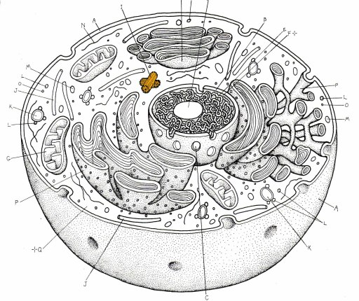
C
A : _________________ B:__________________
C: _________________ D: __________________
E:_________________ F:__________________
F
E
D
B
A

