Chapter 5 – Density & Buoyancy
A scuba diver exploring the dark and mysterious waters off the west coast of Canada might well come face-to-face with a Giant Pacific Octopus, the largest of its kind. This species of octopus is only one example of the large and unusual creatures that inhabit the ocean. How can animals with such huge bodies move so gracefully and so swiftly through the water? What enables completely submerged animals, such as octopuses, fish, and whales, to float at different depths? Why do objects such as icebergs, sailboats, ocean liners, and oil rigs, float partially submerged on the surface?
In this chapter; you will learn about buoyancy, the tendency to rise or float in water or air. Buoyancy causes objects to float in both liquid and gas environments. The upward force exerted on objects submerged in fluids is called buoyant force. The buoyancy of a fluid is related to a fluid’s density – the amount of mass in a certain unit volume of mass in a certain unit volume of a substance.
Have you ever been on a crowded elevator? As the picture below shows, it is definitely uncomfortable when too many people are jammed together tightly, or densely, on an elevator.
There is very little space between the people on a crowded
elevator – they are densely packed together.

Using everyday words, density can be described as the “crowdedness” of the particles that make up matter. In scientific terms, density is the amount of a substance that occupies a particular space. When you describe a substance as being “heavy” or “light” you are referring to the property of density.
According to the particle theory, different substances have different sized particles. The size of the particles determines how many particles can “fit into” a given space. Therefore, each substance has its own unique density, based on particle size. Furthermore, the particle theory suggests that there is empty space between the particles of matter. Could as many people fit into an elevator if each person were surrounded by a large “spacing box” Would larger spaces among the people increase or reduce the density (crowdedness) of the people travelling on the elevator? The answer is shown in the following picture.
Increasing the spaces between people on an elevator will reduce the density.

Density of Solids, Liquids, and Gases
How is the density of a substance related to the substance’s physical state? Imagine filling a film container with liquid water and another film container with water vapour. Both liquid water and water vapour are the same substance, and therefore have particles of the same size. According to particle theory, gas particles have more space between them than do liquid particles. Therefore, the water vapour in the container would have fewer particles that the liquid water. It would be reasonable to conclude that the density of the water vapour is less than the density of liquid water.
How are density and state of matter related to the physical properties of a substance? Solid objects can move easily through liquids and gases. For example, dolphins can leap through the air and then dive back underwater so smoothly that the activity appears almost effortless. According to the particle theory, the fluid properties of water and of air allow water particles and air particles to move out of the way of the firmer, non-fluid bodies of marine animals. Why do solid particles tend to hold together while fluid particles tend to move apart?
When an object moves through a fluid, it pushes particles apart and moves between them. Particles in a solid cannot be pushed apart. To understand why, imagine that you and a few friends are together. You want to prevent anyone else from pushing your group apart and moving between you. What would you do? First, you would have to stand quite close together. Then you would probably hold on to each other very tightly. If you do not let go of one another, no one can move between you. That is what particles in a solid do. Attractive forces among the particles of a solid are stronger than those between fluid particle and this the particle in a solid cannot be pushed apart.
If you were to step onto the surface of a lake, the water would not support your foot. Instead, your foot would go right through the water. In fact, you would continue to fall through the water, pushing the water particles out of the way as shown in the picture below.
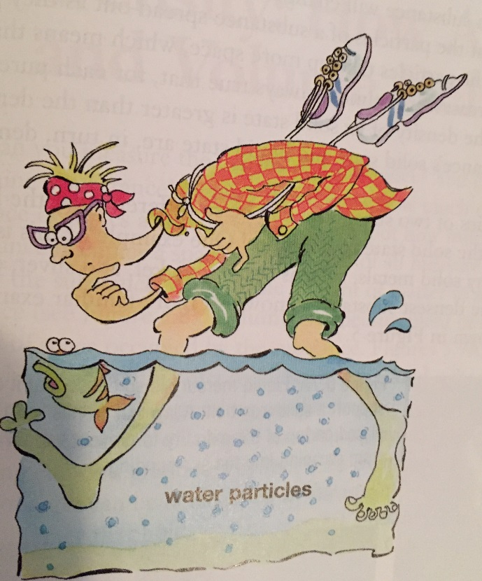
Although liquid particles are sometimes quite closely packed together,
they cannot support objects in the same way that solids can , because the
particles do not have a strong enough attraction for each other. Thus,
liquid particles move apart easily.
Liquids cannot support objects in the same way that solids can, because the particles of a liquid move apart easily, allowing a dense, solid object, such as your foot, to pass though the liquid. The attractive forces between liquid particles are not strong enough to prevent your foot from pushing them apart.
Similarly, you cannot walk on air, because gases are even less dense than solids or liquids. When you move through air, you are moving through mostly empty space. You do not have to move as many particles of air out of the way as you do in water. This explains why running through air is much easier and faster than running through water. In general, gases are less dense than liquids.
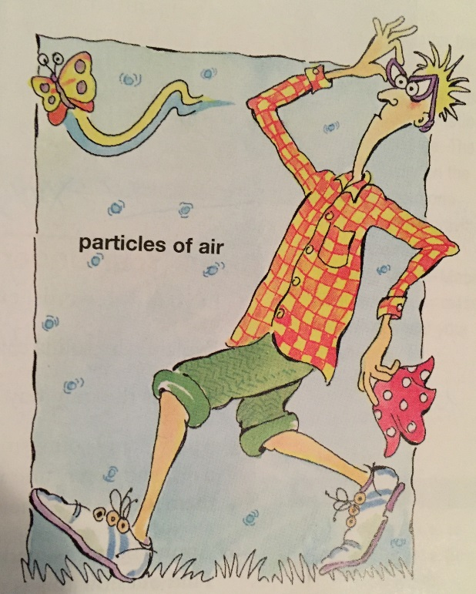
When you move through air, you do not have to move as many
particles of air out of the way as you do water particles in water.
As temperature increases, a substance will change from solid, to liquid, to gas. The particle theory states that the particles of a substance spread out as they gain energy when heated. This, the particles take up more space, which means that the density of the substance decreases. It is almost always true that, for each pure substance (for example, gold), the density of its solid state is greater than the density of its liquid state. The substance’s solid state and liquid state are, in turn, denser than its gaseous state.
In some cases, the densities of two substances can be so different that the liquid state of one is denser than the solid state of the other! Many solid metals, such as copper, nickel, and silver, can float on mercury, one of the densest substances known.

