Mitosis
How does one cell become two? If you look at (1)cells under the (2)microscope, you may be able to observe them in the process of (3)dividing. The best place to look for dividing cells are in parts of an (4)organism that are growing (5)rapidly, such as the tips of young seedlings.
Notice that some cells do not have a (6)solid, round nucleus. Instead, they have (7)clusters of dark threadlike objects. These objects are the (8)chromosomes, which become visible only when a cell is about to (9)divide. Chromosomes contain the cell’s (10)genetic material, or (11)DNA (deoxyribonucleic acid)- instructions for (12)producing new cells with the same characteristics as the (13)parent cell.
During cell (14)division, the genetic material (15)duplicates and then divides into two (16)identical sets of chromosomes. This process is called (17)mitosis. It is very (18)similar in all forms of life, whether the organism is a (19)unicellular micro-organism or a (20)multicellular plant or animal. The two new cells formed by this division are called (21)daughter cells. Each daughter cell gets one set of (22)chromosomes. You will learn more about mitosis in later studies.
All healthy cells have regular rates of (23)dividing. For example, certain bacterial cells divide once every 20 minutes. Frog embryo cells divide in about an hour, cells lining your intestine take about 48 hours to divide, and liver cells divide only once every 200 days.
Phases of mitosis
Mitosis consists of four basic phases: 24)prophase, 25)metaphase, 26)anaphase, and 27)telophase. These phases occur in strict sequential order, and cytokinesis - the process of dividing the cell contents to make two new cells - starts in anaphase or telophase.
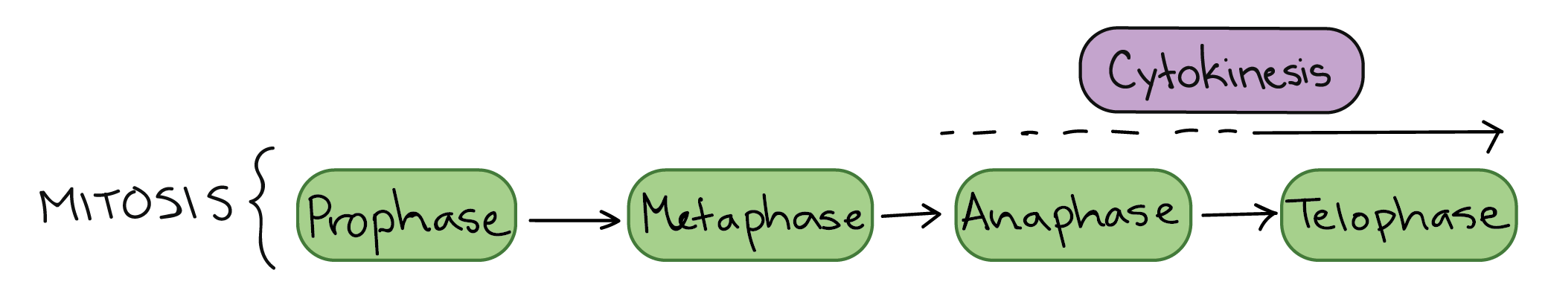
You can remember the order of the phases with the mnemonic: The dog Peed on the MAT.

