Plant cells
Plant cells have all the same organelles as animal cells, as well as two additional organelles. These are the cell wall and chloroplasts.
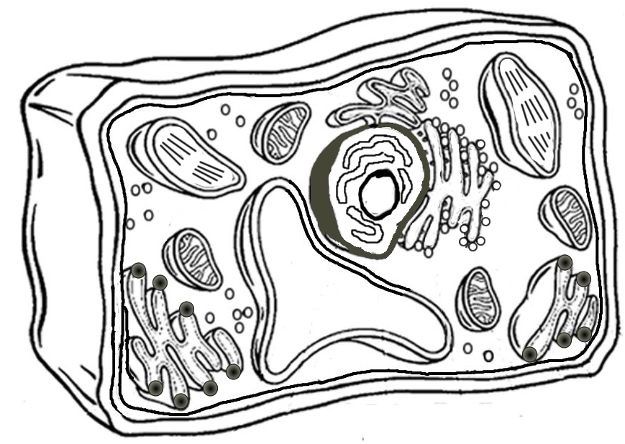
H
G
E
C
B
A
A : _________________ B:__________________
C: _________________ D: __________________
E:_________________ F:__________________
G: ________________ H:__________________
F
D

