Cells and Cancer
Cell division is essential for body growth and repair. What happens if cells begin to multiply and spread in an uncontrolled way? That is what happens in the bodies of people with cancer. Cancer has been described as “mitosis gone wild.” As the abnormal cancer cells continue to multiply, they spread to other parts of the body and damage them. Cancer is one of the leading causes of death in Canada today.
Specialized Cells
Imagine an orchestra made up of 100 trumpet players or 100 violin players. This orchestra would be very limited! To play every kind of music, an orchestra needs a variety of musical instruments – some flutes, some oboes, a piano, drums, and so on. In the same way, a multicellular organism can’t be made up only of identical cells. Although, multicellular organisms grow from single cells that repeatedly divide, their cells are not all the same. Like the instruments in an orchestra, different cells have different appearances and perform different jobs. They are said to be specialized for particular tasks. For example, your muscle cells are shaped to move parts of your body, and your skin cells are built to protect your body from the drying rays of the sun. Humans have about a hundred different types of cells, each with their own particular structure and functions.
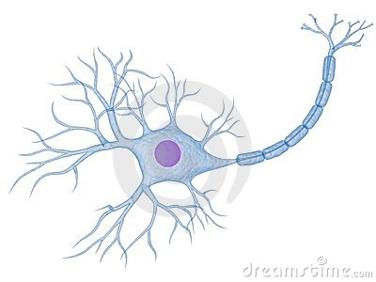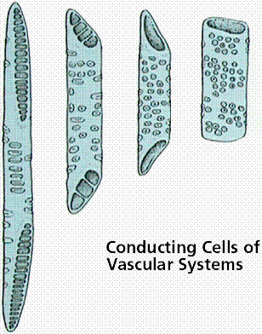
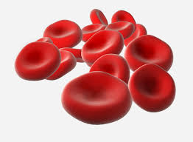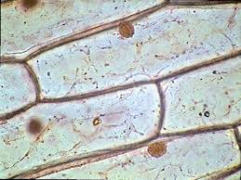
Have a look at the pictures of plant and animal cells, how do the shapes relate to their functions. Nerve cells have long, branched fibers running from the main part of the cell. Red blood cells, shaped to carry oxygen in the bloodstream, have a thin, disk-like shape. This gives them a large surface area to pick up large amounts of oxygen. The water-conducting cells of a plant are tube-like, with thick walls and a network of holes that lets water pass easily through them. Onion skin cells are flat and brick-shaped, so they can fit closely together to form a continuous protective layer.

