Energy and Food
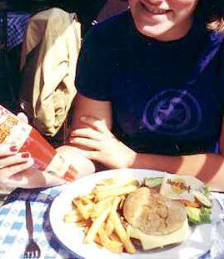
Animals obtain the energy that they need from the food that they eat and green plants make their energy-containing food using sunlight energy.
Fungi are non-green plants; they get their energy from the dead bodies that they decompose.
Therefore, in the living world there are two possible sources of energy: sunlight or the bodies of other organisms. The green plants which use sunlight energy are called autotrophs (this comes from the Greek words auto = self, and trophos = feeding). The animals and fungi which feed on other animals and plants are called heterotrophs (this is also from Greek words which mean "feeding on others").
Not all the food in our diet contains the same amount of energy. Some foods are rich in energy because of the chemicals that they are made of. Foods which are rich in sugar, fat or protein contain a lot of energy.

