Average Density
Ships can be built of steel (which has a density of 9.0 g/cmᵌ) as long as they have large, hollow hulls. A large, hollow hull ensures that the average density of the ship (That is, the total mass of all substances on board divided by the total volume) is less than that of water. Similarly, life jackets are filled with a substance of very low density. Thus, life jackets lower a person’s average density, allowing the person to float.
Average density is useful because it enables objects that would otherwise sink, such as large ships and oil rigs, to float. Average density also helps floating objects to sink. For example, most fish have an organ called a sim bladder (also called an air bladder).
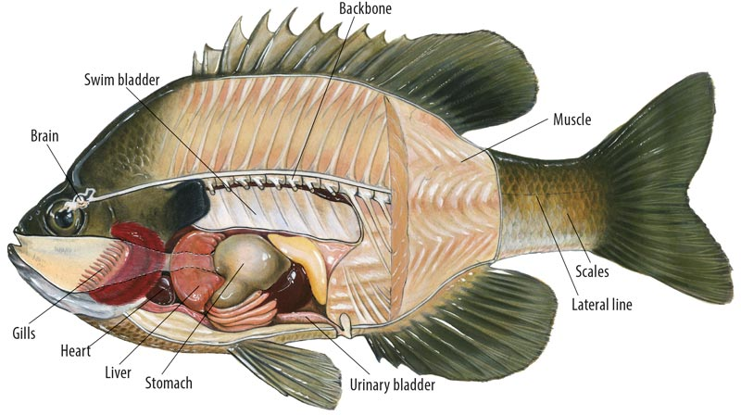
This organ, a large sac near the spine of the fish, contains a mixture of air and water. The fish’s depth in the water depends on how much air is inside the sac. As the amount of air decreases, the fish sinks lower. As the amount of air increases, the fish rises closer to the surface. This depth control structure has been adapted in the submarine, allowing submarine’s crew to adjust its depth underwater.
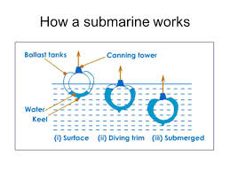
In the case of a fish, the change in average density occurs naturally with the use of the swim bladder. In the case of the submarine, the average density is changed intentionally by letting air and water in and out of the ballast tanks. Can you think of other situations in which the average density is changed naturally or intentionally?
Naturally | Intentionally
1. | 1.
2. | 2.
3. | 3.

