CNBA Pink Shirt Day Order Form
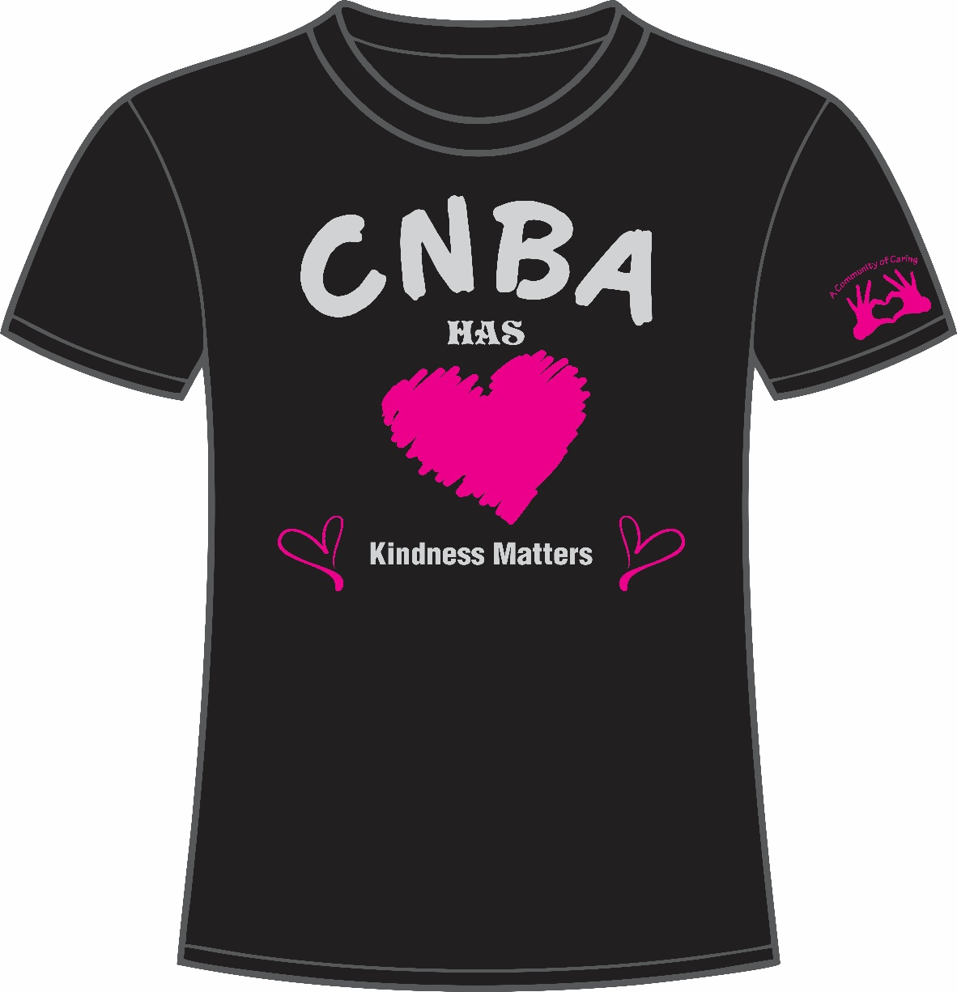
T-shirts are available for purchase at a cost of $15.00 each. They are made of cotton. Orders are due on Monday, February 10th.
Name:
Homeroom:
Circle Size Required | Youth | Adult | Quantity
 | S M L XL | S M L XL  2XL 3XL 4XL | __ @ $15
Total $

