Chapter 1 Pretest

- What is the definition of relative location? Give one example of a relative location?
Relative location is the position of something relative to another landmark. Example: Boiestown is about 50 kilometers north of Fredericton.

- What is the definition of absolute location?
Absolute location is a fixed position that never changes, regardless of your current location. It is identified by specific coordinates, such as latitude and longitude.

- What is the definition of latitude?
Latitude is a measurement of distance from the equator. Latitude lines are the horizontal lines on a map or globe. They go from right to left. “Lat means flat”!

- What is the definition of longitude?
Longitude is a measurement of distance from the prime meridian. Longitude lines are the vertical lines on a map or globe. They go from up and down.

- The coordinates for Montreal are 45.5ᵒN, 76.5ᵒW. Which is the latitude, and which is the longitude?
When using coordinates, you always put the latitude first, and the longitude second.
Latitude = 45.5ᵒN
Longitude = 76.5ᵒW

- What is the prime meridian?
The prime meridian is the imaginary line that divides Earth into two equal parts: the Eastern Hemisphere and the Western Hemisphere. Its longitude is 0. The Prime Meridian passes through Greenwich, England.

- What is the equator?
The equator is the imaginary line that divides Earth into equal top and bottom halves: The Northern Hemisphere, and the Southern Hemisphere.

- What are meridians and what are parallels?
Lines of latitude are called parallels and in total there are 180 degrees of latitude. Lines of latitude start at 0 degrees at the equator and end at 90 degrees at the North and South Poles.
Lines of longitude are known as meridians. These lines run from pole to pole, crossing the equator at right angles. There are 360 degrees of longitude. The distance between longitudes narrows the further away from the equator.

- What is a physical feature? Give 2 examples of a physical feature.
A physical feature is a natural feature that occurs as a result of natural forces. Examples of this are rivers, oceans, mountains, forests, and meadows.

- What is a cultural feature? Give 2 examples of a cultural feature.
A cultural feature is a man-made feature. It is something made by humans, or show signs of human activity. Examples of this are fields that have been cleared for farming, bridges, dams, houses, roads, etc.

- Describe the following:
Nova Scotia in relation to the rest of Atlantic Canada
Nova Scotia is south of the rest of Atlantic Canada.

Atlantic Canada in relation to the American state of Maine
Atlantic Canada is north east of Maine.

Atlantic Canada to the prime meridian
Atlantic Canada is west of the prime meridian.

Atlantic Canada to the continent of Europe
Atlantic Canada is west of the continent of Europe.

Atlantic Canada to Mexico
Atlantic Canada is north east of Mexico.

Atlantic Canada to the Atlantic Ocean
Atlantic Canada is west of Atlantic Ocean.

- What are the two major ocean currents that pass by Atlantic Canada? Are they warm or cold?
The Gulf Stream comes up from the Caribbean. Its waters are warm. The Labrador Current comes down from the Arctic, passing by Labrador. It is cold.

- What does GPS stand for?
GPS stands for Global Positioning System

- How many satellites does GPS use?
Global Positioning Systems use at least 24 satellites.

- How many satellite signals does a device need to be able to read to calculate location?
A device can read up to 6 satellite signals, but needs at least 4 to calculate location.

- What are the 5 key uses of GPS?
The 5 key uses of GPS are location, navigation, tracking, mapping, and timing

- What is one other use of GPS?
Emergency response, entertainment, health and fitness, construction, transportation

- Label the following map of Canada with the province/territory names and their capitals.
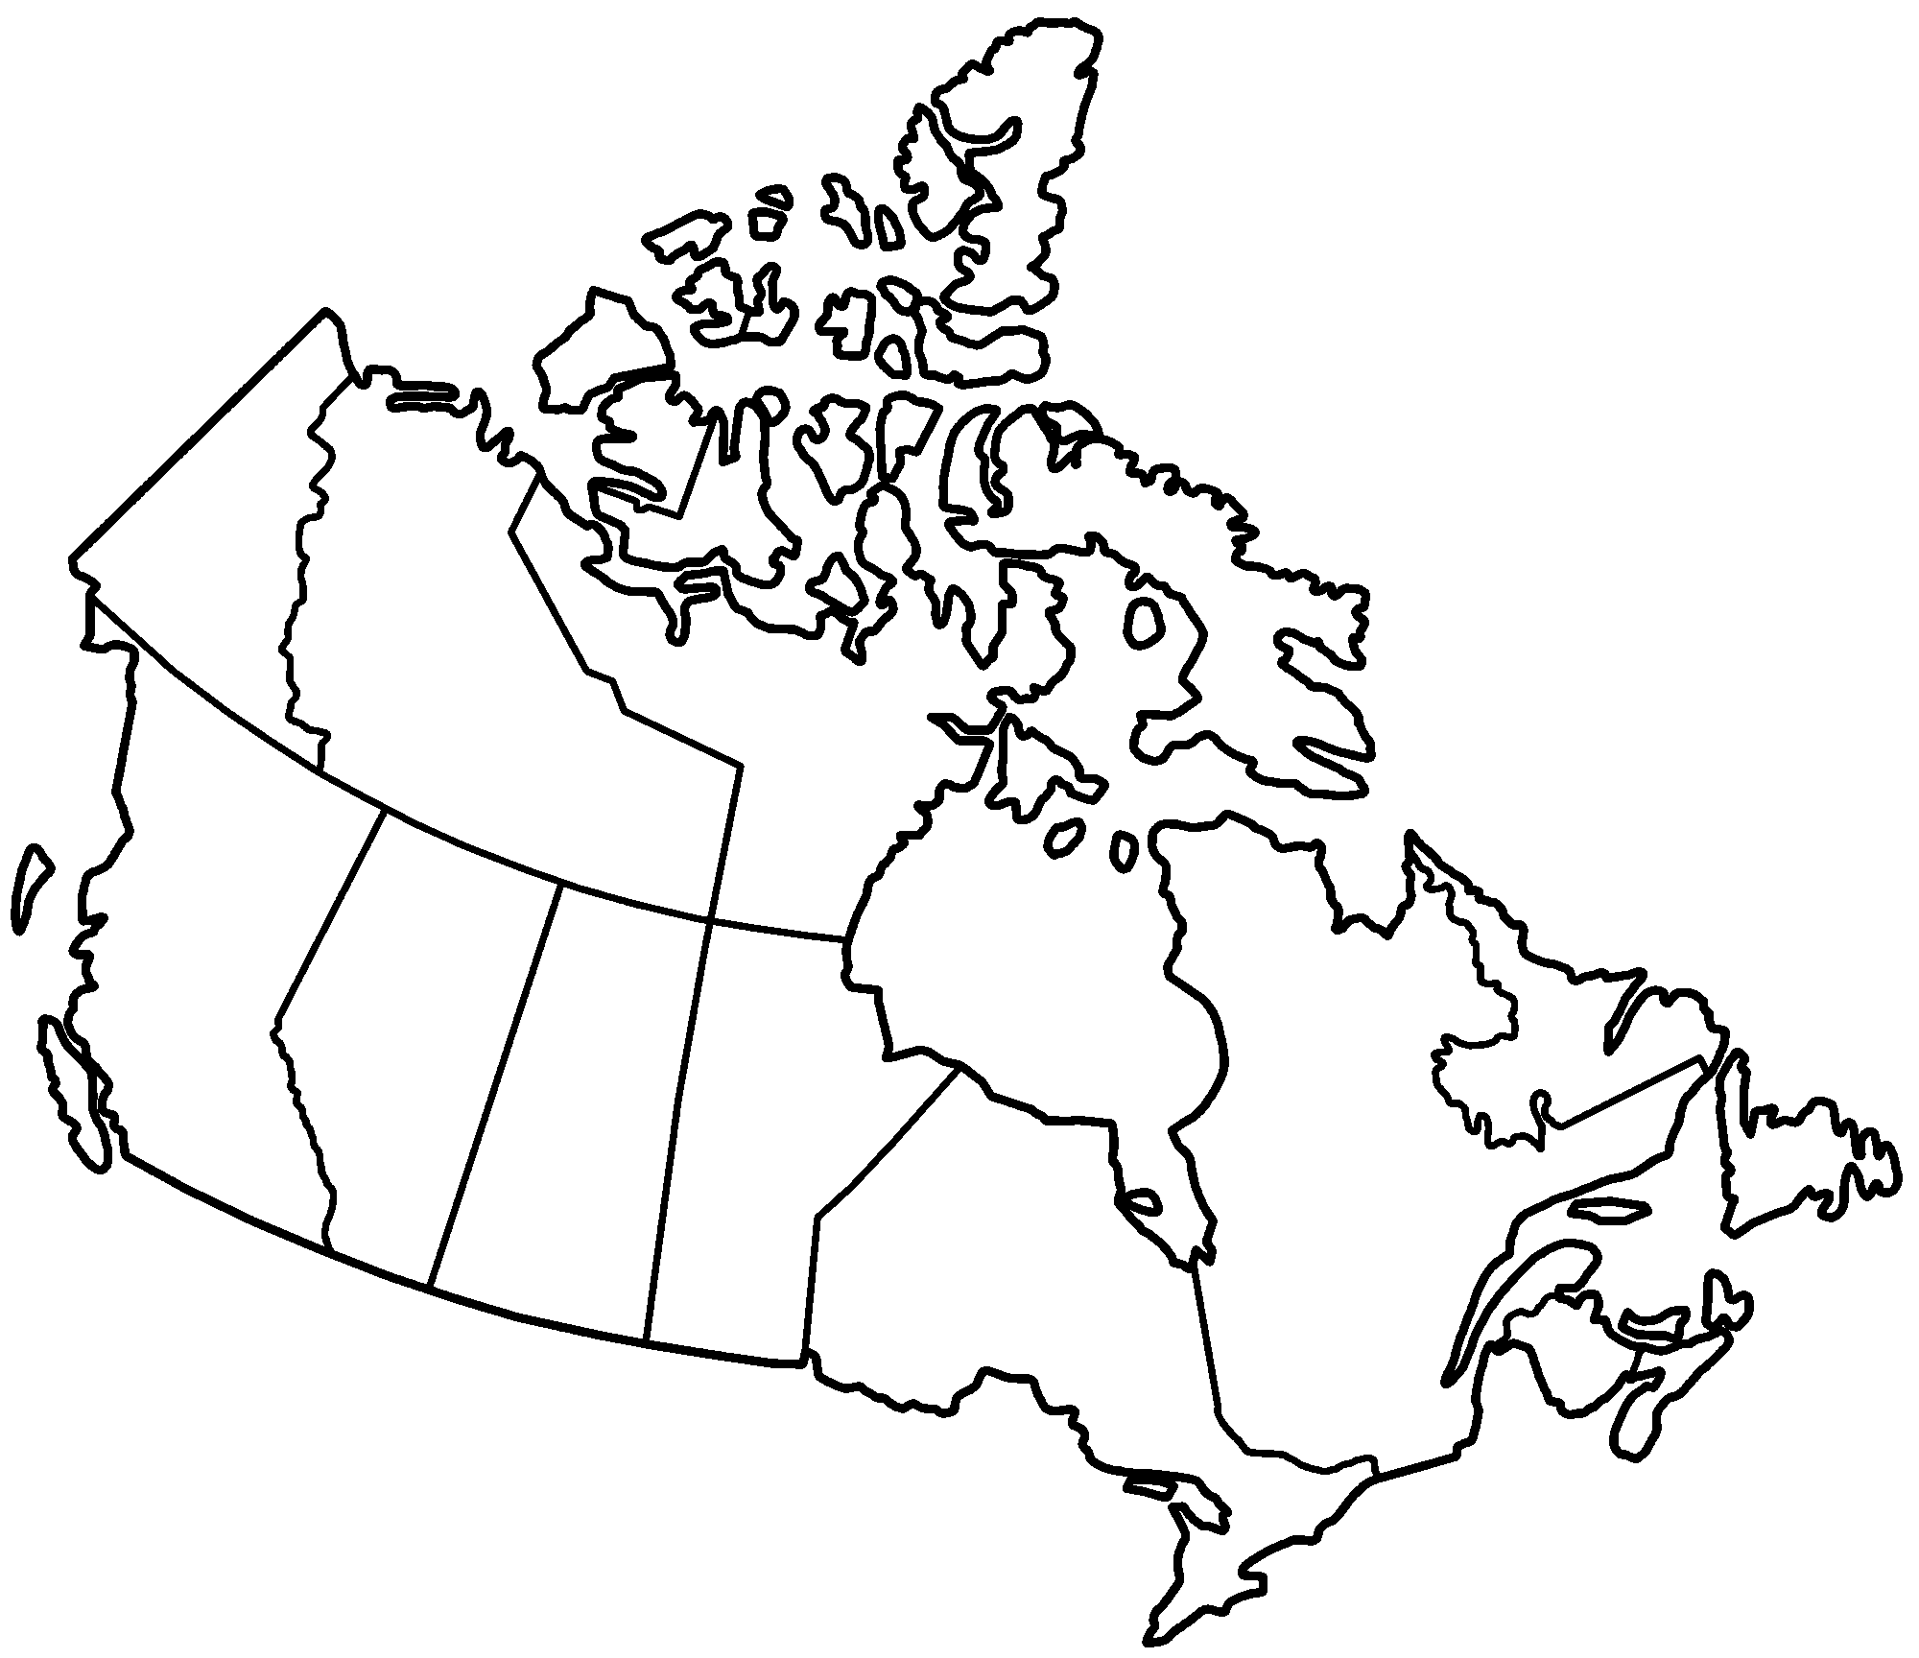
J
K
L
M
I
H
G
F
E
D
C
B
A
 | Province/Territory | Capital City
A | Yukon | Whitehorse
B | Northwest Territories | Yellowknife
C | Nunavut | Iqaluit
D | British Columbia | Victoria
E | Alberta | Edmonton
F | Saskatchewan | Regina
G | Manitoba | Winnipeg
H | Ontario | Toronto
I | Quebec | Quebec City
J | New Brunswick | Fredericton
K | Nova Scotia | Halifax
L | Prince Edward Island | Charlottetown
M | Newfoundland & Labrador | St. John’s

