Pre Test – Chapter 1

1. Name one person who invented one of the first microscopes and observed single cell organisms.

Anton van Leeunwenhoek

Robert Hooke

1. Where does our present-day word “cell” come from?

The word cell comes from the word “cellulae” which means “little rooms” in latin. The term was coined by Robert Hooke.

1. Label the following unicellular organism. (Paramecium)



Food Vacuole

Anal Pore

Oral Groove

Cilia

1. Label the following unicellular organism. (Amoeba)

Food Vacuole

Food Particle



Extended Pseudopod

Pseudopod

1. Label the plant cell.

Endoplasmic Reticulum

Nucleus

Chloroplast

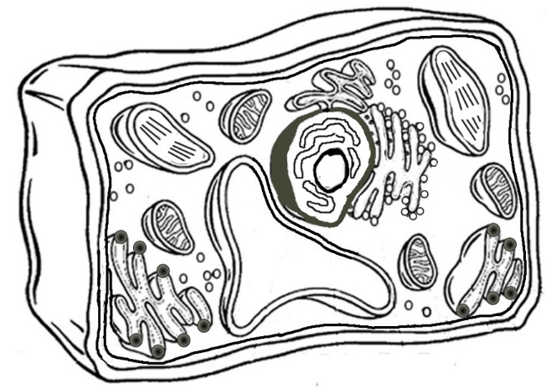

Mitochondria

Cytoplasm

Vacuole

Cell wall

Cell membrane

1. Label the animal cell.

Endoplasmic Reticulum

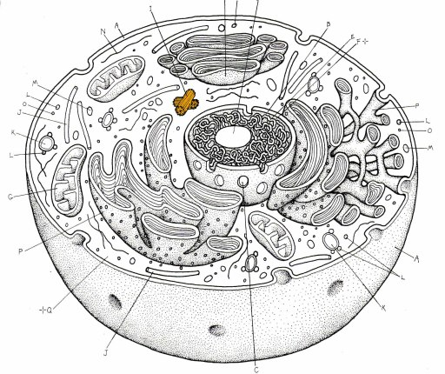

Nucleus

Cell membrane

Mitochondria

Vacuole

Cytoplasm

1. Which is more complex, a unicellular organism or a multicellular organism?

A multicellular organism is more complex than a unicellular organism. Multicellular organisms have many differentiated cells, that are specialized and do specific jobs.

1. Does a blue whale have bigger cells than a field mouse? Explain your answer.

No, a blue whale does not have larger cells than a field mouse. A blue whale is a lot bigger than a field mouse because it has more cells.

1. Which organelle is the “power house” of the cell?

The mitochondria is the power house of the cell. This is where energy is produced.

1. Which organelle carries out photosynthesis in plant cells?

Photosynthesis in plants is carried out by the chloroplasts.

1. Oops
2. Which organelle gives cells strength and support?

The cell wall gives strength and support to plant cells. It is not found in animal cells.

1. Which organelle is made up of moving fluid which distributes materials?

The cytoplasm is the jelly-like fluid that you find in a cell.

1. Which organelle control’s the cell’s activity?

The cell’s activity is controlled by the nucleus.

1. Which organelle is like a thin protective skin?

The cell membrane is a thin protective skin that controls the movement of materials in and out of the cell.

1. Which organelle stores materials?

Materials in a cell are stored in the vacuoles.

1. Which organelle is a covering for the nucleus?

The nucleus is covered by the nuclear membrane.

1. Where are chromosomes found?

Chromosomes, which contain genetic material, are found in the nucleus.

1. What is the cell wall made of?

The cell wall is made of a tough material called cellulose

1. Explain the theory of spontaneous generation.

In the past, it was commonly believed that some living organisms, such as mice, flies, and maggots, could be produced by non-living matter such as air or water.

1. Who proved that the theory of spontaneous generation was wrong, and how did they do it. (You can draw a picture if it helps you explain)

Fransesco Redi proved the theory of spontaneous generation to be false by placing rotting meat in jars. He covered some of the jars, and left the others open to the air. The covered jars did not produce any new flies. The uncovered jars did produce flies. Fransesco Redi showed that flies do not just appear out of thin air, they are the result of flies laying their eggs in rotting meat.

Louis Pasteur also proved that the theory of spontaneous generation was false by boiling a broth of water, yeast, and sugar. This killed the micro-organisms inside. There were condensed moisture and dust in the neck of the bottle, but it was not in contact with the broth and no micro-organisms grew. After tipping the container so that the broth could come in contact with the water and dust it began to grow micro-organisms.

1. What is the cell theory?(4 parts)
2. All living things are composed of one or more cells.
3. Cells are the basic units of structure and function in all organisms.
4. All cells come from previously existing cells.
5. The activity of an entire organism depends on the total activity of its independent cells.
6. What is the function of the endoplasmic reticulum?

The endoplasmic reticulum transports materials to different parts of the cell, or outside the cell, using a system of canals.

1. What is an organelle?

An organelle is a structure inside a cell with a role to play in the activities necessary for life.

1. What is a cell?

A cell is the smallest unit that can perform the functions of life.

1. What is the difference between multicellular and unicellular?

A unicellular organism only has one cell. Multicellular organisms have more than one cell, and are more complex.

1. What two organelles are ONLY found in plant cells?

Chloroplasts and cell wall.