Chapter 2 Pre-Test Name:
- A salamander growing back its tail is an example of what process?

- Define osmosis.

- A material that lets some substances through but keeps others out is known as what?

- During our class experiment, we used a plastic bag to represent what kind of membrane? Impermeable, permeable, or selectively permeable?

- What is cellular respiration?

- What are the structures which contain the cell’s genetic material (DNA) called?
- What does cell specialization mean?

- Explain mitosis.

- What is active transport? How is it different from osmosis and diffusion?

- A parent cell splits into 2 identical cells. What are these cells known as?

- Explain diffusion.

- What are carrier proteins and what roll do they play in our bodies?

- Where are the chromosomes found in the cell?

- Give an example of cellular regeneration in humans.

- What is the cell membrane responsible for?

- Why do different cells have different appearances?

- What do diffusion and osmosis have in common?

- What happens when cells divide out of control?

- Name 3 kinds of specialized cells.

- Give 3 examples of regeneration in the animals.

- How do we grow larger? Are we born with the same number of cells that we have today?

- In what direction do particles travel? From high to low concentration, or from low to high? What happens when they reach equilibrium?

- Label the following diagram.
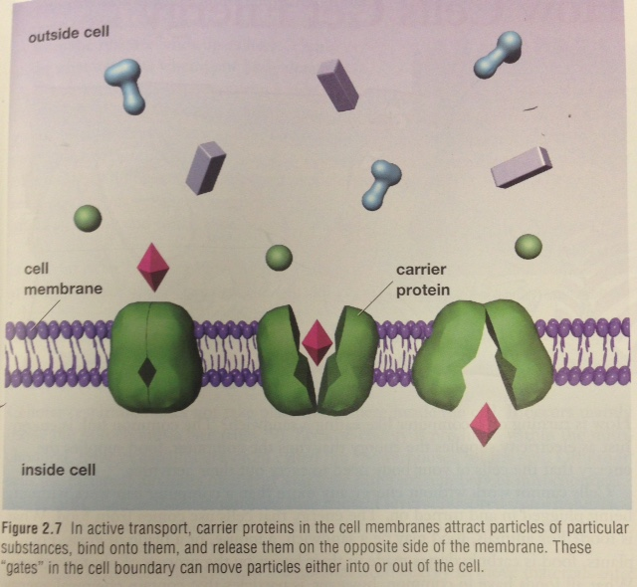
- What is the equation for cellular respiration?

- In which organelle does cellular respiration take place?

- Do all cells have the same number of mitochondria? Why or why not?

- Do all organisms undergo mitosis?

- What are the 4 phases of mitosis called?

- What do we call materials that cause cancer? Give 2 examples.

- Give 3 examples of organs or tissues that can be replaced in the human body through transplant.

- How do plants get the energy they need?

- What do we call organisms that can produce their own food?

- What are the 2 possible sources of energy on Earth?

- What do we call animals and fungi that feed on other organisms?

- Name 2 types of foods in our diet that contain a lot of energy.

