November 26, 2017
Re: Permission Slip for TNB’s production of A Christmas Carol

Dear parent and/or guardian:

On Friday, December 15, middle school students will be travelling by bus to The Fredericton Playhouse to see Theatre New Brunswick’s production of A Christmas Carol.

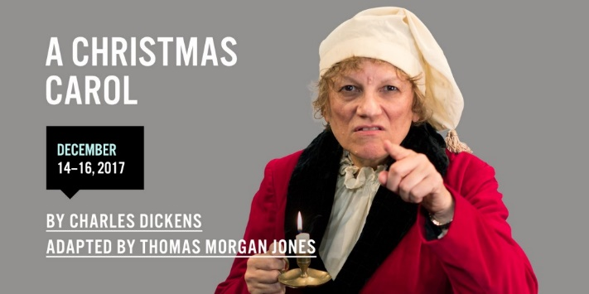

A fresh adaptation of a timeless holiday classic.
Join Cratchit, Marley, Fezziwig and the rest of Dicken’s unforgettable characters as they work to teach old Ebenezer and thing or two about how good it feels to be kind, caring and accepting…all year long.

The performance cost is $10; however, your child’s price is $7, which should be submitted to homeroom teachers as soon as possible. Students will be leaving the school at approximately 8:20 a.m. and returning at 2:30 p.m. (10:00 a.m. show).

Following the performance, students will be going to McDonald’s for lunch. Students are asked to bring money to buy a meal. If preferred, students may bring a bagged lunch.

A parent and/or guardian must sign below and return this form with your child to the homeroom teacher with the $7 admission fee. .

I _________________________________ (name of parent and/or guardian), permit ___________________________________ (name of student) to travel from Central New Brunswick Academy to The Fredericton Playhouse by bus to attend a student matinee on December 15, 2017.
___________________________________ (parent and/or guardian signature)

Thank you for your support,
Carolyn Hatt
Music Teacher

