 

**Spelling – Grade 6**

***Doubling the Final Consonant***

1. shipment
2. shipper
3. flatly
4. flatten
5. admits
6. admittance
7. omits
8. omitting
9. expels
10. expelled

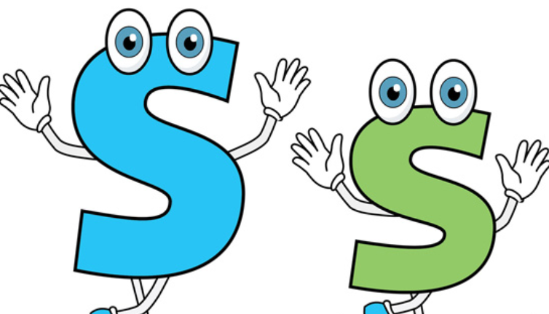

**Spelling – Grade 6**

***Doubling the Final Consonant***

1. miss
2. kiss
3. bell
4. fill
5. hill
6. stall
7. dress
8. pass
9. poll
10. stroll