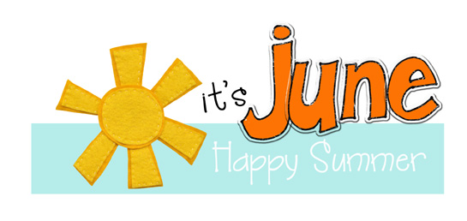

CES Newsletter 2021
UNSCENTED PRODUCTS:
Please respect that we are
a scent free environment
when purchasing sunscreen,
bug spray, etc. for usage
at the school.

We are in our final month of this school year. At this time, we would like to thank you for the opportunity to be a part of your child’s education.
Your continued support and co-operation have been greatly appreciated.
Sunday | Monday | Tuesday | Wednesday | Thursday | Friday | Saturday
 |  | 1 | 2 | 3 | 4 | 5
Chipman Public Library Story Walk
Call 339-5852 to register
6 | 7 | 8 | 9 | 10 | 11 | 12
Student Appreciation Day
Lots of fun activities planned for the students
13 | 14 | 15 | 16 | 17 | 18 | 19
20 | 21 | 22 | 23 | 24 | 25 | 26
 |  |  | ~Gr. 5 Promotion @ 1pm  (not open to public) | ~Kindergarten Promotion @ 1pm  (not open to public) | ~ Report Cards Issued  ~Last day of school for students
27 | 28 | 29 | 30
School Supply Money for 2021-2022:
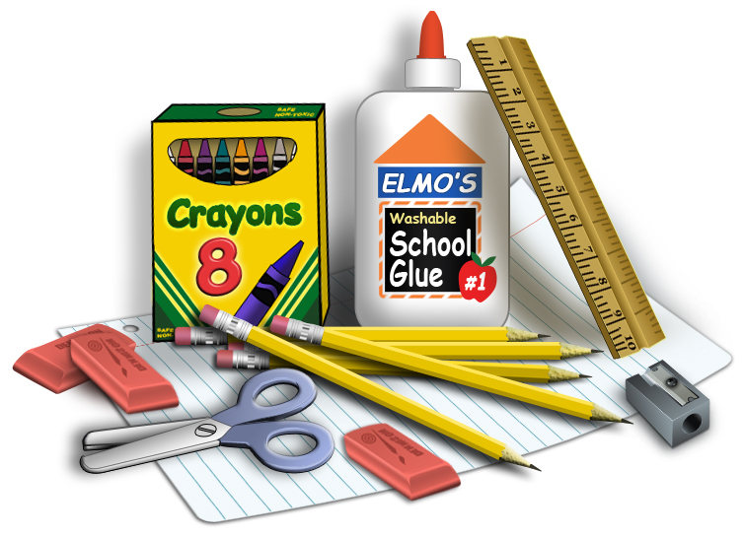
The K-5 teachers will be collecting $40 in September. Parents will be required to provide indoor sneakers, book bag and lunch bag. K-5 teachers will make all necessary purchases for your child’s school supplies for 2021-2022. The teachers will be purchasing all supplies for students so that all students have the same materials. If you are not in agreement with this please contact the school and we will provide you with a supply list.

