

CES Newsletter 2022
UNSCENTED PRODUCTS:
Please respect that we are
a scent free environment
when purchasing sunscreen,
bug spray, etc. for usage
at the school.

We are in our final month of this school year. At this time, we would like to thank you for the opportunity to be a part of your child’s education.
Your continued support and co-operation have been greatly appreciated.
Sunday | Monday | Tuesday | Wednesday | Thursday | Friday | Saturday
 |  |  | 1 | 2 | 3 | 4
 |  |  |  | Grade 5 to CFAS for Orientation
5 | 6 | 7 | 8 | 9 | 10 | 11
 |  | Grade 5 Year End Trip to Green Hill Lake |  | Student Appreciation Day  Lots of fun activities planned for the students
12 | 13 | 14 | 15 | 16 | 17 | 18
 |  |  |  | K-5 Trip to the Movies!
19 | 20 | 21 | 22 | 23 | 24 | 25
 | Activity Day | Rain Date for Activity Day | ~Gr. K Promotion @ 1pm  4 attendees/student | ~Gr. 5 Promotion @ 1pm  4 attendees/student | ~ Report Cards Issued  ~Last day of school for students
26 | 27 | 28 | 29 | 30
School Supply Money for 2022-2023:
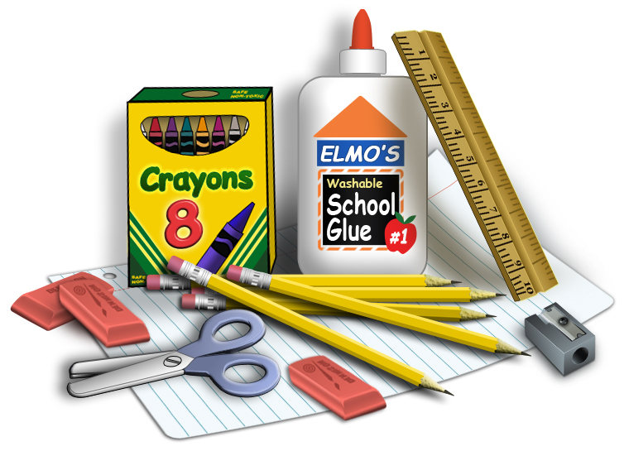
The K-5 teachers will be collecting $50 in September. Parents will be required to provide indoor sneakers, book bag and lunch bag. K-5 teachers will make all necessary purchases for your child’s school supplies for 2022-2023. The teachers will be purchasing all supplies for students so that all students have the same materials.
If you are not in agreement with this, please contact the school and we will provide you with a supply list.

