

CES Newsletter 2023
UNSCENTED PRODUCTS:
Please respect that we are
a scent free environment
when purchasing sunscreen,
bug spray, etc. for usage
at the school.

We are in our final month of this school year. At this time, we would like to thank you for the opportunity to be a part of your child’s education.
Your continued support and co-operation have been greatly appreciated.
Sunday | Monday | Tuesday | Wednesday | Thursday | Friday | Saturday
 |  |  |  | 1 | 2 | 3
 |  |  |  | ~Gr. 4 Author Visit
4 | 5 | 6 | 7 | 8 | 9 | 10
 | ~After school Basketball | ~Gr. 2 Trip to Library | ~Gr.4 Trip to Ducks Unlimited Wetlands  ~After school Basketball | ~Grade 5 Year End Trip to Green Hill Lake  ~ Gr. K and 4 Trip to Library | ~Grade 5 Trip to CFAS for Orientation  ~Gr. 11 Drama Presentation
11 | 12 | 13 | 14 | 15 | 16 | 17
 | ~After school Basketball | ~World UNBound presentations for students | ~K Promotion 1pm  ~Please note-NO Basketball after school | ~Gr. 5 Promotion 6pm  ~Gr. 1 and 3 Trip to Library | ~Gr. 5 Trip to Library
18 | 19 | 20 | 21 | 22 | 23 | 24
 | ~After school Basketball | ~Field Day | ~Rain Date for Field Day  ~Last Day for After school Basketball | Gr. K-5 Trip to Cineplex | ~ Report Cards Issued  ~Last day of school for students
25 | 26 | 27 | 28 | 29 | 30
School Trips: Permission forms will be coming home for these trips.
School Supply Money for 2023-2024:
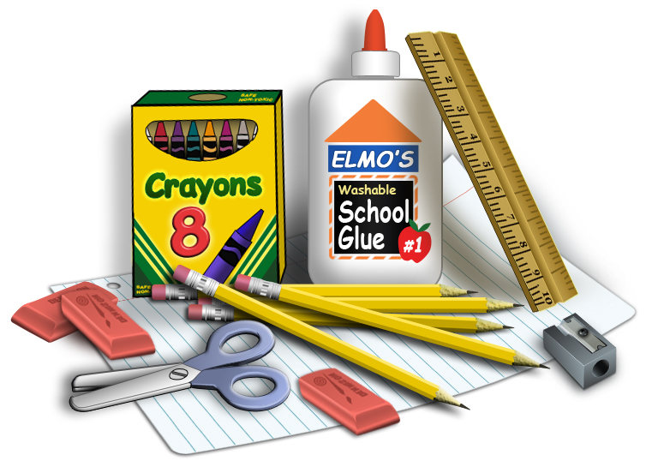
The K-5 teachers will be collecting $50 in September. Parents will be required to provide indoor sneakers, book bag and lunch bag. K-5 teachers will make all necessary purchases for your child’s school supplies for 2023-2024. The teachers will be purchasing all supplies for students so that all students have the same materials.
If you are not in agreement with this, please contact the school and we will provide you with a supply list.

