CAMBRIDGE-NARROWS COMMUNITY SCHOOL
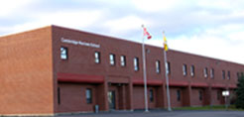
2158 Lakeview Road
Home of the Huskies
Cambridge-Narrows, New Brunswick E4C 1N8
Tel: (506) 488-3500 – Fax: (506) 488-3505
______________________________________________________________________________
Nelson Arsenault - Principal
Margie Goodin - Vice-Principal
Sandra Jenkins - Administrative Assistant

School Supplies/Student Fees 2017-2018

Elementary students pay a $40 student/supplies fee in September. The following family rate is available; a family of 3 children will pay $100 and a family with more than 3 children would pay an extra $10 per child.
Example: 4 children per one family pays $110, 5 children per one family pays $120.

Elementary Students will need to bring:
1 pair of indoor sneakers
1 lunch bag
1 backpack big enough to carry a 1” binder (binder will be supplied)

