Keswick Valley Memorial School
Grade 3-5 School Supplies List 2018-2019

On the back of the page, you will find the list of supplies that your child will need for next year. This is a general list, there may be some additional items requested by the homeroom teacher at the beginning of the school year.
All books, tools and clothing should be clearly marked as belonging to your child. It is a good idea to keep a back-up set of some supplies at home for project work. We encourage our students to reuse their supplies from past years if they are in good condition.
We encourage you to look around a little before you begin your shopping, as many stores (such as Staples and Wal-Mart – they will price match flyers!) have incredibly low prices on school supplies in late summer, better even than Dollarama or similar places.

Students are asked to change into gym clothes (shorts or sweatpants and a different t-shirt) and properly-fitting (tied) sneakers for all Physical Education classes. Deodorant is recommended as well.
Each student is asked for $30.00 (Student fee) which covers duo tangs, French journals (gr. 4-5), Bristol board for art portfolios, supplies for experiments, crafts, and other curricular activities, special events, photo finishing, rewards and incentives, mini exploratory, etc.

The elementary team is inviting parents to drop off their supplies early (August 27th-31st between the hours of 8:30am-4:00pm) to avoid heavy backpacks on the first day of school. If you are interested in doing this, please make sure that your items are packaged together and clearly marked on the outside with your child’s name. There will be a table set up in the elementary wing to drop your items off at. Please do not leave your supplies in the office.

We are very much looking forward to seeing you in the fall!
Have a fantastic summer!
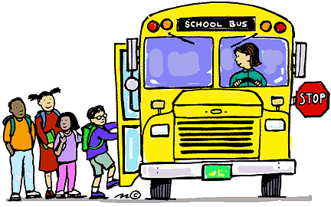
- 3 boxes of tissues (This may need to be replenished before the school year ends)
- 1 heavy-duty plastic 2-pocket folder
- 1 heavy-duty plastic duotang with pockets (for homework and notices)
- 1 pkg. of 10 page protectors
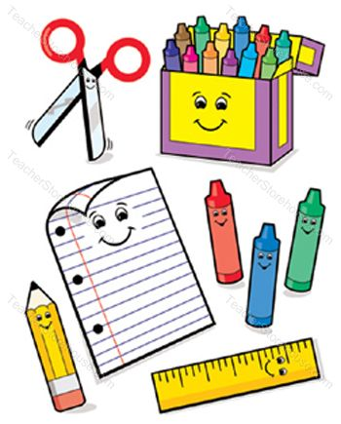
- 2 large glue sticks
- 1 pair of scissors
- 1 pkg. wax crayons
- 1 pkg. Crayola markers
- 1 pkg. pencil crayons
- 1 pkg. of highlighters
- Approximately 50 pencils (“Staedtler” brand or comparable)
- 8 white erasers
- 30cm ruler
- 1pkg. each medium and large zip-lock baggies
- 1 300-page 3-subject notebook
- 1 hard-covered journal (non-coiled, “Composition”)
- 1 hardcover sketchbook (not scrapbook)
- 1 pkg. of assorted color card stock
- 1 pkg (200 sheets) looseleaf
- 1 basic calculator
- 1 set of headphones
- 1 small whiteboard – plain, no cork (8 1/2 x 11)
- 1 pkg. plain paper (500 sheets)
- 2 pkgs. whiteboard markers
- Handheld pencil sharpener (with a cover) for sharpening pencil crayons
- non-marking sneakers
- backpack
- pencil case or box
Please do not send binders, liquid paper, electronics, and mechanical pencils.
If you have any questions or require clarification, please do not hesitate to contact us by calling the school (363-4717).
Thanks in advance,
KVMS Elementary Team

