June 2017
Dear Parents,
For the 2017-2018 school year, we are purchasing the student’s school supplies. The student’s cost is $50.00.
This will cover all school supplies your child will need throughout the year. This enables us to purchase good quality items at reduced prices. It also ensures that all children have the necessary supplies for the curriculum. We will buy materials and distribute them as they are needed. Please make cheques payable to Priestman Street School.
In addition to the $50.00, your child will need the following on the first day:
- Indoor sneakers with white soles suitable for physical education. If your child is unable to tie shoelaces, please send ones with Velcro fasteners.
- One lunch box.
- A school bag large enough to carry the lunch box and homework. (Please do not get ones with wheels as they are too large and heavy for the children)
- One box of Kleenex
- Please return the bottom portion of this note on the first day.
See you on the first day of school, Tuesday September 5th, 2017.
Thank you for your support,
Yours truly,

Lesley O’Brien
Grade One/Two English Teacher
-------------------------------------------------------------------------------------------------------------
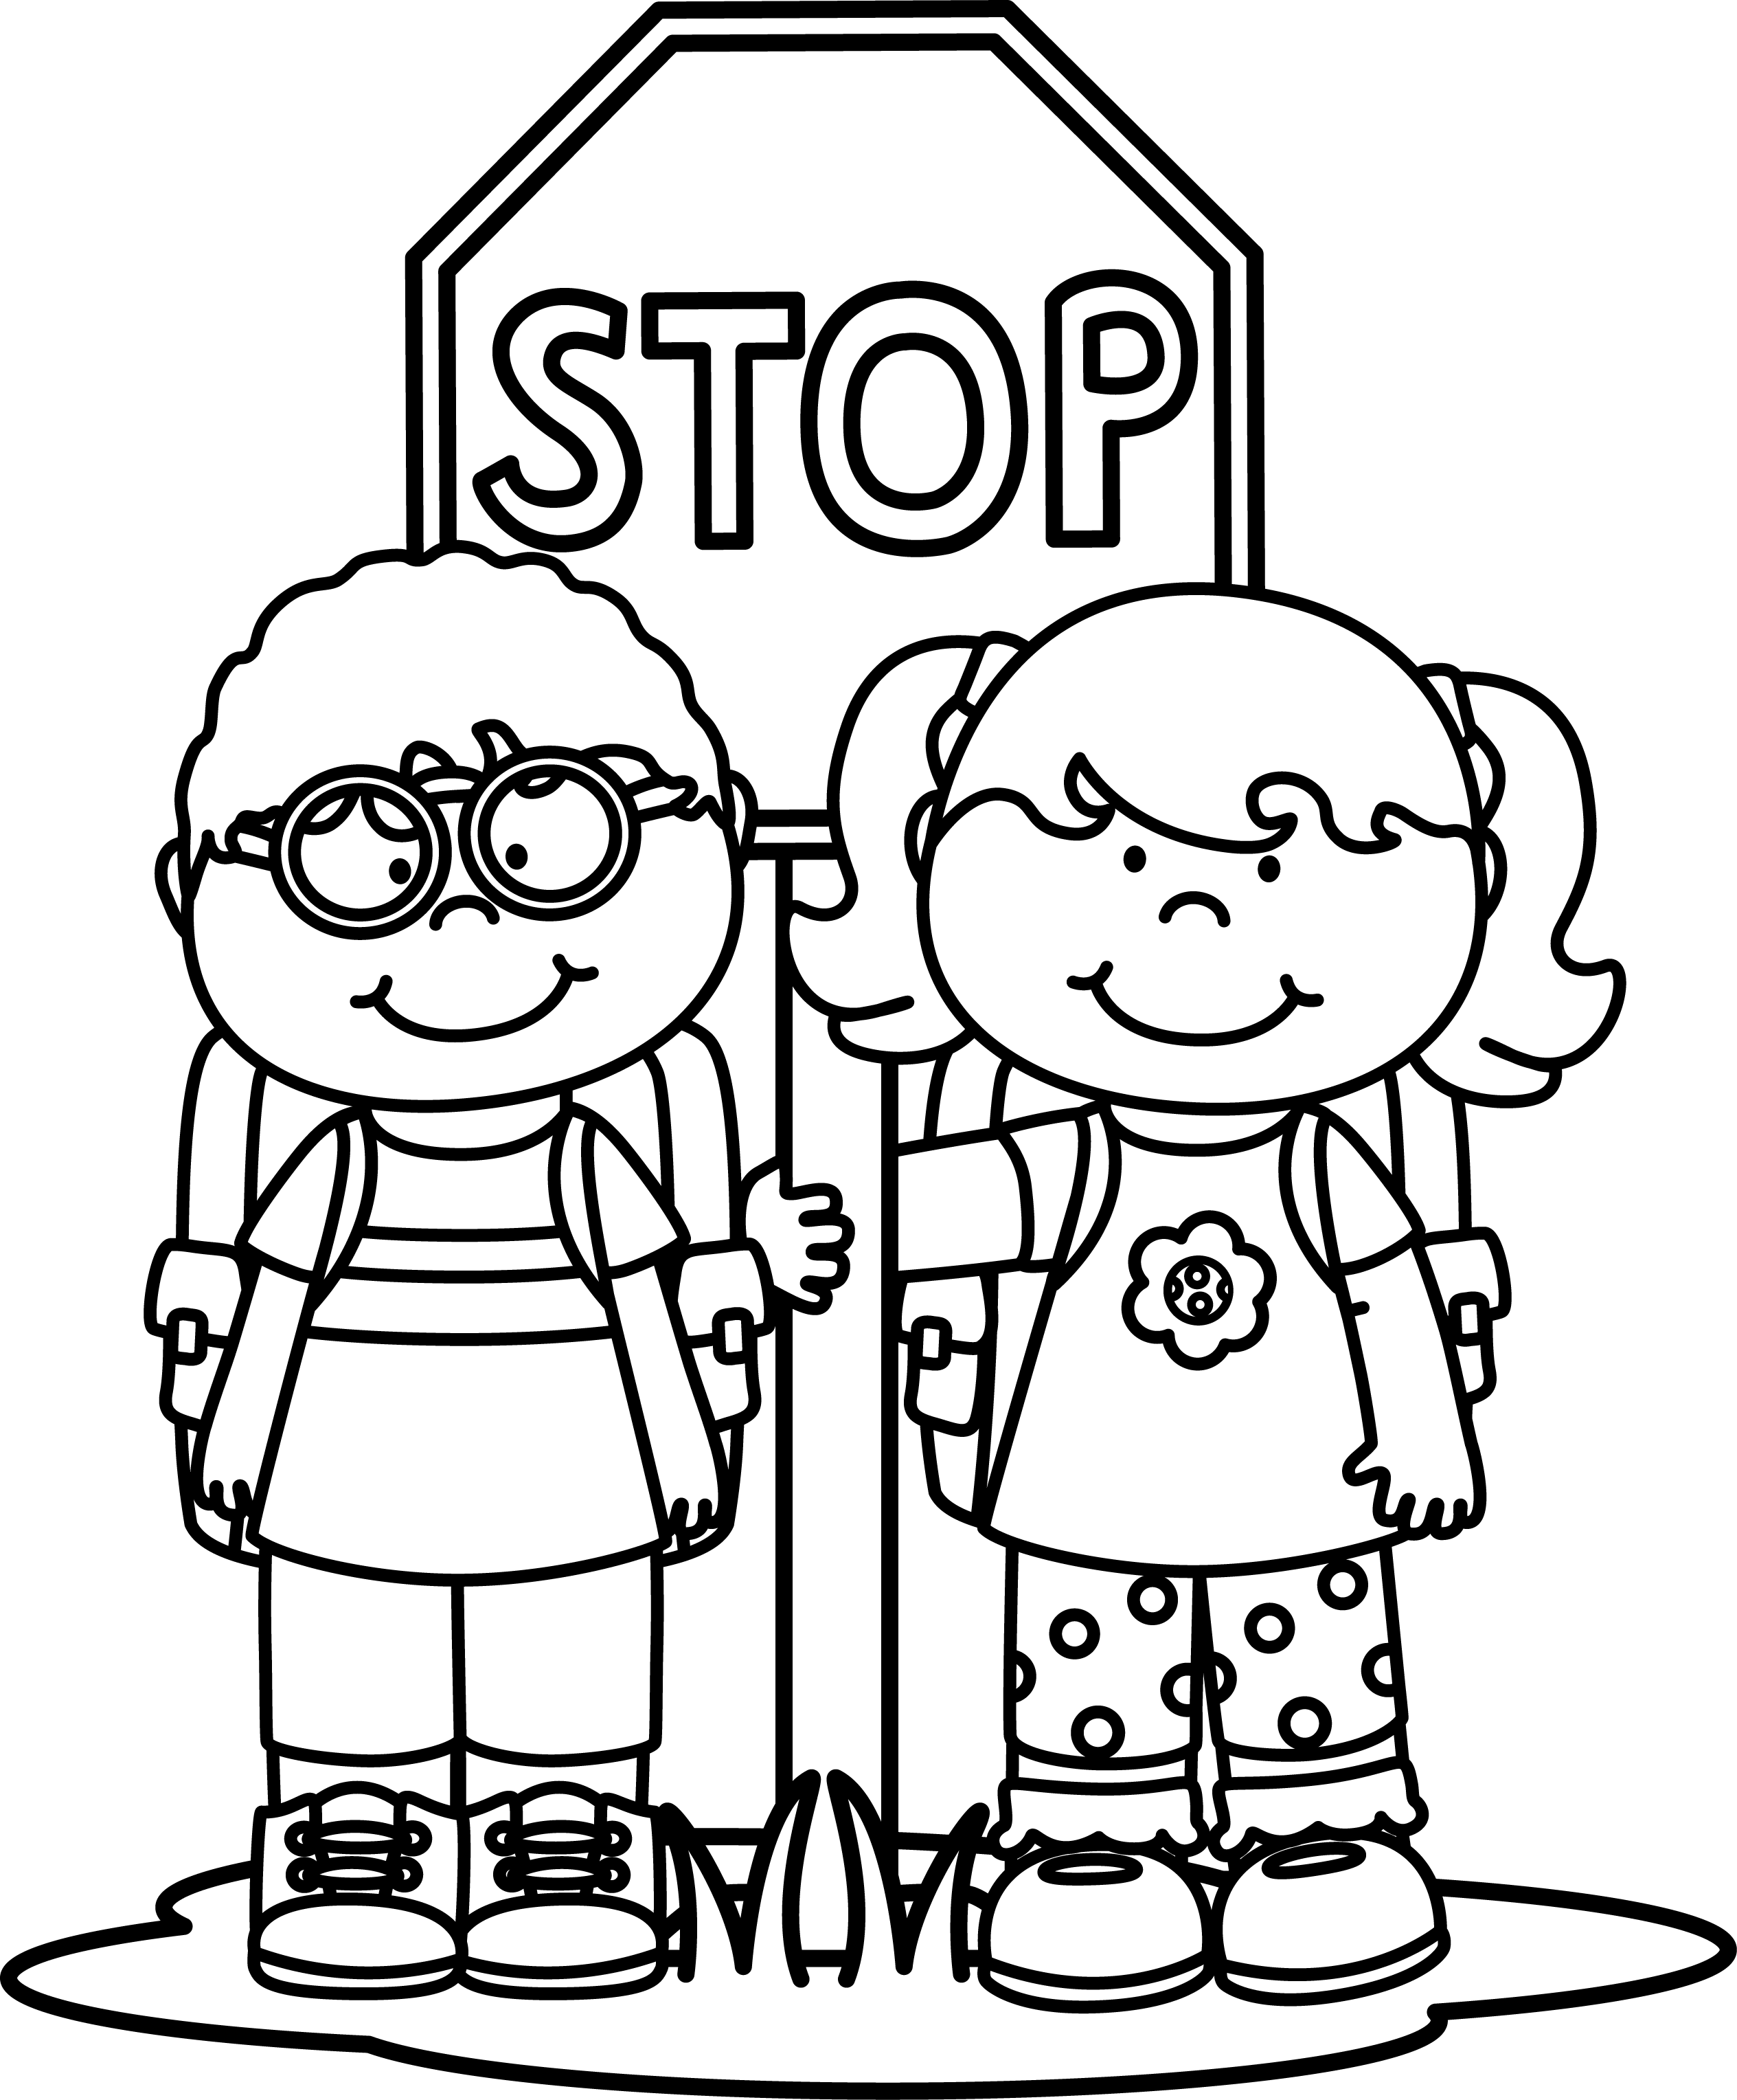
Please send this paper with your child on the first day of school.
Child’s name _________________________________
Where does your child go after school? _______________________________________________
Bus # (if you know it) _________
Phone number where you can be reached during the
day on Sept. 5th. __________________

