Keswick Valley Memorial School
Middle School Supplies - 2017- 2018
-------------------------------------------------------------------------------------------------------------------------------
*$25.00 School fee: special events, supplies, locker rental, photo finishing
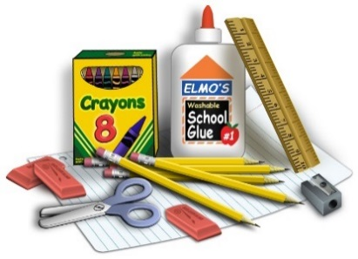
Pencil Case:
HB pencils
Blue and black pens
White erasers
1 pkg. of highlighters
1 large UHU glue stick
1 pkg. of fine white board markers
1 pkg. of Sharpies
Personal ear buds
USB stick
Masking tape

Shared Supplies:
3 pkg. of looseleaf
1 pkg. of blank paper
1 pkg. white cardstock
1 pkg. Crayola pencil crayons
1 pkg. Crayola markers
1 pkg. of large Ziplock bags
1 pkg. of small Ziplock bags
2 boxes of Kleenex
1 white board
1clip board

PDCP:
1 duotang (orange)

PIF:
1 duotang (blue)

Science:
1 duotang (green)

Social Studies (grade 8):
1 duotang (red)

Social studies (grade 6 and 7):
1.5 inch binder (solid color)

Health:
1 duotang (black)

Math:
3 subject coil notebook
2 duotangs (yellow)
1.5 inch binder (solid color)
1 pkg. of 10 page protectors
1 pkg. of index cards
1 deck of playing cards

Language Arts:
1.5 inch binder (solid color no zippers)
1 pkg. of dividers
1 pkg. of index cards
1 pkg. of Post It Notes
1 Composition Notebook (Dollar Store)
1 pkg. of 10 page protectors

PE:
Indoor sneakers (No skate boarding shoes)
Unscented deodorant
Appropriate clothing for PE class

