PAMS School Supply List
2017-2018

$25 student fee (due by Friday, September 30 or arrangements made with administration)
20 duotangs
1 – 2” binder
1 – 1” binder
12 Hilroy notebooks
2 Composite Notebooks (Dollarama)
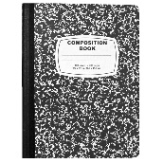
4 packages loose leaf
4 packages pencils
1 package markers
1 package pencil crayons
Erasers
Glue stick
Scissors
Geometry set (Grade 6 and 7 only)
Memory stick
Pencil case
Highlighter
Headphones (Dollar Store)
Calculator (Dollar Store)
Phys. Ed – Indoor sneakers, proper gym clothes

