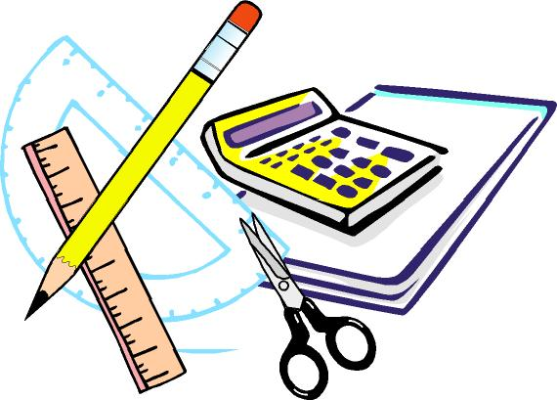
Keswick Valley Memorial School
Grade 1-2 School Supplies List 2018 - 2019

On the back of the page, you will find the list of supplies that your child will need for next year. This is a general list; there may be some additional items requested by the homeroom teacher at the beginning of the school year. It is also a good idea to keep a back-up set of some supplies at home for homework.
We encourage you to look around a little before you begin your shopping, as many stores (such as Staples and Walmart – they will price match flyers!) have incredibly low prices on better quality school supplies in late summer, better even than Dollarama or similar places.

Students are not asked to change into gym clothes at this age, but should have a change of clothing in the event of an emergency in a plastic bag. They also need properly-fitting non-marking soled sneakers for indoors and for Physical Education classes.
Each student is asked for $30.00 (Student fee) which covers a variety of consumable items such as: duotangs, supplies for experiments, crafts, projects and other curricular activities, special events, photo finishing, rewards and incentives, mini explorers, etc.

We are very much looking forward to seeing you in the fall!
Have a fantastic summer!
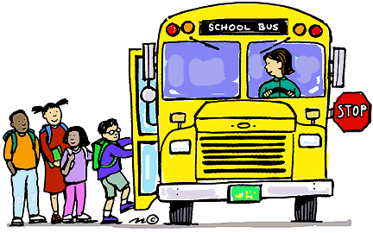

PLEASE DO NOT LABEL THE FOLLOWING ITEMS:

. 1 package of HB or Dixon pencils (Dollar Store pencils are NOT a good choice)
. 1 package of black triangle shaped pencils (DIXON triconderoga HB2)
. 3 white erasers
. 3 boxes of Kleenex
. 1 package of whiteboard markers (Dollar Store)
. 1 box large Ziploc baggies
. 1 box small (sandwich size) Ziploc baggies
. 1 package of thick-tip Crayola markers
. 1 black “Sharpie”
. 2 packages of page protectors (10 per pack)
. 1 piece of white bristol board (to be used for an art portfolio)
. I package of cardstock (any color/ any amount)
. 4 large glue sticks (UHU yellow are the best)
. 1 package of pencil crayons
. 2 Half and half Hilroy books (½ plain / ½ lined)
. 1 2-pocket folder

PLEASE LABEL the following items:
. Lunch bag
. Backpack
. Indoor non-marking sneakers (if your child can not tie, please send slip-on or Velcro shoes)
. Change of clothes (put in plastic bag and label bag please)
. 1 pair of metal scissors (if your child is left-handed, please purchase left-handed scissors)
. 1 pencil case or pencil box
. 1 dry erase white board (Dollar Store ones are perfect!)
. 1 artist sketch book

If you have any questions or require clarification, please do not hesitate to contact us by calling the school (363-4717) or email:

caitlinlong@nbed.nb.ca
Maxine.brewer@nbed.nb.ca

Thanks in advance!
KVMS Primary Team

