Ms. Stiles
Teacher’s Name
English 10
10 December 2019
50 Word Summary
To Kill a Mockingbird by Harper Lee
This novel is set in the 1930s and examines a young girl’s understanding of a court case that is marred in prejudice. The narrator, Scout, often provides readers with unreliable information due in large part to her age, but also her privileged status in Maycomb. Her family lineage as well as her father’s position as county lawyer afford her some advantages in this society. It is mostly through the prodding of the hired help, Calpurnia, that Scout is made aware of her privilege. Similarly, author, Harper Lee, also had a father who was a lawyer and was raised in a time and place where prejudice was rampant. It is clear that Lee makes a statement that is meant to challenge this status quo during this time; however, how would the insights made in this issue change if readers analyzed this issue through the lens of a person of colour?
“Passing” by Langston Hughes
This short story is set in the 1950s in a landscape different from the deep South. It is set in the northern city of Chicago that underwent a cultural revolution known as the Harlem Renaissance which celebrated the contributions and strengths of black culture. The author, Langston Hughes, uses the persona of a young man named Jack to highlight the inner struggle he faces as a black man who presents himself as white, but culturally was raised by a mother confronted with racism. Hughes writes from the perspective of a reliable narrator, and, as a result, is better able to show how a person of colour struggles from a present term known as double consciousness. What is lost and gained from an unreliable perspective? How are issued presented differently from this lens?
Thesis:
These texts prove that people of colour are reduced to an economy of stereotypes when narrators tell their narrative through the lens of an unreliable narrator.
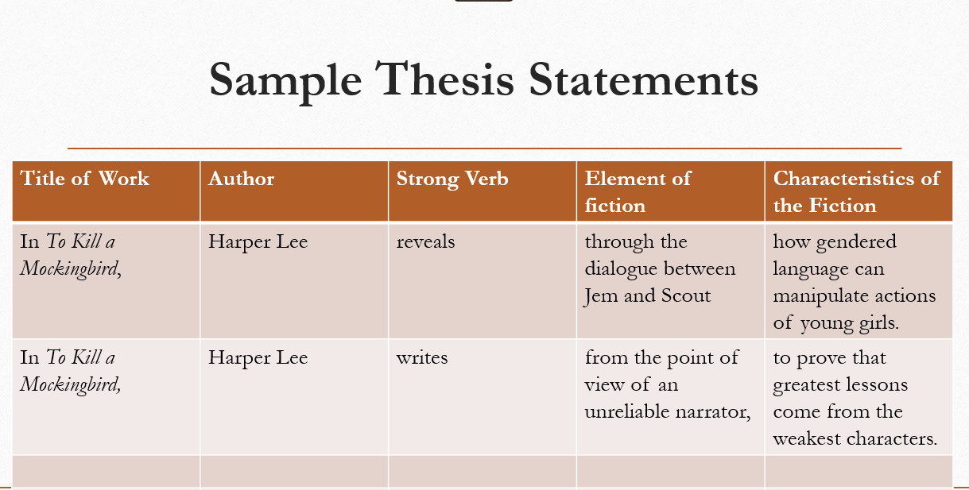
Paragraph One:
In 1900, fine instrument mechanic Erwin Perzy first discovered that glass globes filled with water offer tiny yet powerful spotlights when cast on an object. These globes became popularized as what is now appreciated as the Christmas holiday globe. These globes could be adapted to literature as the lens viewed to understand a novel’s setting. In Harper Lee’s, To Kill a Mockingbird the young narrator, Scout, experiences her own form of domed existence in the small town of Maycomb. Her age and experience limit her from seeing beyond her own situation as a privileged white child. In contrast, Langston Hughes’s, Passing, explores narrator Jack’s more insightful understanding of his world beyond the lens of a person of colour. Both of these texts were written after the Harlem Renaissance, a period that encouraged the rebirth and celebration of black culture. Although both address similar theme topics regarding justice in the face prejudice, one appears less moralistic and more authentic. Through the lens of a reliable narrator such of Jack, a sharper highlight is cast on the problem of prejudice. Characters appear less one-dimensional and the issues they face are more complex. Scout recalls only comments that identify characters in simplistic ways. These texts prove that people of colour are reduced to an economy of stereotype when narrators tell their narrative through the lens of an unreliable narrator.
Topic sentence
Evidence
Discussion
Punch Sentence
. (https://www.mentalfloss.com/article/71983/brief-history-snow-globes).
Lead-in: Intro to broad subject (anecdote, interesting detail, provocative question)
Text: State works of literature and authors to be studied
Overview: Provide a brief overview of the work of literature to be discussed (history, plot summary)
Summary: Ideas you will address in the body of your essay
Thesis Statement: Your answer to your question.

