A Whack on the Side of the Head (an excerpt)
by Roger Van Oche

Children enter school as question marks and leave as periods.
- Neil Postman

Life can be like a big noisy party with people talking, music playing and glasses clinking. But even with all this noise, it’s possible for you to understand the person across the room. That’s because our attention is selective – we can tune in certain things and tune out others.
See for yourself. Take a look around where you’re sitting and find four things that have red in them. With a red mindset, you’ll find that red jumps right out at you. Similarly, when you learn a new word, you hear it eight times in the next three days. That’s because people find what they are looking for. If you look for beauty, you’ll find beauty. If you look for conspiracies, you’ll find conspiracies. It’s all a matter of setting your mental channel.
Where do you learn to set your mental channel? One important source is your formal education. There you learn what is appropriate and what is not. You learn many of the questions you use to probe your surroundings. You learn where to search for information, which ideas to pay attention to, and how to think about these ideas. Your educational training gives you many of the concepts you use to order and understand the world.
……………………………………………

Much of our educational system is geared toward teaching people to find the “right answer.” By the time the average person finishes college, he or she will have taken over 2600 tests, quizzes and exams. The right answer approach becomes deeply ingrained in our thinking. This may be fine for some mathematical problems where there is in fact only one right answer. The difficulty is that most of life isn’t that way. Life is ambiguous; there are many right answers – all depending on what you are looking for. But if you think there is only one right answer, then you will stop looking as soon as you find one.
When I was in sophomore school, my teacher put a small chalk dot on the blackboard. She asked the class what it was. A few seconds passed and then someone said, “A chalk dot on the board.” The rest of the class seemed relieved that the obvious had been stated, and no one else had anything more to say. “I’m surprised at you,” the teacher told the class. “I did the same exercise yesterday with a group of kindergartners, and they thought of fifty things it could be: an owl’s eye, a cigar butt, a rotten egg, and so on.”
In the ten-year period between kindergarten and high school, not only had we learned to find the right answer, we had also lost the ability to look for more than one right answer. We had learned how to be specific, but we had lost much of our imaginative power. I can’t overstate the danger in this. If you have only one idea, you have only one course of action open to you, and this is quite risky in a world where flexibility is a requirement for survival.
An idea is like a musical note. In the same way that a musical note can only be understood in relation to other notes, an idea is best understood in context of other ideas. If you have only one idea, you don’t have anything to compare it to. For more effective thinking, we need different points of view. Otherwise, we’ll get stuck looking at the same things and miss seeing things outside our focus.
One technique for finding the second right answer is to change the questions you use to probe the problem. How many times have you heard someone say, “What is the answer?” or “What is the result?” These people are looking for the one answer. And that’s all they’ll find – just one. If you train yourself to ask questions that solicit plural answers like “What are the answers?” or “What are the results?” you will find that people will think more deeply and offer more than one idea.

The best way to get a good idea is to get a lot of ideas.
- Linus Pauling

You may not be able to use all of them, but out of the number you generate you may find a few that are worthwhile. This is why professional photographers take so many pictures. They’ll change the exposure and the filters, because they know that out of all the pictures they take, there may be only a few that capture what they’re looking for. It’s the same thing with thinking: you need to generate a lot of ideas to get some good ones.
Another technique for finding more answers is to change the wording in your questions. If an architect looks at an opening between two rooms and thinks, “What type of door should I use to connect the two rooms?” that’s what she’ll design – a door. But if she thinks, “What sort of passageway should I put here?” she may design something like a hallway or a courtyard. Different words bring in different assumptions.
Here’s an example of how such a strategy can work. Several centuries ago, a curious but deadly plague appeared in a small village in Lithuania. What was curious about this disease was its grip on the victim; as soon as a person contracted it, he’d go into a deep, almost death-like coma. Most died within a day, but occasionally a hardy sole would make it back to health. The problem was that since 18C medical technology wasn’t very advanced, the unafflicted had a difficult time telling whether a victim was dead or alive.
Then one day it was discovered that someone had been buried alive. This alarmed the townspeople, so they called a town meeting to decide what should be done to prevent such a situation from happening again. After much discussion, most people agreed on the following solution. They decided to put food and water in every casket next to the body. They would even put an air hole from the casket up to the earth’s surface. These procedures would be expensive, but they would be more than worthwhile if they would save people’s lives.
Another group came up with a second, less expensive, right answer. They proposed implanting a twelve-inch long stake in every coffin lid directly over where the victim’s heart would be. Then whatever doubts there were about whether the person was dead or alive would be eliminated as soon as the coffin lid was closed.
What differentiated the two solutions were the questions used to find them. Whereas the first group asked, “What should we do if we bury somebody alive?” the second group wondered, “How can we make sure everyone we bury is dead?”
Much of our educational system has taught us to look for one right answer. This approach is fine for some situations, but many of us have a tendency to stop looking for alternative right answers after the first answer has been found. There are many ways to find the second right answer, but if you don’t look for them, you won’t find them.

“Closing of the North American Mind”
by Robert Nielsen

In this provocative essay, Robert Nielsen reviews a book by American philosopher Allan Bloom. This book critiques the American education system, which Nielsen considers to be in the same state of disarray as the Canadian one. What do you think?
Instead of encouraging us to think and live well, “higher education,” according to this scathing bestseller, is offering shifting values and irresponsible freedom.

Now that higher education is within easier reach of Canadians than ever before, it’s time to ask: What’s so high about it? That’s the question we are urged to consider by Allan Bloom’s book, The Closing of the American Mind, which has surprised its author and publisher by becoming an international best-seller. In Canada as well as the United States, it has provoked keen debate over what the aims of education should be.
If we are content merely to have our universities train doctors, lawyers, engineers, scientists, and other professionals, they are probably serving us adequately. But if we share Bloom’s fervent belief that universities should also offer students pathways to “the good life” of wisdom and virtue, then they are letting us down badly.
Subtitled “How higher education has failed democracy and impoverished the souls of today’s students,” the book scathingly indicts the universities for abandoning moral truth in favour of a shallow, shifting mix of “values.” This moral relativism tens to justify whatever current opinions and behaviour students feel comfortable with; and they may pass through four years without ever encountering a professor – or book – that challenges them to do some serious thinking about their ideas
Bloom, a classical scholar and philosopher, has taught at several North American universities, including the University of Toronto, and his criticisms are applicable to the Canadian as well as to the American scene. Bloom finds today’s students “nice” in that they are tolerant and willing to concede everybody the rights they claim for themselves. They are not, he said, especially moral or noble. They don’t fall in love, they have sexual “relationships” that are easy to start and easy to abandon. They have little idealism. “There is a whole arsenal of terms for talking about nothing – caring,’ ‘self-fulfillment,’ ‘expanding consciousness,’ and so on.”
Students have no understanding of evil and even doubt its existence, thus lacking awareness of the depths as well as the heights of human nature. They read few books, and find neither pleasure nor insights for living in the great literature of the past; in history, no lessons for the present.
Futile Propaganda. The universities, of course, don’t shape these “flatsouled” young people. They arrive on campus as products of homes, schools, and a commercially packaged youth culture far more influential than either parents or teachers in forming their tastes and attitudes. Here Bloom widens his target to our modern society itself.
Even in relatively happy homes, he says, “the dreariness of the family’s spiritual landscape passes belief.” Parents have quit their traditional role of instilling beliefs in religion, morals, and patriotism. Once “the Bible was the common culture, one that united the simple and the sophisticated, rich and poor, young and old.” Now neither it nor other great books passed down to us are read and discussed in the home because “nobody believes that the old books do, or could, contain the truth.” Claims Bloom: “Fathers and mothers have lost the idea that the highest aspiration they might have for their children is for them to be wise-as priests, prophets, and philosophers are wise. Specialized competence and success are all they can imagine.”
In default of moral education at home, the schools give courses in “value clarification.” These prompt children to talk about abortion, sexism, and the arms race, “issues the significance of which they cannot possibly understand.” Such education is little more than propaganda, Bloom contends, and futile propaganda at that. The values at which the children arrive will change as public opinion changes-because they are not grounded in experience or passion, the bases of moral reasoning.
Meanwhile reading and writing are widely ill-taught in public schools, and television replaces reading in the home. This compels universities to set up remedial classes for the many high-school graduates who cannot read or write well enough to cope with first-year courses.
Delusive Openness. How do the universities respond to the masses of uncivilized young people? In general, Bloom maintains, by accommodating in every field except science and professional training the students’ ignorance and paltry aims.
Literate or not, earnest or trifling, rich or poor, nearly every student, says Bloom, enters university with one fixed belief-that truth is relative. Students assume that ideas are valid only for their own time and place, or perhaps only for the individual holding them; that there are no universal and eternal verities for people to learn and live by. This leaves everyone free to think and do as they please, without worrying about right and wrong, so long as they don’t infringe on others’ freedom to do likewise. The only sin is intolerance.
Such “openness,” Bloom says, actually leads to closed minds because it makes students incurious about real distinctions between good and bad, between right and wrong, between truth and error, instead of leading them to seek knowledge and certitude. In Bloom’s view, “to deny the possibility of knowing good and bad is to suppress true openness.”
Bloom says education should make students curious about man’s highest aspirations, as opposed to his low and common needs. And they have to become aware that the answer is not obvious, but neither is it unavailable. It can’t be found, however, without consulting the great thinkers and writers of the past.
The quest should be led by the humanities-literature, philosophy, and history But the humanities faculties are in poor shape to carry out the task after caving in to the demands of a student “rabble” in the 1960s, Bloom alleges. Relaxed academic standards and easy grading made it hard for a student to flunk out. Junk courses were devised to cater to the demands for political “relevance.”
The universities are quieter now, but Bloom warns against assuming that they have recovered their quality and integrity. Students can choose humanities courses in cafeteria style, picking out a list of soft ones that will get them an arts degree without giving them coherent knowledge.
At the same time, the faculties go their separate ways. At the University of Toronto, science students need take only three of their twenty courses in either arts or social science, and non-science students need take no science at all. The different faculties compete for students, but don’t even try to collaborate in offering anyone a rounded education.
“These great universities,” Bloom writes, “which can split the atom, find cures for the most terrible diseases, and produce massive dictionaries of lost languages, cannot generate a modest program of general education for undergraduate students.” A good program of liberal education, he says, “feeds the student’s love of truth and passion to live a good life.” He adds that it is easy to devise courses of study that thrill those who take them; the difficulty is getting them accepted by the faculty
Students come to US universities ignorant and cynical about their country’s history, Bloom says. Their cynicism, at least, stands to be increased by “revisionist” historians who promote either or both of two poisonous distortions of history. They malign the character and ideas of the American founding fathers, and they pervert recent history to make the United States rather than the Soviet Union the villain in the contest between communism and democracy. (Some of these revisionists have moved north to places on Canadian university faculties, where they fuel anti-Americanism.) Thus young Americans are taught to be apologetic instead of proud of a political heritage that made their country the leading democracy and themselves perhaps the most privileged youth ever.
A milder form of this erosion is happening in Canada, where the British heritage used to be central to the teaching of literature and history. “Now,” says Thomas Pangle, a former student of Bloom’s who is today a professor of political philosophy at the University of Toronto, “a Canadian student is not expected to know any more about English literature than a student in Missouri. If a university teacher quotes Dickens or Shakespeare, he can’t count on the students sensing any echoes.” Canadian universities have generally gone along with the trend, although at the University of Toronto the eminent scholar Northrop Frye held the fort by insisting on the study of the Bible and Shakespeare.
“Ignorant Shepherds.” Bloom’s is a profound book, full of rewards to the attentive reader because of the richness of his thought and the clarity, energy, and wit of his writing. Near the end he offers a poignant metaphor of where we now stand in relation to the great tradition of human learning:
“We are like ignorant shepherds living on a site where great civilizations once flourished. The shepherds play with the fragments that pop up to the surface, having no notion of the beautiful structures of which they were once a part. All that is necessary is a careful excavation to provide them with life-enhancing models.”
The restoration, if it comes, will be no easy task. The causes of the ills Bloom exposes in our education and our society are too deep for quick fixes-although a return to competent teaching of the three R’s in school would be a useful beginning.
It is no surprise that the book has come under sharp attack. It defies almost every tenet of fashionable modern thought, and leaves no academic ox ungored. What is surprising, and heartening, is the phenomenal response to it. A year after its publication it was still on The New York Times best-seller list. This can only mean that many people sense a hollowness at the core of modern life which cannot be filled by more science and technology, more wealth and comforts, more sex and amusements.
A critic who credited the book’s success to smart promotion was corrected by New York author Midge Deeter, a close observer of today’s youth. “The reason the book sold well,” she says, “is that a lot of people, young people in particular, found themselves and their own feelings of emptiness reflected in it. The people who started the great publicity snowball were young people who read this and said, ‘My God, that’s us.'”
There are indeed young people who want more from university than a few years of irresponsible freedom. They feel cheated. Bloom’s book offers a wealth of clues to what they are missing, and to what must be done to make higher education worthy of the name. From it young readers will emerge, it is hoped, champions of healthy change-change that restores the ancient goal of thinking and living well.



The data on this page are current as of June 2014.

Key Messages
- British Columbia, Ontario, and Alberta are the top performers among all the provinces, earning “B” grades on the Education and Skills report card.
- Manitoba, Saskatchewan, New Brunswick, and Newfoundland and Labrador all earn “D’s” overall, while P.E.I. earns a “D–,” scoring worse than the lowest-ranked international peer country.
- The largest provincial differences occur on student reading, science, and math skills—with provinces earning anywhere from an “A+” to a “D–” grade.
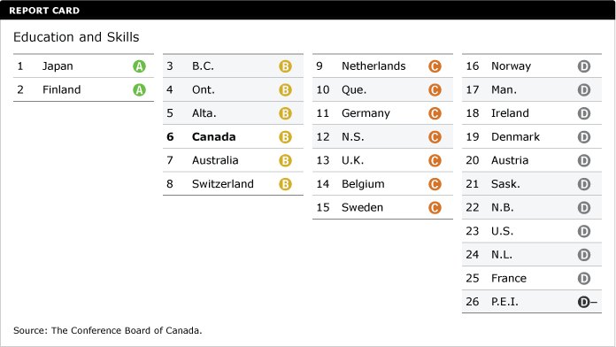

Putting education and skills in context
Education is typically seen as the most powerful route to improving private and public prosperity and well-being.

Educated people not only earn higher incomes but also contribute disproportionally to business innovation, productivity, and national economic performance. There is a strong and direct relationship between educational attainment and economic growth. A 2003 multi-country study from the European Commission found that if the national average educational attainment level is increased by a single year, aggregate productivity increases by 6.2 per cent right away and by a further 3.1 per cent in the long run.¹
Education also affects social outcomes. Higher educational attainment has been linked to increased civic engagement, higher life satisfaction, and lower crime rates.² Moreover, there is evidence that more educated people make decisions that lead to healthier and longer lives.³ Education is an important contributor to well-being and a critical force for driving success.
K–12: Indicators in this level focus on the performance of students from kindergarten to Grade 12. Countries are compared on their performance on the OECD’s Programme for International Student Assessment (PISA), a test administered to 15 year olds every three years. PISA assesses students’ skills in reading, math, and science. Countries are also evaluated on how well immigrant students are faring on PISA compared with native-born students, as well as on the number of resilient students—those students who are disadvantaged socio-economically yet score well on the PISA math test. Finally, high-school attainment rates are compared.

Do Canada’s youth have the skills needed to succeed?
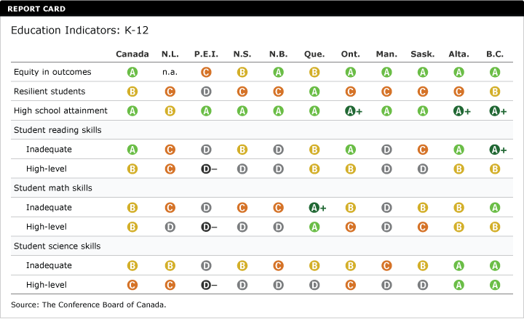
Canada performs well at the national level on the 2012 PISA reading, math, and science tests. At the provincial level, however, significant differences emerge. Some provinces managed to earn high grades—such as Alberta and B.C., with all “A”s or “B”s—but several other provinces are performing significantly below the levels needed. Even within provinces there are differences in outcomes. For example, Quebec earns an “A” grade for its large share of students with high-level math skills but a “D” on high-level science skills.

Also troubling is that, like the majority of its peers, Canada’s performance on student skills declined between 2009 and 2012.

While the poor performance of some provinces is troubling, the fact that other provinces are excelling on certain aspects of student skills means that there is an opportunity to learn from those provinces. What policies, practices, and techniques are they using to produce excellent results? How can other provinces replicate their successes? Provinces can also look to international peers. Finland perennially performs well on student tests. And while most countries performed worse on the 2012 test, Japan successfully reduced its share of students with inadequate skills, earning “A” grades on all six measures of student skills in the 2012 PISA test.

For each of the readings, answer the following questions:

1. What does the article state/imply is the purpose of education?

2. Identify a statement with which you
a) agree
b) disagree

3. What do the readings have in common? Elaborate.

