Journalism 120: Rubric for Close-Read
Student Name:____________________________________ Final Mark:_____/10
Guidelines: Choose one article from allsides.com and complete a close-read of the article by identifying elements of bias. Your 10 annotations in the margins should identify and explain the type of bias used in your article. Although no one article will contain all forms of media bias, your annotations should reflect a variety of examples.
Types of bias:
- Bias through omission - Bias through placement
- Bias through tone / word choice - Bias by headline
- Bias through names / titles - Bias through statistics and crowd counts
- Bias through source control (“puff-pieces,” pseudo-events - Bias through photos, captions, and camera angles
This assignment is due: _____________________________________.

Here is a sample of a close-read comment:
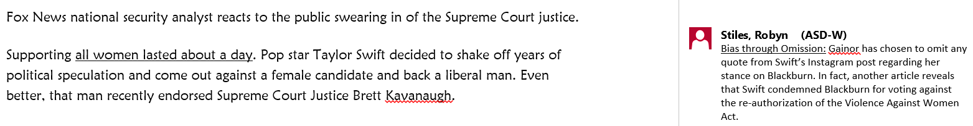

 | 9-10  Thorough | 7-8  Acceptable | 5-6  Attempted, Some Gaps | 3-4  Partial / Incomplete | 1-2  Inaccurate
Number of Annotations | 10 annotations are present. Student shows solid evidence of linking their comments to multiple forms of bias. | 10 annotations are present. Student shows some evidence of linking their comments to multiple forms of bias. | 7-8 annotations are present. Student shows some evidence of linking their comments to multiple forms of bias. | 7-8 annotations are present. Student shows evidence of linking their comments to multiple forms of bias. | Fewer than 7 annotations are present. Student shows evidence of linking their comments to multiple forms of bias.

Journalism 120: Rubric for Close-Read
Student Name:____________________________________ Final Mark:_____/10
Guidelines: Choose one article from allsides.com and complete a close-read of the article by identifying elements of bias. This assignment is due: _____________________________________.
 | 9-10  Thorough | 7-8  Acceptable | 5-6  Attempted, Some Gaps | 3-4  Partial / Incomplete | 1-2  Inaccurate
Number of Annotations | 10 annotations are present. Student shows solid evidence of linking their comments to multiple forms of bias. | 10 annotations are present. Student shows some evidence of linking their comments to multiple forms of bias. | 7-8 annotations are present. Student shows some evidence of linking their comments to multiple forms of bias. | 7-8 annotations are present. Student shows evidence of linking their comments to multiple forms of bias. | Fewer than 7 annotations are present. Student shows evidence of linking their comments to multiple forms of bias.

Journalism 120: Rubric for Close-Read
Student Name:____________________________________ Final Mark:_____/10
Guidelines: Choose one article from allsides.com and complete a close-read of the article by identifying elements of bias. This assignment is due: _____________________________________.
 | 9-10  Thorough | 7-8  Acceptable | 5-6  Attempted, Some Gaps | 3-4  Partial / Incomplete | 1-2  Inaccurate
Number of Annotations | 10 annotations are present. Student shows solid evidence of linking their comments to multiple forms of bias. | 10 annotations are present. Student shows some evidence of linking their comments to multiple forms of bias. | 7-8 annotations are present. Student shows some evidence of linking their comments to multiple forms of bias. | 7-8 annotations are present. Student shows evidence of linking their comments to multiple forms of bias. | Fewer than 7 annotations are present. Student shows evidence of linking their comments to multiple forms of bias.

