2017-2018 Student Clothing 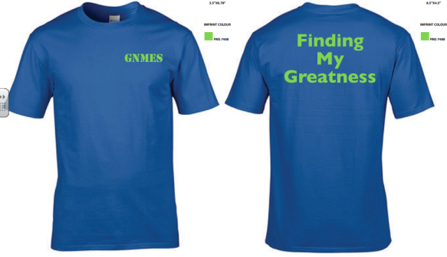

This year, we are selling T-shirts and Hoodies for students. They will have GNMES on the front left, and Finding My Greatness on the back. T-Shirts are $15 and Hoodies are $30. Please complete your order, and send Cash only in by November 15th. The shirts are made by Gildan and are royal blue shirts with green printing. Sizes: Youth S, M, L, XL or Adult sizes S, M, L, XL, or XXL. Please specify size on the order form.
Name: ___________________ Class: ______________
T-shirt: Size ______________ Hoodie: ______________ Total: $ _______________

2017-2018 Student Clothing

This year, we are selling T-shirts and Hoodies for students. They will have GNMES on the front left, and Finding My Greatness on the back. T-Shirts are $15 and Hoodies are $30. Please complete your order, and send Cash only in by November 15th. The shirts are made by Gildan and are royal blue shirts with green printing. Sizes: Youth S, M, L, XL or Adult sizes S, M, L, XL, or XXL. Please specify size on the order form.
Name: ___________________ Class: ______________
T-shirt: Size ______________ Hoodie: ______________ Total: $_________________

