**EAT FOR EDUCATION**

**GEARY GAZETTE**

**At Geary Elementary Community School:**

***“We C.A.R.E.”***

**January 15, 2018 twitter.com/gearygators**



Eat for Education will be held this year on **Saturday, February 10th**. Please mark your calendars and plan to attend Breakfast at the Lion’s Club, between 7:30 – 10:30 a.m. The planning process for this school fundraiser is just beginning. A form will be coming home seeking your support. You can also help support the breakfast by sending in pancake mix with your children in grades K-2 and syrup with your child in grades 3-5. Thanks so much!

**Home and School**

The next meeting of the Home and School Committee will be held on **Wednesday, January 17th at 6:00 p.m.** As always, the Home and School has a busy agenda planned. Even if you have never attended a meeting in the past we welcome parents to attend these meetings, as many hands make light work.

The Hot Lunch Program, with Sharon Eldridge at the helm continues to be a success. Menus go out every two weeks for families. Sending the orders back in a timely manner is critical to the success of the program now that lunch is being served on Monday as well. Lunch is two dollars with milk each day. The food is delicious and nutritious so if you miss an order you miss two weeks of hearty eating! Additional volunteers are always welcome.

There will be a Home and School sponsored **Valentine’s Dance** for the children on **Friday, February 9th**. Keep your ears and eyes open for the date.

The **Spring Bazaar** is an annual event that the Home and School plans. Dates for this event are **April 27th for the Children’s Bingo and April 28nd for the Spring Bazaar.** This family oriented event is one that allows the Home and School to provide fiscal support to the school – time and time again! Mark your calendars please!

**STAFFING**

Please welcome, Mr. Bowering as our new grade 1 teacher. Mrs. Killam is now working as EST Literacy in ASD-W. Best wishes Mrs. Killam. As well, we have Ruth Claybourn back helping out while Roberta, our Community School Coordinator recovers from a fall at school.

Learn more and register for training at **elfnb.com** or call **1-855-898-2533.** We can’t wait to hear from you!

**CARE Assembly**

**Cooperation, Appropriate Actions, Respect, Excellence in Learning**

On Tuesday, January 30th, the students in our school will attend a CARE assembly.   The CARE Crew, which consists of some students from grade 5, will explain the importance of Appropriate Actions in our school.  Examples such as using your manners, recycling, tying shoes, leaving rocks and snow on the ground, and telling the truth will be some of the appropriate actions that will be modeled for the school.  Students will also have an opportunity to see the results of the Gaia Project, in which the garbage from the school was analyzed. Students will learn some appropriate ways to dispose of left-over food and how to package lunches in an earth friendly way. We hope all students will learn from the CARE Crew and will walk away with more knowledge of how to be a good citizen in our community!

**Intensive French – Grades 4/5 & 5**

Currently, grade 4/5 students experience 980 minutes of French language instruction weekly. Madame Peters uses authentic oral language experiences to teach children conversational and written French. The Intensive French (IF) block is coming to a close for grade 4/5 on Friday, **February 2nd**. On **Monday,** **February 5th** thechildren begin the English Language portion of their program. They will move classrooms and be taught a compacted English curriculum by Mrs. Crowhurst and Mrs. Knorr. Mr. Lanteigne will continue French instruction with the 4/5 students.

The grade 5 students who are currently working with Mrs. Crowhurst and Mrs. Knorr will move into the Intensive French portion of their year with Mme. Peters. This is a wonderful opportunity for our students to learn French and to set goals for themselves as they move on to middle school. Late French Immersion is available in grade 6 as is Post-Intensive French.

Our grade 4 students currently receive 150 minutes of Pre-Intensive French as well. Before grade 4 students are exposed to 30 minutes weekly of French Cultural Experiences.

**National Anti-Bullying Pink Day**

The National Pink Shirt Day is on **Wednesday, February 28th, 2018**. Citizens across the country are encouraged to take a stand against bullying and to show support of this cause by wearing Pink. Our students are encouraged to wear PINK on this day as well as a symbol of our commitment to choose kindness! If you don’t have a pink shirt, wear white as this is a symbol of peace.

**Daily Announcements/Playground Pals and other Roles of Responsibility**

Did you know that the grade 5 students in our school read the announcements to the other boys and girls each day? They take this role of responsibility very seriously. These students also collect funds for the IWK on Friday’s Hat Day! As well, students in grade 5 are library helpers, playground pals and so much more. They are the oldest students in the school and as such we expect them to model appropriate behavior and help the younger students throughout the school. These grade 5 students do a wonderful job. They are so trustworthy and helpful. The staff are so proud of these students!! Their willingness to take on roles of responsibility is a reflection of the values that are instilled in them at home. Thank you parents!

**Sliding**

Students and staff will take advantage of the great snow conditions while they last. Parents please make sure your children have snow pants, mitts and hats to play safely as these activities are part of our curriculum. As well, please feel free to come up to the school in the evenings and on weekends to go sliding as a family. As I write, the rain is taking our snow but hopefully conditions will improve.

**Canada 150 Art Acquisition Program**

Thanks to a Canada 150 Art Acquisition Program, our school will be purchasing a piece of art from New Brunswick artist, Michel Duguay. The art work, “Peser Ses Mots” will arrive at our school this week. Thank you Mrs. Geburt for helping us action this acquisition.



**Storytent**

On **Thursday**, **January 25th,** Storytent will be held at Geary Elementary Community School at 6:00 p.m. Storytent is geared to children, age 4-6 years to help with language and literacy development. Children may come in their PJ’s to enjoy bed-time stories read inside a real tent. As well, there will be a little campfire sing song before the evening ends. The children attending receive a gift, drink and snack at home time. We hope to see you there so we can celebrate Family Literacy Day with you all! This event will also serve as a Headstart Meeting as these students are at the heart of our target audience. Come camp out with us and read some great books.

**Mittens**

Just prior to Christmas, an anonymous lady brought a bag of home knit mittens to the school for our students. The mittens are already on the hands of students. Extra mitts come in handy when children either don’t have, or misplace their own mittens. With the need for outside play being a high priority it is great to know that all of our students are well dressed for the weather. Thank you so much to these ladies who generously made donations to our school to keep wee hands dry and warm.

Gateway Tim Horton’s also warmed little hands this winter with their “Mitten Tree”. Thank you for thinking about our students. This initiative matters.

**Library Club**

Our librarian, Elizabeth Geburt has Library Club for students on Wednesday and Thursday mornings at recess time. This club is very popular with the students and follows calendar themes like, Remembrance Day and Orange Shirt Day, to name a few. Books are a way for our students to explore their world and our library has many wonderful interest books. Thank you Mrs. Geburt.

**Writers in Schools Program**

Through the Writers in Schools Program (WiSP), we are very lucky to have an author visit us on Wednesday, January 17th. Lynn Davies grew up in Riverview and Newcastle, New Brunswick. She writes poetry, essays, reviews, stories for children, and currently lives in Fredericton. She’s taught creative writing and book making for children at UNB and the Beaverbrook Art Gallery.

Lynn will combine a poetry reading with a writer’s workshop in which students engage in the writing process. Lynn has some neat tricks for getting reluctant writers to collaborate with her- and before they know it, they have a piece of writing. Our students will learn a great deal from Lynn and her creative style. Be sure to ask your child about her visit!

**Keeping Children Smoke-Free**

January is **Tobacco Reduction Month**, and this is a good time to think about how to keep your child’s environment smoke free.

**Tobacco Facts:**

* Tobacco smoke contains over 4000 chemicals including at least 70 which are carcinogenic or cause cancer.
* The top 6 toxins which are released when a tobacco product is burned are: tar, nicotine, carbon monoxide, formaldehyde, hydrogen cyanide and benzene.
* Besides cancer, smoking is responsible for many other diseases
* Because children breathe faster than adults, they are particularly sensitive to second hand smoke. Asthma rates are much higher in children whose parents smoke, and children are more likely to develop ear infections if exposed to second hand smoke.
* E-cigarettes or vaping is not recommended by Health Canada because of possible health risks, nicotine poisoning and addiction. Nicotine free or flavoured vaping products are also not recommended.

**Tips for Talking to Children:**

* Take advantage of opportunities to let your child know about the harmful effects of tobacco.
* If your children are involved in sports, remind them that remaining smoke free will help their performance in physical activity.
* Talk to your child about peer pressure and practice how to refuse smoking or vaping.

**What Else You Can Do:**

* Quit Smoking, being a positive role model is important
* Protect your child from second hand smoke
* Speak out and support smoke free spaces in our communities.

**Need Help?** Go to: **www.smokershelpline.ca** or call 1**-877-513-5333**

**Garbage Audit at GECS**

Grade 4 students sorted, measured and brain stormed a days’ worth of garbage with the GIAI Project’s Jane and Fabrice and came up with some viable solutions to a real world problem. It was a very interesting day with so much student engagement. This was truly “action research” folks.

Check out their research (attached) and see the recommendations that came from a “One Day’s Garbage at GECS!”

Great critical thinking skills kids! Great Action Plan!

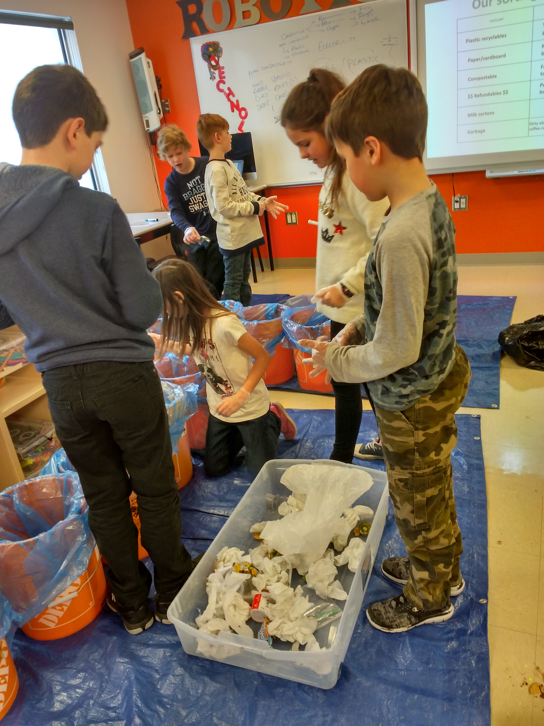

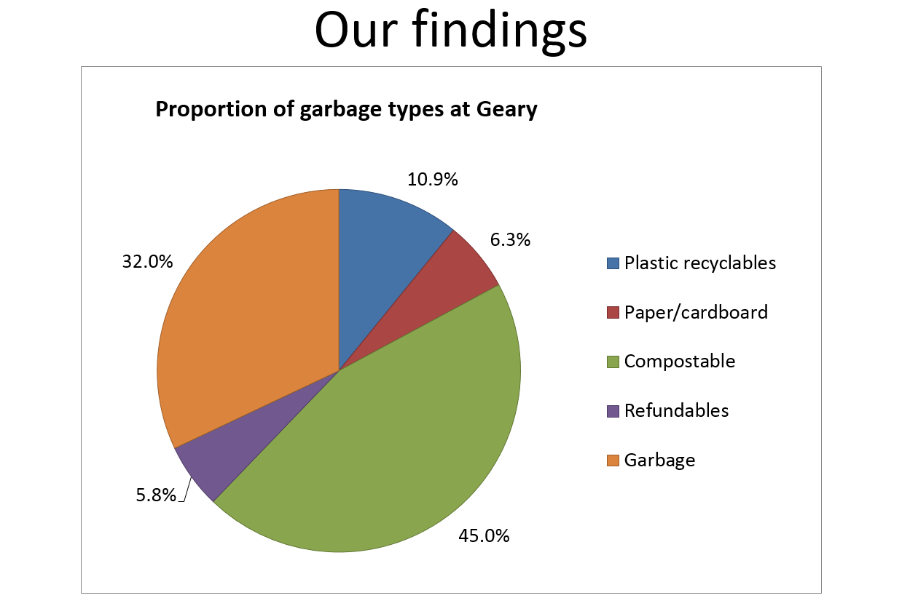



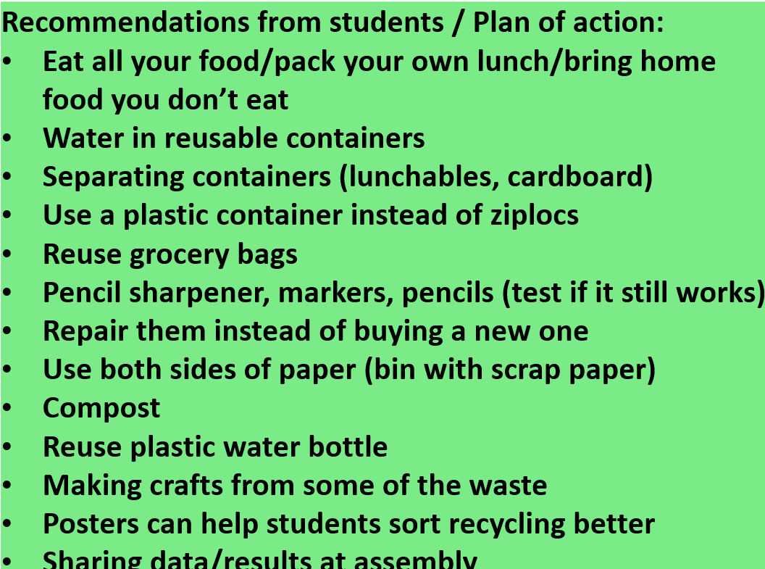



|  |  |
| --- | --- |
| **IMPORTANT DATES TO REMEMBER** | |
| Monday, January 5th | **Hot Lunch begins – Hot lunch is offered Mon-Thurs** |
| Wednesday, January 7th | **WiSP – Author Lynn Davies will visit our school.**  Community Food Smarts – pick up day at Lions Club 1:30 – 6:30 p.m.  **Home and School Meeting in Library at 6:00 p.m.** |
| Tuesday,  January 23rd | **Lens of Our Land – grade 3 and 4 invite Beth Crawford** |
| Thursday, January 25th | **Story Tent from 6-7 to celebrate and recognize Family Literacy Day!** |
| Friday,  Friday, January 26th | **3-5 Teachers have a Common Marking Day – Writing**  OHS Badminton Jamboree – 1:15-3:00 |
| Saturday, January 27th | Family Literacy Day  **Read to your children today!** |
| Tuesday, January 30th | Lens of our Land – Beth Crawford visits grade 3 and 4 **CARE Assembly – 11:00 a.m.** |
| Friday, February 2nd | **Ground Hog Day**  **Badminton @Summerhill:1:30–2:50** |
| Monday, February 5rd | **Intensive French – Grades 4/5 and 5 classes switch.** |
| Wednesday,  February 7th | **Community Food Smarts order deadline** |
| Friday, February 9th | **Valentine Dance** |
| Saturday, February 10th | **Eat For Education** Pancake Breakfast – Lion’s Club 7:30-10:30 a.m. |
| Wednesday, February 14th | **Valentine’s Day**  Community Food Smart – pick up |
| Thursday, February 15th | **Canada’s FLAG DAY** |
| February 12 -16 | **Staff Appreciation Week** |
| Monday, February 19th | NB Family Day  **No School for students** |
| Tuesday, February 27th | **Early Dismissal for Students @ 11:30.**  PL for staff – First Nation |
| Wednesday,  February 28th | **National Pink Shirt Day**  **PINK SHIRT DAY/Friendship Day** (wear pink and if you don’t have pink, wear white!)  Anti-bullying Awareness |
| Thursday, March 1st | 9:00 TNB visits  *A Herman Tale* |
| March 5th  – 9th | **MARCH BREAK**  **No school** |
| Thursday, March 15th | **BLEP – Roland Bibeau Concert – 9:00 a.m.** |
| Tuesday, March 27th | **NO SCHOOL FOR STUDENTS** |
| Wednesday, April 4th | **Headstart Registration 2018-2019**  **12:45 in Headstart Room** |
| Monday, April 9th | **Report Cards** |
| April 27 & 28th | **Bingo/SPRING BAZAAR** |