**GEARY GAZETTE**

**At Geary Elementary Community School:**

***“We C.A.R.E.”***

**January 17th, 2017 twitter.com/gearygators**



**EAT FOR EDUCATION**

Eat for Education will be held this year on **Saturday, February 11th**. Please mark your calendars and plan to attend Breakfast at the Lion’s Club, between 7:30 – 10:30 a.m. The planning process for this school fundraiser is just beginning. If you would like to help, there will be a meeting at the School after our PSSC meeting on January 24th. The PSSC meeting is at 6:30 p.m. and the Eat for Education meeting will begin at 7:30 p.m. You can also help support the breakfast by sending in pancake mix with your children in grades K-2 and syrup with your child in grades 3-5. Thanks so much!

**Home and School**

The next meeting of the Home and School Committee will be held on **Wednesday, January 18that 6:00 p.m.** As always, the Home and School has a busy agenda planned. Even if you have never attended a meeting in the past we welcome parents to attend these meetings, as many hands make light work.

The Hot Lunch Program, with Sharon Eldridge and Jessica Lynn at the helm continues to be a success. Menus go out every two weeks for families. Lunch is two dollars with milk each day. The food is delicious and nutritious so if you miss an order you miss two weeks of hearty eating! Additional volunteers are always welcome.

There will be a Home and School sponsored **Valentine’s Dance** on **Friday, February 17th** for GECS students at the school from 6:30 – 7:30 p.m. Doors open at 6:15. The cost is 3.00 per child. If your child is under 6 you need to plan to attend with them. There will be a canteen available for treats to be purchased at this event. Have fun!

The **Spring Bazaar** is an annual event that the Home and School plans. Dates for this event are **April 21st for the Children’s Bingo and April 22nd for the Spring Bazaar.** This family oriented event is one that allows the Home and School to provide fiscal support to the school – time and time again! Mark your calendars please!



Learn more and register for training at **elfnb.com** or call **1-855-898-2533.** We can’t wait to hear from you! 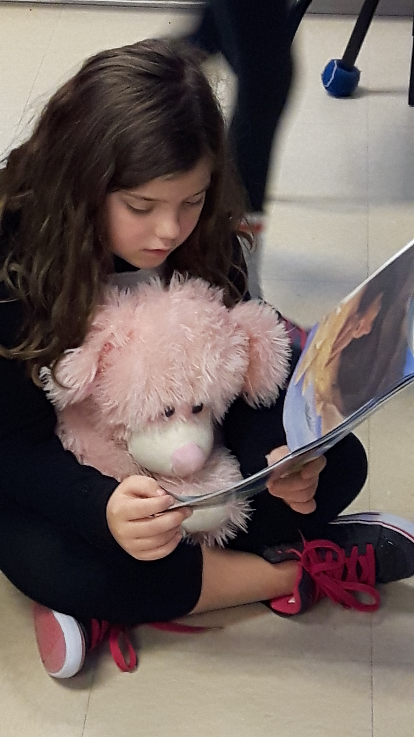

Reading is such an important goal for kids!

**CARE Assembly**

**Cooperation, Appropriate Actions, Respect, Excellence in Learning**

The Geary Elementary CARE Crew will present their second assembly of the year on **Monday, January 30**. This assembly will focus on Appropriate Actions and will reinforce expected behaviour while at school and in our community.

**Intensive French for Grade 5**

Currently, grade 5 students experience 980 minutes of French language instruction weekly. Madame Peters uses authentic oral language experiences to teach children conversational and written French. The Intensive French (IF) block is coming to a close on Friday, **February 3rd**. On **Monday,** **February 6th**  children begin the English Language portion of their program. This means that instruction in French will be limited to 150 minutes weekly and English Language Arts, Science, Social Studies, etc. will be compacted to give students the instructional outcomes required of the Grade 5 Prime curriculum. This is a wonderful opportunity for our students to learn French and to set goals for themselves as they move on to middle school. Late French Immersion is available in grade 6 as is Post-Intensive French. Our grade 3/4 students currently receive 150 minutes of Pre-Intensive French as well. Before grade 4 students are exposed to 30 minutes weekly of French Cultural Experiences.

**WITS and National Anti-Bullying Pink Day**

On **Tuesday, February 21st,** students will continue to increase their knowledge about using their WITS (Walk Away, Ignore, Talk it out, Seek Help) and how to be a good friend and citizen at school and in their community. We will have a group of students from Oromocto High School visit our students. These OHS students will facilitate different centers in which our students will rotate to gain more knowledge on how to take a stand against bullying and also how to be a kind, accepting and compassionate citizen.  We are also planning to have special guests to talk about internet safety. Our students are very fortunate to have these positive role models visit and to listen to their important message. Remember to wear PINK on this day!

The National Pink Shirt Day is on **Wednesday, February 22nd**! Citizens across the country are encouraged to take a stand against bullying and to show support of this cause by wearing Pink. The message this year is “Kindness Is In All of US”. This has been a theme for our school all year- that it only takes one act of kindness to make a difference for someone and that this act can encourage others to be kind as well. Our students are encouraged to wear PINK on this day as well as a symbol of our commitment to choose kindness!

**Moon Mouse**

Our School was the lucky recipient of a Playhouse School Access Grant and as such, all of our students from kindergarten to grade five are invited to the Playhouse on **Monday,** **February 27th** to watch *Moon Mouse*. Moon Mouse tells the story of Marvin, a mouse who longs to be a hero, and ends up taking the space adventure of a lifetime! This will be a wonderful opportunity for our students and we are positive they will love the performance!

**Theatre New Brunswick Visits on Tuesday, February 28th**

On **Tuesday, February 28th**, Theatre New Brunswick’s Young Company will visit our school to perform the production of *The Damsel in Distress Who Saved Herself.* In this production a witch has kidnapped a princess. A prince has come to save her, but doesn't know how. In this witty play by Fredericton's Kira Smith, the damsel is the hero who can fight with great skill, while the prince is good at singing and sewing and cooking. Together they must find a way to escape the witch’s castle, and learn a thing or two along the way. We have enjoyed many TNB- Young Company performances over the years and we are certain our Headstart to grade 5 students will all delight in this play!

**Daily Announcements/Playground Pals and other Roles of Responsibility**

Did you know that the grade 5 students in our school read the announcements to the other boys and girls each day? They take this role of responsibility very seriously. These students also collect funds for the IWK on Friday’s IWK Hat Day! As well, students in grade 5 are library helpers, playground pals and so much more. They are the oldest students in the school and as such we expect them to model appropriate behavior and help the younger students throughout the school. These grade 5 students do a wonderful job. They are so trustworthy and helpful. The staff are so proud of these students!! Their willingness to take on roles of responsibility is a reflection of the values that are instilled in them at home. Thank you parents!

**NB Student Wellness Survey**

The *New Brunswick Student Wellness Survey* is a provincial initiative of the Department of Social Development – Wellness Branch*,* in partnership with the Department of Education and Early Childhood Development and the New Brunswick Health Council (NBHC). The elementary portion of this initiative, the *New Brunswick* ***Elementary*** *Student Wellness Survey*, began in 2007-2008 and was repeated in 2010-2011 and in 2013-2014. The survey gathers information from **students** in grades 4 and 5 and **parents/guardians** of students in grades K to 5. It surveys attitudes and behaviours regarding healthy eating, mental fitness, bullying, physical activity and tobacco use.   
By taking the time to complete this survey, students and parents can contribute to their school’s improvement plans and student wellness activities. On ***January 23rd*, *2017***our school will be participating in this survey, as we aim to improve the health and wellness of children in our community. Paper copies of the survey will be sent to families this week.

**Writer in School**

Through the Writers in Schools Program (WiSP), we are very lucky to have an author visit us on Thursday, February 16. Diane Carmel Léger grew up in the village of Memramcook, New Brunswick, and taught for 20 years in Victoria, British Columbia. Homesickness for Acadie led her to write the bestselling youth novel, La butte à Pétard, which was the name of her village before the Deportation of the Acadians. It was followed by another bestseller in 1990, Maxine’s Tree***,*** a picture book which was inspired by her family’s involvement in saving Canada’s tallest tree.

This year, Diane released Mémére Soleil, Nannie Luneand its translation, My Two Grandmothers. The unedited manuscript for **My Two Grandmothers: Mémére and Nannie** won an Honorable Mention in the 2014 New Brunswick Writers’ Competition. Diane’s dynamic presentations will inspire all of us and will show our students how to use life’s experiences to build a story.

**Storytent**

On **Thursday**, **January 26th,** Storytent will be held at Geary Elementary Community School at 6:00 p.m. Storytent is geared to children, age 4-6 years to help with language and literacy development. Children may come in their PJ’s to enjoy bed-time stories read inside a real tent. As well, there will be a little campfire sing song before the evening ends. The children attending receive a gift, drink and snack at home time. We hope to see you there so we can celebrate Family Literacy Day with you all!

**Mittens**

Just prior to Christmas, 2 anonymous ladies brought a bag of home knit mittens to the school for our students. The mittens are already on the hands of students. Extra mitts come in handy when children either don’t have, lose or misplace their own mittens. With the need for outside play being a high priority it is great to know that all of our students are well dressed for the weather. Thank you so much to these ladies who generously made donations to our school to keep wee hands dry and warm.

**Library Club**

Our librarian, Elizabeth Geburt has Library Club for students on Wednesday and Thursday mornings at recess time. This club is very popular with the students and follows calendar themes like, Remembrance Day or Christmas, to name a few. Books are a way for our students to explore their world and our library has many wonderful interest books.

**Bilingual Learning Environment Plan (BLEP)**

This year, we have invited **Roland Bibeau (Beebo)** to visit our school so that all children will be exposed to French Cultural Experiences. Roland Beebo will come to our school on Friday, **January 27th at 9:00 a.m.** He will perform for K to grade 5 students.

School concerts feature videos with lyrics to help students sing along. Upon booking, each school receives a demo CD with most songs that will be performed at the concert. The songs will be taught ahead of time so that the children can sing along with lyrics. This concert will be paid for by our BLEP fund. No charge for children to attend. It will be an honour to have Beebo back as his concerts are spectacular!

**Sliding**

Our physical education (P.E.) classes will include a sliding component if the icy conditions improve. Students and staff will take advantage of the great snow conditions while they last. Parents please make sure your children have snow pants, mitts and hats to play safely as these activities are part of our curriculum. As well, please feel free to come up to the school in the evenings and on weekends to go sliding as a family. The rain has taken our snow for now but hopefully conditions will improve.

**LEGO CLUB**

Lego Club will resume today, **Tuesday, January 17th, 2017**. It will be the Blue Bricks who attend today, followed by Green Bricks next week and then Red Bricks. The schedule will continue on a rotational basis. The students were given a calendar in the fall. Please remember that Pick Up time for students is 5:00 p.m.

**MENTAL FITNESS**

Mental Fitness is the ability to cope with life and personal changes in healthy and productive ways. It includes:

1. Building Healthy Relationships
2. Emotional Fitness
3. Relaxation
4. Coping with Stress
5. Facing Difficulties
6. Overcoming Addictions

**COMBAT STRESS AND ANXIETY** and fear”

Stress is the “wear on the body. It is how we respond to events in our lives. Not all stress is bad. It can pump you up and give you energy if it’s not too much. Stress is unavoidable – so we have to learn ways to deal with it.

Too much stress on your mind and body can make you feel sad, miserable and anxious. People who wait too long to compensate can end up burned out.

**TAKE PHYSICAL ACTION**

Physical activity releases hormones that enhance mood and reduces stress. Walking and yoga help reduce stress. Relaxation also helps refocus energies. Eating well provides stamina while poor eating creates distress in your body. (***OEC Words of Wellness)***

|  |  |
| --- | --- |
| **IMPORTANT DATES TO REMEMBER** | |
| Tuesday,  January 17th | **Lego Club begins - Blue Bricks Pick up at 5 p.m.**  Hot Lunch this week |
| Wednesday,  January 18th | Community Food Smarts – pick up day at Lions Club 1:30 – 6:30 p.m.  **Home and School Meeting in Library at 6:00 p.m.** |
| Monday,  January 23rd | **NB Student and Parent Wellness Survey – please complete and return promptly**  Pink Shirt orders due today! |
| Tuesday,  January 24th | **PSSC Meeting**  **6:30 p.m.**  Eat for Education Meeting 7:30 p.m. |
| Thursday, January 26th | **Story Tent from 6-7 to celebrate Family Literacy Day!**  OHS Badminton invitational, 6-8 p.m. |
| Friday,  January 27th | Family Literacy Day  **Beebo Concert –**  **9:00 a.m. (BLEP)** |
| Monday, January 30th | CARE Assembly  **Clusters begin for grades 3-5 for 4 consecutive Mondays.** |
| Tuesday,  January 31st | **Makerspace Day** for grades 2-5 |
| February 2nd | **Ground Hog Day** |
| Friday, February 3rd | **Intensive French portion of year ends for grade 5 students.** |
| February 11th | **Eat For Education** Pancake Breakfast – Lion’s Club 7:30-10:30 a.m. |
| February 14th | **Valentine’s Day** |
| Wednesday,  February 15th | **Canada’s FLAG DAY** |
| Thursday, February 16th | **Author Visit- Diane Carmel Leger** will read to our students |
| Friday,  February 17th | **Valentine’s Dance (H&S)**  **6:30 – 7:30 p.m.** |
| Tuesday,  February 21st | **PINK SHIRT DAY/Friendship Day** (wear pink and if you don’t have pink, wear white!)  Anti-bullying Awareness |
| Friday,  February 24th | Professional Learning Day  **No School for Students** |
| Monday,  February 27th | Field Trip to Playhouse |
| Tuesday,  February 28th | Theatre New Brunswick visits |
| March 6th  – 10th | **MARCH BREAK**  **No school** |
| Wednesday,  April 5th | **Headstart Registration 2017-2018**  **12:45 in Headstart Room** |
| Tuesday,  April 4th | **Report Cards – Term 2** |
| Thursday,  April 6th | **Student-Led Conferences in the evening.** |
| April 10th | **PL day – no school for students (interviews in a.m.)** |
| April 14 - 17 | **Easter Break** |
| April 21st | Children’s Bingo |
| April 22nd | Spring Bazaar |
| April 28th | Professional Learning Day  **NO SCHOOL** |

**Volunteer’s Matter A Lot**

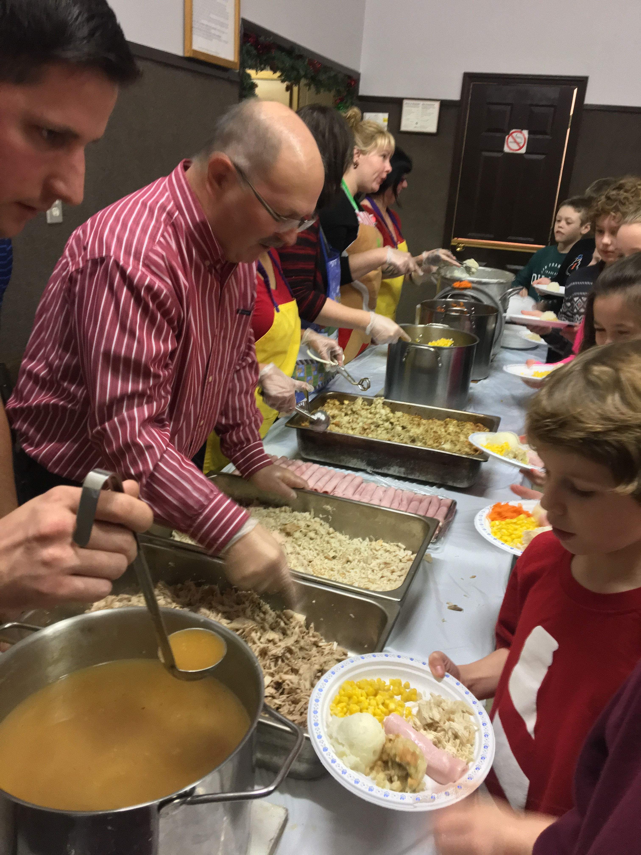

Turkey Dinner at the Lions Club – many thanks!