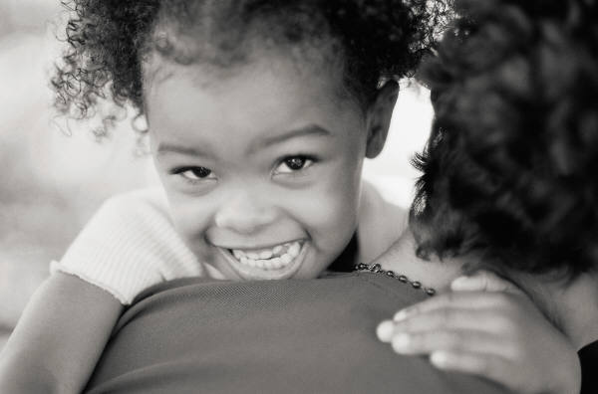

Kindergarten orientation will be held at each school before the end of the school year. This will be an opportunity for your child to visit a kindergarten classroom, try out a few activities and take a short bus ride. It will also be an opportunity for parents to ask questions about the start of kindergarten in September.

**Friday,**

**May 26th, 2017 @ 1:30**

**Geary Elementary Community School**

**Mark the time and date on your calendars!**

**Mark the time and date on your calendars!**

## Kindergarten Orientation

**For more information:**

Contact your school.

Mark the date and time on your calendars☺

Some **Books** to check out!

*Duck on a bike*

By David Shannon

*Going on a bear hunt*

By Michael Rosen

*The wonderful pigs of Jillian Jiggs*

By Phoebe Gilman

*Mouse’s First Spring*

By Lauren Thompson

*Chicka Chicka, Boom Boom*

By Bill Martin Jr. & John Archambault

*The Kissing Hand*

By Audrey Penn

“A torn jacket is soon mended; but hard words bruise the heart of a child.” -Henry Wadsworth Longfellow

May 2017

Oromocto Education Centre

To School

Newsletter

Transition

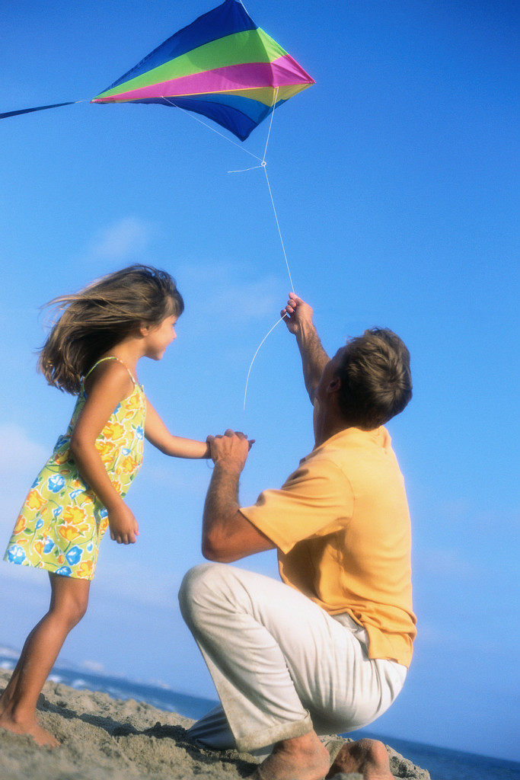

Getting Ready for Kindergarten

**At School Children Will: At home you can prepare your child by:**

* Make a variety of choices Help your child make choices at home (eg. clothes to

(eg. choosing activities in the class, wear, activities to do).

materials to use).

* Share materials and space Provide opportunities for your child to be with

with other children. other children, to learn to share, wait and take

turns.

* Need to adapt to new people, Provide new situations for your child (eg. going to

situations, and routines the library for story time). Talk about what to

expect beforehand.

* Dress themselves to go home Encourage your child to practice putting on jackets,

and to play outside. zipping up zippers and putting on shoes.

* Communicate needs to other Encourage your child to use language to make needs

children and adults. known and to solve problems (eg. getting a drink, going to the bathroom, asking for help).

* Follow multi-step directions Provide unrelated directions to your child to follow

and encourage them to mentally repeat them.

(eg. Put the puzzle away and pick up your hat.)

What Else Can I Do With My Kindergarten Bag?

In the winter, everyone received their Welcome to Kindergarten bag full of educational materials. Are you now looking for more ideas of what to do with your child?

• Put all of the magnetic letters (choose only all upper case or all lower case) in a bag. Have your child pull a letter out of the bag and find that letter around the house. Do they see it in their books? In the newspaper headlines? On your grocery list?

• Trace around the numbers or letters with a pencil. Color them in or make designs within the lines.

• Have your child act out their favorite part from one of the books or any book that they like to have

read to them.

If I had my child to raise all over again,  
I'd build self-esteem first, and the house later.  
I'd finger-paint more, and point the finger less.  
I would do less correcting and more connecting.  
I'd take my eyes off my watch, and watch with my eyes.  
I'd take more hikes and fly more kites.  
I'd stop playing serious, and seriously play.  
I would run through more fields and gaze at more stars.  
I'd do more hugging and less tugging.

~Diane Loomans, from "If I Had My Child To Raise Over Again"