School supply graphic



# Geary elementary Community School

## 2015-2016 School Supply List

**Kindergarten – Grade 1 – Grade 2**

Dear Parents/Guardians:

During the past several years, the K-2 teachers at Geary Elementary Community School have collected money to buy school supplies and materials for the children in their classes. Doing this allows us to ensure that the students have everything they need for the whole school year. After consulting as a team, we have decided to do this again for the 2015-2016 school year. The amount needed for the school year will be $35. If you have 2 or more children in K-2, we will offer a family plan for $60. Payment will be expected in full on the first day of school. Receipts will be available upon payment.

Please note that your child only needs to bring a book bag, a lunch box, and indoor sneakers, which are necessary for gym. Your child needs a bag of extra clothing at school. All articles brought to school should have your child’s name on them.

**Thank you in advance for your support,**

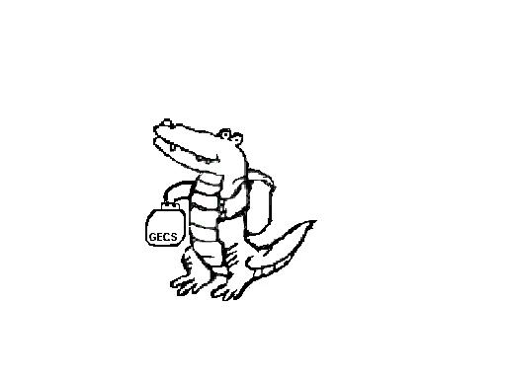

**Grade 3**

1 Coil Scribbler (Thick)

2 Hilroy Notebook packages (4 per pack)

3 large glue sticks (UHU if possible)

2 white erasers

1 pencil case

2 packages of pencils

1 package of crayons

1 package of pencil crayons

1 package of markers

1 highlighters

1 package of loose-leaf

1 sketch pad (can be found at the Dollarama)

1 metric ruler

1 Scissors

2 boxes of Kleenex

1 USB Stick (no more than $6.00)

**Grade** **4**

1 Coil Scribbler (Thick)

8 Hilroy Notebooks

2 large glue sticks (UHU if possible)

2 white erasers

1 pencil case

2 packages of pencils

1 package of markers

1 package of pencil crayons

1 package of loose-leaf

1 sketch pad (can be found at the Dollarama)

1 metric ruler

1 highlighter

1 Scissors

2 Box of Kleenex

**Grade 5**

2 Hilroy Notebooks (4 per pack)

2 large glue sticks (UHU if possible)

4 white erasers

1 metric ruler

1 coil scribbler (thick)

2 packages of pencils

1 package of pencil crayons

2 highlighters

1 package of loose-leaf

1 sketch pad

(can be found at the Dollarama)

1 scissors

2 boxes of Kleenex

**Please note:**

**Grades 3-5:**

**Please send in $10.00 to purchase duo tangs and extra pencils & loose-leaf – for organizational purposes, it is better to have color coded duo tangs.**

* **Label all supplies with student’s name in permanent marker.**
* **Send supplies in on the first day of school.**
* **Specialists may require additional school supplies after school begins.**