Basketball New Brunswick Middle School Provincial Schedule 2017

Varsity Girls: Bayside is host
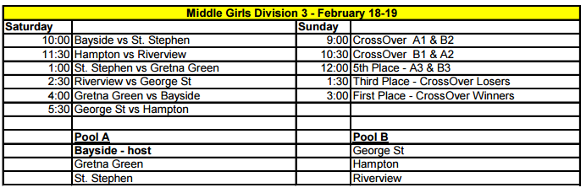
Junior Varsity Girls: Caledonia is host
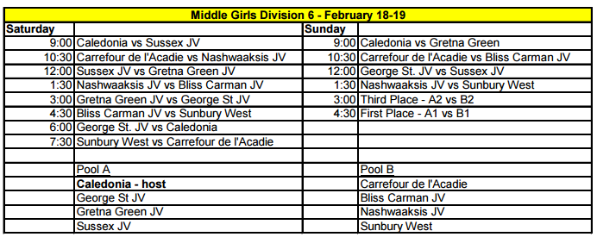

Varsity Boys: Townsview is host
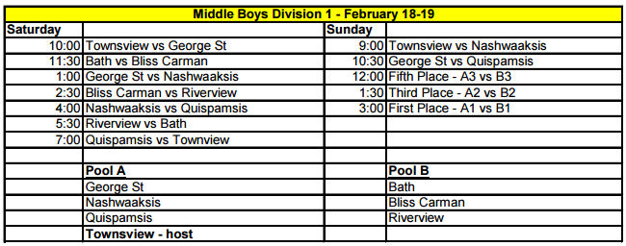

Junior Varsity Boys: Harry Miller is Host
