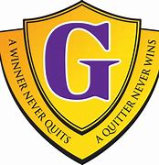 **George Street Middle School Home & School Fundraiser**

**License # - 1527577 56 010**

**Please see below for the 6 baskets we are selling raffle tickets for! Each ticket is 2 dollars; you can purchase as many as you would like! All proceeds go directly back to the school community to enhance the teaching & learning for all. If you purchase tickets and do not have a child attending GSMS, it is important you check back to our school website on Dec. 7th where the winners’ names will be posted because we may not have your contact information. Ticket sales close Nov 30, 11:59 PM**

**If you have a child attending GSMS or any other school in the district, you can use your regular school cash online page and search the baskets under “ASD-W” public items.**

**If you do not have a child in the school system, you can follow the link below. Simply register for an account (email, name, and password), confirm your account at the confirmation email it sends you, and then when you sign-in, go down to the bottom and click “I do not wish to add a student”. At the link, you will see all 6 baskets listed under George Street School.** <https://anglophonewest.schoolcashonline.com/>

**Thank you for supporting our school community. Please see the basket details below!**

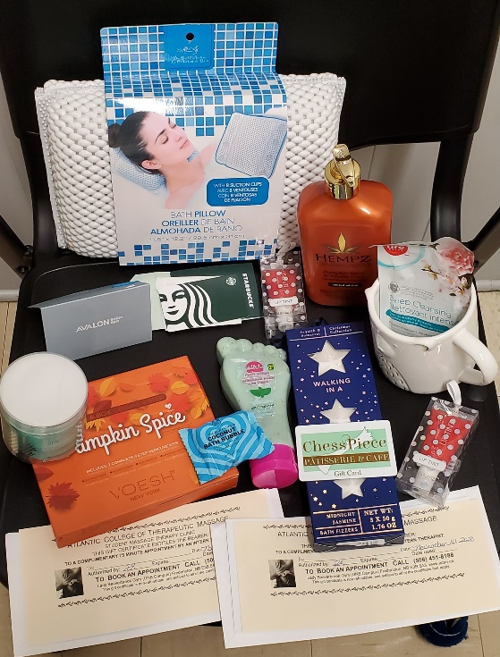**Basket #1** - Pamper Yourself

Bath pillow

Bath fizzers/bombs

Lotion

Lip Tint

Pumpkin Spice Pedi in a Box

Foot Scrub

Mug

Face Cleansing Pads

Facial sheet mask

Two Atlantic College of Therapeutic Massage

gift cards (75 min appointments)

$25 Avalon Gift Card

$25 Starbucks Gift Card

$20 Chess Piece Gift Card

Approx. Value $160

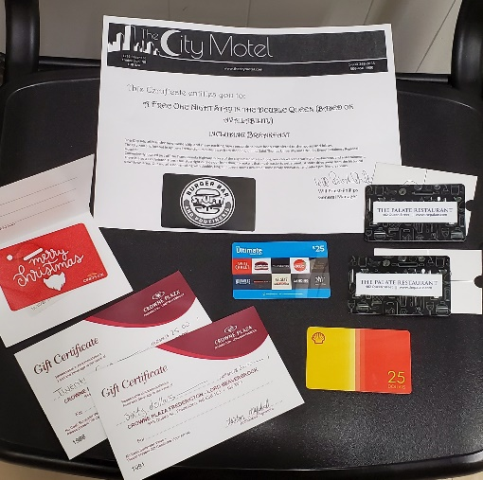

**Basket #2** – Adult Night

2 x $50 Gift Cards to The Palate Restaurant

$25 Ultimate Dining Gift Card

$25 Shell Gas Card

$25 Cineplex Gift Card

One night stay in the double queen room @ The City Motel

$25 Stuft Burger Bar & Poutinerie Gift Card

$85 Gift Certificate to Crown Plaza Hotels & Resorts

Approx. Value $375

**Basket #3** – Gift Cards

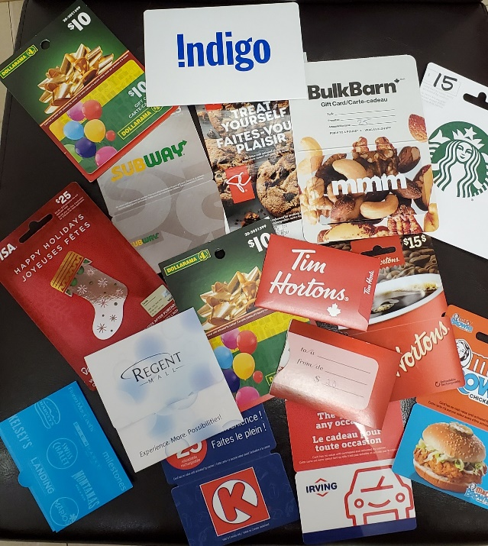

Bulk Barn - $25

Dollarama - $20

Mary Browns - $25

Regent Mall - $10

Tim Hortons - $45

Irving - $10

Visa - $25

Ultimate Dining Card - $50

Chapters - $40

Atlantic Superstore - $10

Starbucks - $15

Circle K (Irving) - $25

Subway - $15

Value - $315

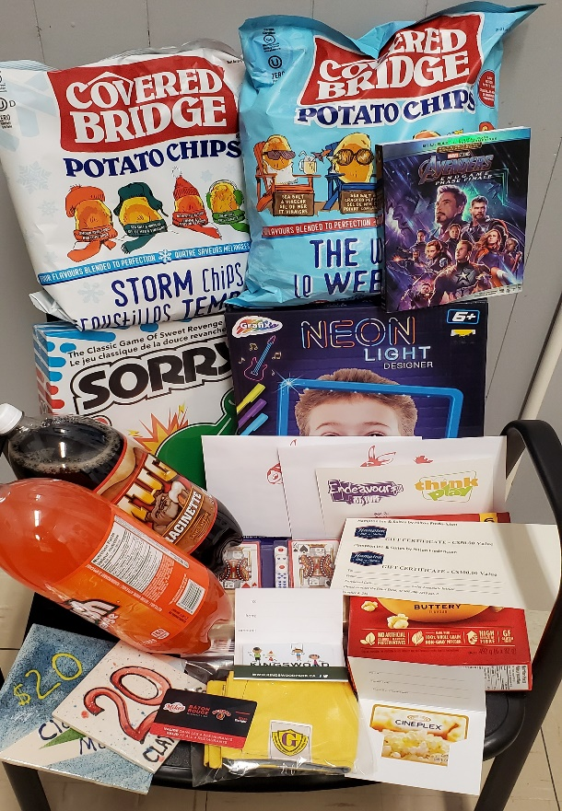

**Basket #4** – Family Night

Avengers Endgame Blu Ray Movie

Kid’s neon light drawing board

Playing Set (Dominos & Cards)

2 Gold GSMS facemasks

2 Covered Bridge Chips

2 bottles of pop

Box of popcorn

Sorry boardgame

$20 Kingswood Gift Card

2 x $20 Clay Café Gift Cards

2 x $20 Think Play/Endeavours Gift Cards

$150 Voucher to Hampton Inn & Suites

$60 Pizza Delight Gift Card

$50 Cineplex Gift Card

Approx. Value - $420+

**Basket #5** – Arts & Crafts

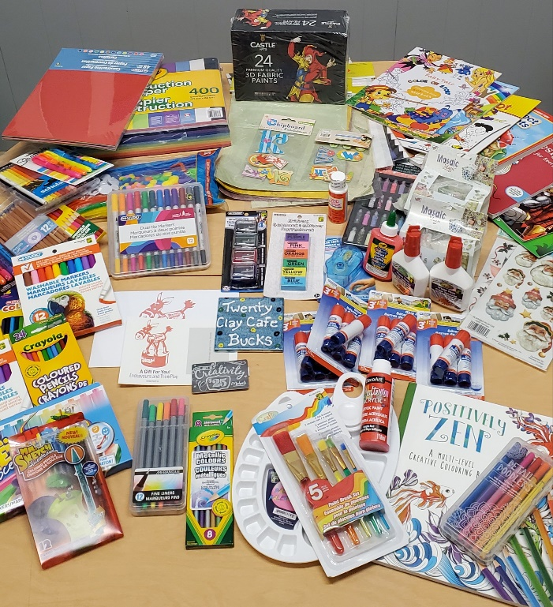$20 Think Play/Endeavours Gift Card

$25 Michael’s Gift Card

$20 Clay Café Gift Voucher

Make your own earrings set

Adorable stickers!

1 - 24 colours 3D fabric paint set

400+ sheets construction paper

2 packs assorted pottery pieces

1 pack mini glitter bottles

1 craft pack (pipe cleaners, googly eyes, etc.)

5 – Handmade paper for crafts

1 pack mini poster boards

Paint tray with set of brushes, and red paint

Mod Podge

Variety of markers (7 packages)

Variety of coloured pencils (7 packages)

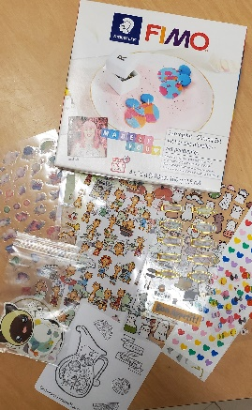Highlighters (2 packages)

7 activity books (connect the dots, colouring…)

2 Zen teen/adult colouring books

16 Glue sticks

3 Liquid glue

2 packages of rub-on transfer stickers

Erasers

Sharpeners

Double-sided tape

Approx. Value - $235

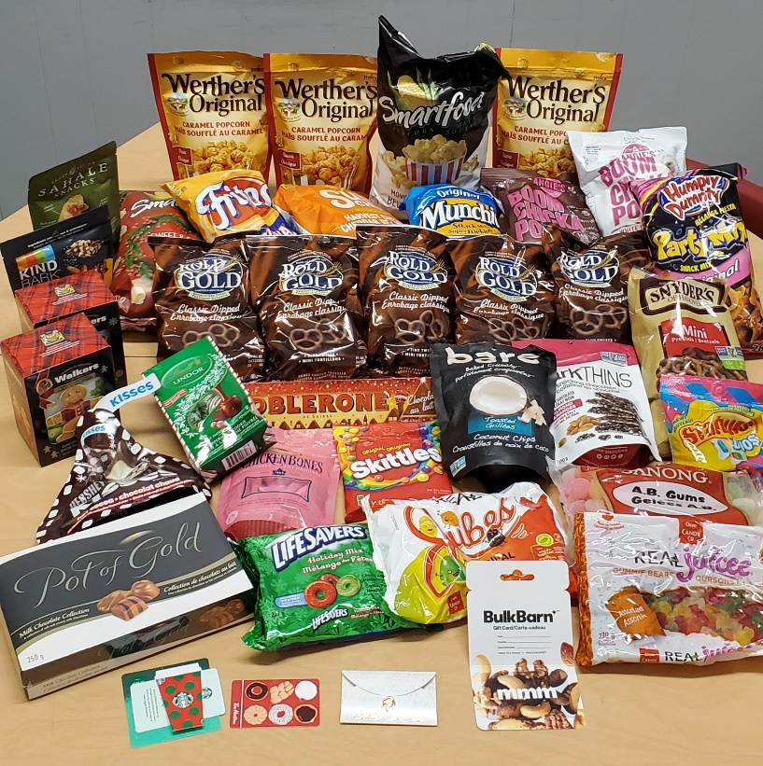

**Basket #6** – Treats!

$15 Tim Hortons Card

$25 Laura Secord Card

$25 Starbucks Card

$30 Bulk Barn Card

Chicken Bones

Family Size Toblerone

Lindor and Pot of Gold Chocolates

Lots of popcorn (various flavours)

Lots of chips

Regular and Chocolate covered pretzels

Hersey Kisses

Gummies, candy

Cookies (lots!)

Juicy Jellies

Hot chocolate and tea

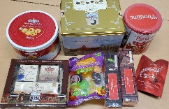

Approx. Value - $250+