12 Days of Giving

Campaign for Liberty Lane
Dec 1-Dec17

What is Liberty Lane?
Liberty Lane offers housing and support programs to people who have been affected by domestic violence. Their goal is to enable individuals and their children who have experienced domestic violence to attain personal and economic independence and a future free from violence.

​

GSMS is collecting the following items for Liberty Lane.

Grade 6  -Drinks | Grade 7  – Paper Products | Grade 8  – Cleaning Supplies
Coffee  Coffee filters  Keurig pod  Tea  Juice  Juice boxes | Toilet paper  Paper towel  Kleenex | Laundry soap  Dryer sheets  Dish detergent  All purpose cleaner

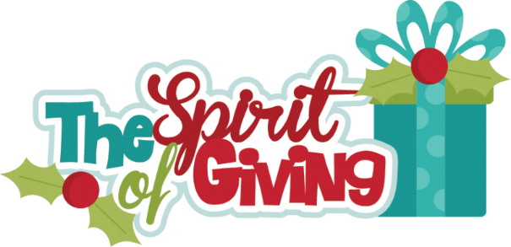
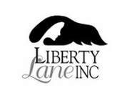
Thank you from GSMS Community Allies

