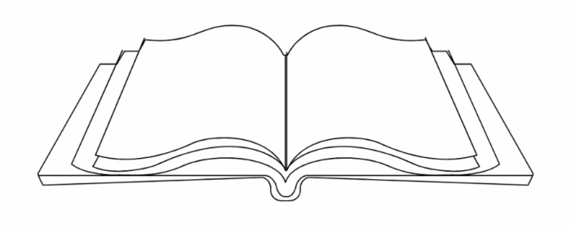
Name: ______________________________ Class: _________
BEST BOOK OF THE YEAR SPEECH

Reveal the best book you read this year - one minute long, live or recorded! Share a teaser to the book and why you recommend it. Why did this book inspire you? How did it make you feel? Books that we love leave us wanting more. Why does this book deserve to be crowned “Best Book of the Year” for grade 6? Persuade your audience and be creative. Work on your gestures and prepare your performance. While you present, a slide with the book’s cover will be behind you so that we can write down the title recommendations!

Objective: Student will be able to communicate information and ideas effectively and clearly, and to respond personally and critically. Student will use word choice and emphasis making a conscious attempt to produce a desired effect.
CATEGORY | 4/4+ | 3/3+ | 2 | 1
Content  Main idea presented with interesting, relevant details | Content always clear, focused and appropriate. Main ideas draw audience’s attention and developed by compelling details. | Content clear, focused and appropriate. Main ideas stand out and developed by strong details. | Content requires extensive inferences by audience. Not suited to audience or purpose. | Content lacks a clear purpose or central theme.
Voice  Enunciation, projection, intonation | Voice always clear. Tone and volume always appropriate to ideas. Pauses used to enhance ideas. | Voice is clear and words are clearly pronounced. Attempts made to vary tone and pace. | Voice sometimes clear, not always. Some attempt to vary tone and pace. | Voice isn’t clear and tone/pace does not enhance the content
Word Choice  Clear, engaging language | Language is original. Words carefully selected for maximum impact. Poetic devices are included. | Language original. Variety of carefully selected words. Some poetic devices included. | Language is ordinary, lacking precision, variety and clarity. | Language does not show evidence of poetic devices or carefully chosen words.
Effectiveness of Speaker  Sincerity, ability to engage listener (conviction) | Audience is deeply engaged, eager to follow performance and responds enthusiastically. | Audience is engaged in the presentation. | Audience is slightly disengaged throughout performance. Delivery not entirely smooth, but information is delivered. | Audience distracted by lack of clarity in delivery.

YOUR MARK:

