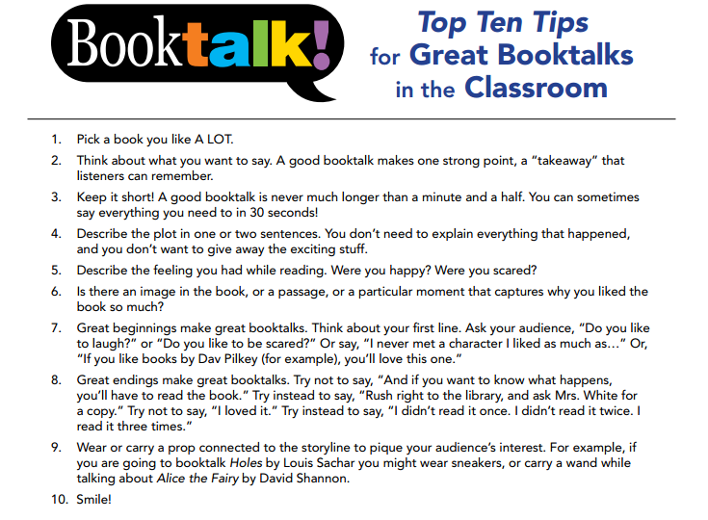

Your Job: After you finish reading your novel, we want to hear about it. Everyone will have a chance to talk briefly about their book to the rest of the class.

Here is what your presentation must include:

- Title of your book (please have a copy of your book available to show us
- Author’s name
- A short discussion of what happened in the book ( keep it brief and don’t give the ending away)
- Your opinion of the book – Let us know what you thought about your book. Did you like it? Why/Why not? Remember, you do not have to love the book, please be honest.
- Tell us about your favourite part(if your favourite part is the ending, choose a different part you found interesting)
- Choose an interesting part of the book (no more than 1 page) and read it to the class.
- A question about your novel will be drawn from a jar for you to answer (you will have a chance to see the possible questions first in order to be prepared)

How did I do? | 4 | 3 | 2 | 1
Presentation
- My voice was loud and clear
- I spoke with enthusiasm
- I engaged my audience
- I enjoyed my book talk
Organization
- I was well prepared
- I hooked my audience in my introduction
- I stayed on topic throughout
- I wrapped up my talk and left my audience wanting more
Content
- I am very knowledgeable about this book
- I explained what my book is about, but not too much detail
- I chose a section to read aloud
- I read the blurb on the back
- I didn’t spoil the ending

