Gesner Street News
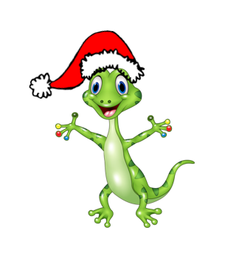
December 2022 Edition

Celebrating the Season
We invite you to join as we celebrate the spirit of Christmas at our concert on Thursday, December 15 with two performances at 9 AM for A-J last names and 10:30 AM for K-Z last name. Our talented students, under the direction of Mrs. Hall will perform for families on this special day. If school should be closed on the 15th the backup date is December 16th with performances at 9 AM and 10:30 AM.
As parking is limited, there are some options for visitors. There is a visitor parking lot at the school, but this usually gets full rather quickly. Families can park in the bus lane leaving space for emergency vehicles and as well as parking on Gesner Street and McLaren. Please do not park on our neighbor’s yards.
Learning to Skate Feels Great!
As an extension of our Physical Education program, Gesner students will have the opportunity to go skating at the Kings Arrow arena several times through the winter months. This opportunity is free of charge for our children and district school buses will provide transportation. More information and a schedule will follow when it gets closer to each grade level’s turn. Even if your child has limited skating ability, they learn quickly at this early age. The school has a limited number of skates and helmets that can be borrowed by our students. Skates and helmets can be great Christmas gifts. Parents, grandparents and caregivers are always welcome to join us during this time.
Grade 2 students will start skating first, then a few weeks later grade 1 and afterwards the Kindergarten students will have a turn.

GECKO Learning for December
Our focus is on Compassion. During this month we will be teaching and talking about caring, sharing, thinking of others, showing concern, helping others, emotional intelligence, empathy and celebrating differences.

Growth Mindset
This month’s Growth Mindset challenge is We Love a Challenge. We will be teaching students about the difference between equity and equality, developing student’s responsibility and set and communicate high expectations of all students.

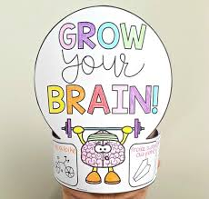

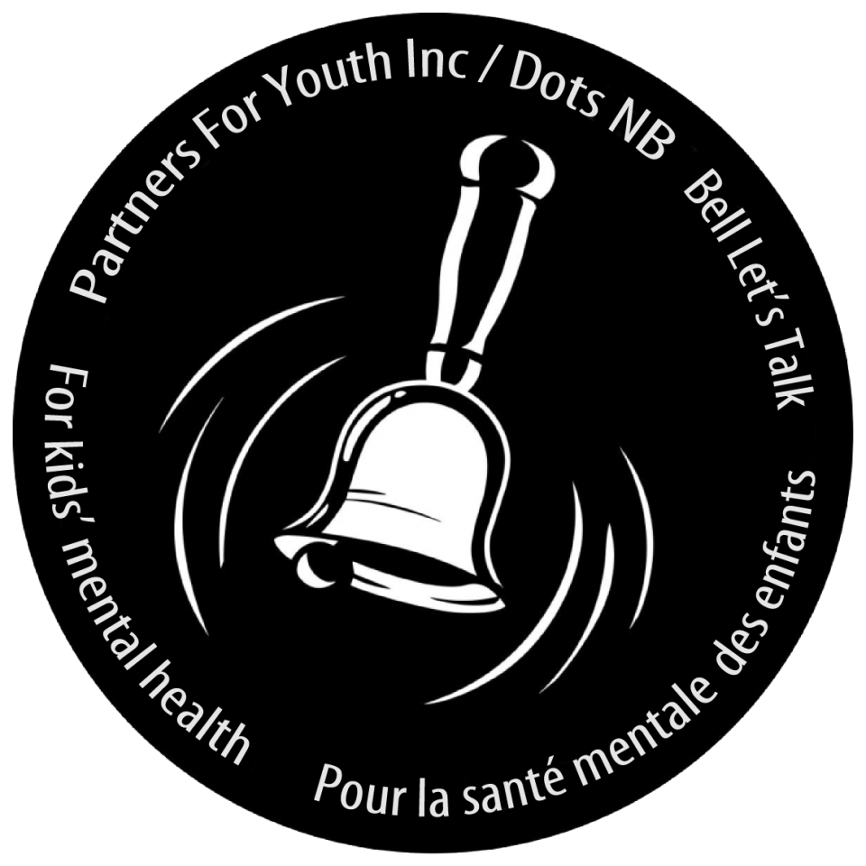
Ring A Bell Campaign
On Thursday, December 1st students in New Brunswick will be celebrating Ring a Bell Day. This day is part of a grassroots movement that has been empowering youth, family, and community to take positive actions in support of kids’ mental health.
As part of the Dots for Kids Day Ring A Bell Campaign students will be learning about mental health and wellness in schools from November 28 - December 1.

**On Dec. 1st just before lunch we will be making a noise as a whole school with the staff ringing bells to bring awareness to this campaign.

Sharing with the Oromocto Food Bank
Each year the Gesner school community takes on a service project to help others. This year, we are collecting items for the Oromocto Food Bank. Students are invited to bring in a food item or two that will be collected in their classrooms. Also, guests attending the Christmas concert can do the same. Our students love to share what they have with others. Bravo!

Dates to Remember
The final day for students prior to Christmas break will be Friday, December 23rd. This will be an early dismissal at 11:00. Students will return to school on Monday, January 9th.

Cultural Concert at Gesner
On December 21st at 11 AM, New Brunswick entertainer, Art Richard, will present a seasonal concert for our students. Much of this musical treat will be shared in French so students will learn lots of French words!
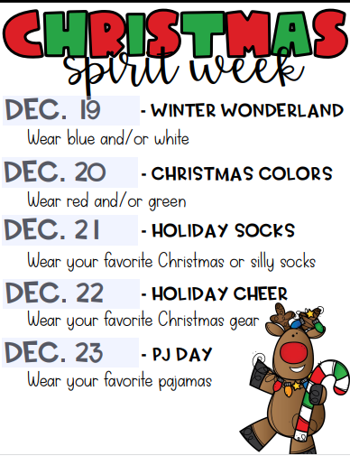
We wish all Gesner families a peaceful, healthy, joyous holiday season and we look forward to seeing everyone in the New Year.
December
2nd | No school of students – Professional Learning for Teachers
8th | Parent Teacher Interviews PM
9th | No school for students – Parent Teacher Interviews am
15th | Holiday Concert – storm day 16th
23rd | Last day before Holidays. – Early Dismissal – 11:00
January
9th | First day back for students after Christmas break.

