Gesner Street News

November 2022 Edition

Report Cards and Parent –Teacher Conferences
Students will receive report cards on
Thursday, December 1st. Teachers will arrange conference times with families to discuss student progress, share student successes and reinforce student goals. Parent/Teacher conferences will be held on the evening of December 8th and the morning of the 9th either in-person, phone or through TEAMs. We look forward to meeting with parents during these times.
Students do not attend school on December 9th.

Excellence in November
Our GECKO focus for the month of November is Excellence. We will be learning about how to be your best self, take pride in your work, show grit and perseverance.



3GStrong is a program that Gesner has chosen to partner with as we teach grit, growth-mindset and grace to the kids in your life. This will help us to create a 3GStrong community through teaching social skills, perspective and empathy, help students develop a desire to put forth effort and more! Be listening to your children as they will be talking our social graces, emotions and their hippocampus.

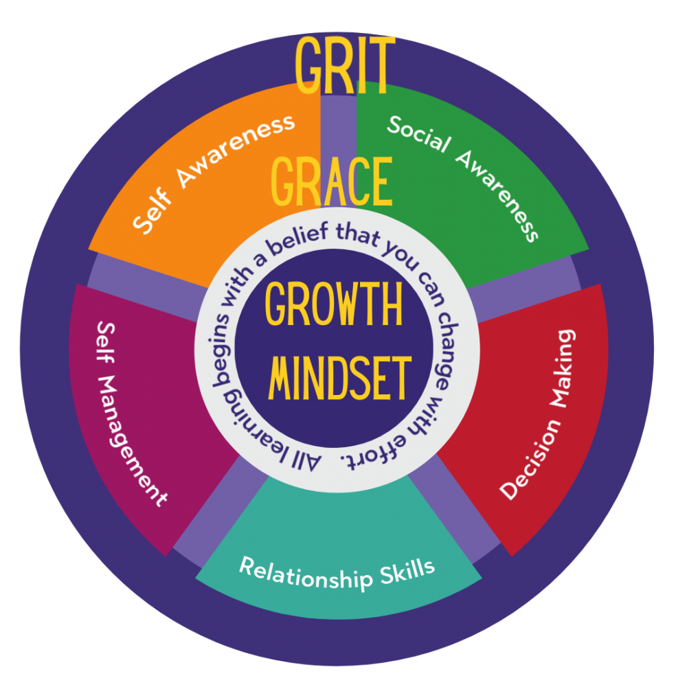

Remembrance Assembly
On Wednesday, November 8th 11am, we will be having the Royal Canadian Legion, Branch 63 for a Remembrance Day Assembly. Please encourage your child to wear red on this day. Any students who are members of Scouts, Sparks, Girl Guides or Beavers are welcome to wear their uniform. We are proud to live in a community where our military provides leadership and safety for all of us.

Parent School Support Committee
Greetings from the Gesner PSSC! Our next meeting will be held on Nov.9th at 6:30 pm. All are welcome to attend. If interested in joining a committee to help with a goal, please contact the school. We would love to have your help!

National Jersey Day – Friday, November 4th. Students are encouraged to wear their own team jersey or their favourite team jersey that day.

Gesner Christmas Concert
The Gesner School Christmas concert will be on December 15th with a storm date of December 22nd. There will be two times, more information to follow. Mrs. Hall our music teacher is working on this very hard so we know it will be amazing. Stay tuned 😊

Growth Mindset at Gesner!
We have been working hard at Gesner to build our knowledge about Growth Mindset! Students are learning about their brains; how important it is to have a Positive Growth Mindset rather than a fixed mindset and that hard work and practice has a positive effect on learning achievement.
Each month we have a new Mantra that we share with the students. In September, students learned that “Everyone can learn!” We created a whole school collaborative art display of our Garden of Growing our Mindset. In October, students learned how their “Brain is like a muscle that grows!”. Students learned how “neurons that fire together, wire together” and that hard work is a huge contributor to learning. The new mantra for November is “I Am a Valued Member of This Learning Community!”
Click this link to learn more about our growing brains:
https://www.youtube.com/watch?v=JC82Il2cjqA
Gesner Staff thanks you for your ongoing support and dedication to our students. Have a marvelous month of November.
Dates to Remember!!
November
4th | National Jersey Day
9th | PSSC meeting at 6:30
8th | Remembrance Assembly at 11am
11th | Remembrance Day – no school
18th | No School for students – Professional Learning for Staff
December
1st | Report Cards go home
2nd | No school for students – Professional Learning for Staff
8th | Parent Teacher Interviews in Evening
9th | Parent Teacher conferences in the morning, professional learning in the afternoon – no school for students
15th | Christmas Concert
Dec. 23rd | Last day before Christmas break

Website:
http://web1.nbed.nb.ca/sites/ASD-W/Gesner/Pages/default.aspx

Facebook:
https://www.facebook.com/Gesner-Street-Elementary-School-114945196991019

Twitter: @GesnerStElemen1



