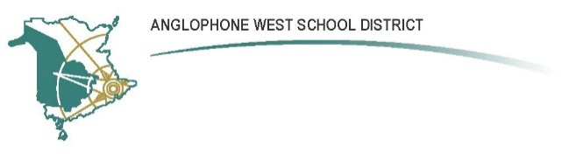
SCHOOL NAME: Keswick Ridge School
Address: 166 McKeen Dr., Keswick Ridge, NB E6L 1N9
Parent School Support Committee
Minutes
Date: 6 June 2022 Time: 6:30pm
Location: Virtual Teams Meeting

PSSC Members Present:  Candace Gilmore, Jeremy Smith, Justine Macleod, Shawna Quinn  Regrets:  Joel English, Stephanie Seheult, Amy Crowther, Deb Parent | School/DEC Representation Present:  Melissa Chetwynd, Vice Principal  Regrets: Chris Roach, Nathan Langille

The Chair called to order the final PSSC meeting of the school year.

Classroom and Staffing Changes 2022-23
Grade 1 French Immersion is back for 2022-23, but Grade 2 FI will not be reinstated.

Kindergarten enrollment this year is higher than ever at 32.

Due to higher enrollment in lower grades, K-2 classes have become ‘bottom-heavy,’ and a decision was made to create a dedicated Grade 2 class to better prepare students for Grade 3. In 2022-23, there will be 3 K-1 classrooms and 1 Grade 2 classroom.

2022-23 Staff
Principal: N. Langille
Resource: D. Gallow

K/1: C. Hemming
K/1: M. Boreland
K/1: K. Howland
2: C. Crandall
3: D. MacLeod
4: K. Keys
5: To be posted. (K. Fraser returning from mat leave as .8 FTE.)
6: C. Roach
7/8: To be posted

FI 1: S. Christie
FI 3/4: L. Morris
FI 5: E. Jost

On behalf of the PSSC and the parent-school community, the chair warmly thanked departing educators Melissa Chetwynd, Annette Stehouwer and Heidi Leblanc for their outstanding work, and wished them every success as they move on to new opportunities and roles in the coming year.

Student Sports 2022-23
There’s a need to proactively plan for intra- and extramural sports (which have lapsed somewhat during the pandemic) in order to offer sports team experiences at KRS that are comparable to other schools. Jeremy has begun to reach out to community members who may be interested in volunteer coaching during the school year. The bus that delivers high school students at 3:20 might be available for extramural team bussing (need to investigate).

Mrs. Boreland and Mrs. Howland coached intramural 3-5 basketball this year, two days per week – a popular activity for students.

Student Summer Learning Opportunities 2022
The District is coordinating initiatives and EECD funds designed to challenge the ‘interrupted learning’ that students experienced during the pandemic. Initiatives include:
- K-5 calendars of activities linked to specific K-5 outcomes (including French Immersion) and Gr. 6-8 choice boards. These resources will be available to families from the school website and KRS will have printed copies.
- Virtual catalogue with links to local libraries, the YMCA, clubs, events and sessions for kids, etc.
- For high school: online learning opportunities for credit and upgrade.
- Grant opportunities for educators to run camps out of schools during the summer, to purchase supplies for packages to send home, or to sponsor students to attend camps elsewhere. Grants are broad in scope and applications are due this week.
  - Science Leads Jeremy and Peter are interested in helping to coordinate and run Science camps in the area (Kingsclear Consolidated, KV, KRS). Will Gilmore would be available to facilitate Earth Science sessions and activities.

Governance Changes 2022-23
Changes announced earlier this year are dynamic, and EECD has responded to feedback by planning to keep PSSCs as part of school governance structure, with one member from each PSSC representing at a regional level. Formal plans forthcoming.

Jeremy will reach out to current PSSC members and potential new members later in the summer to confirm membership for next year.

Adjournment

