2.0 Order of Operations

Problem | Evaluate the following arithmetic expression: 3+ 4 x 2
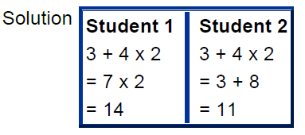

It seems that each student interpreted the problem differently, resulting in two different answers. Student 1 performed the operation of addition first, then multiplication; whereas student 2 performed multiplication first, then addition. When performing arithmetic operations there can be only one correct answer. We need a set of rules in order to avoid this kind of confusion. Mathematicians have devised a standard order of operations for calculations involving more than one arithmetic operation.

2.0 Order of Operations Continued
Rules for Order of Operations
B.E.D.M.A.S

Rule 1: | First perform any calculations inside parentheses.
Rule 2: | Next perform all multiplications and divisions, working from left to right.
Rule 3: | Lastly, perform all additions and subtractions, working from left to right.

The above problem was solved correctly by Student 2 since she followed Rules 2 and 3.

2.0 Order of Operations Continued

Example 1: | Evaluate each expression using the rules for order of operations.

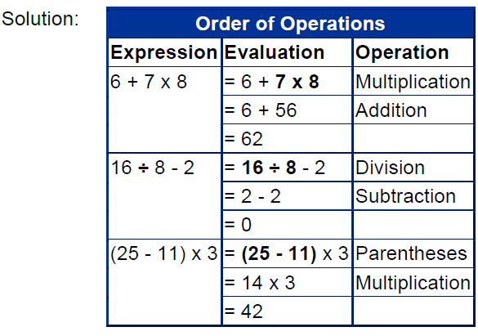

In Example 1, each problem involved only 2 operations

2.0 Order of Operations Continued
The next four examples have more than two operations.

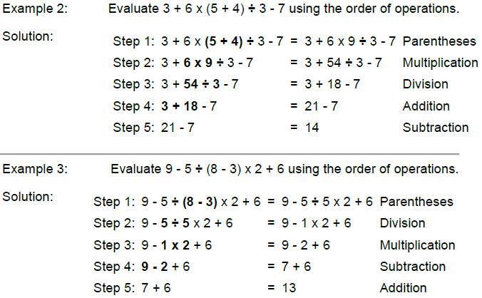
In Examples 2 and 3, you will notice that multiplication and division were evaluated from left to right according to Rule 2. Similarly, addition and subtraction were evaluated from left to right, according to Rule 3.

2.0 Order of Operations Continued
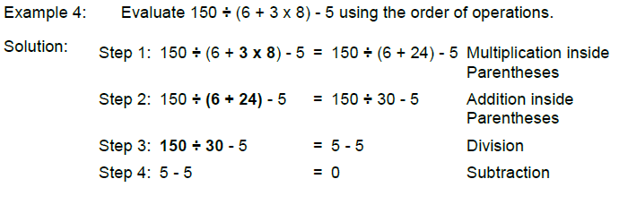
When two or more operations occur inside a set of brackets these operations should be evaluated according to rules 2 and 3

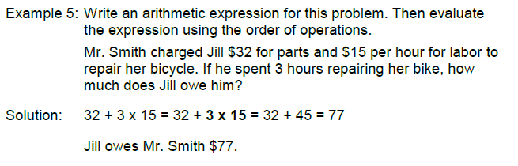

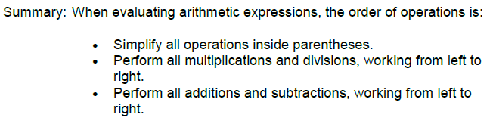

2.1 Integers

Integers – are a set of whole numbers and their opposites.

Example:
(+1, -1) (+2, -2) (+3, -3) (+4, -4)…… and so on
Where do we use Integers in everyday life?
- Temperature
- Money
- Stock Market
- Sports (golf)
- Retail Stores (sales, stock, profits/loss)
- Populations
- Banking

2.1A Multiplication Integers

Rules for Multiplying Integers:
(+) x (+) = (+) (+) x (-) = (-)
(-) x (+) = (-) (-) x (-) = (+)

Examples:
(+6) x (+2) = (+12) (+6) x (-2) = (-12)
(-6) x (+2) = (-12) (-6) x (-2) = (+12)
2.1B Addition of Integers

Rules for Addition of Integers: (direction of movement on number line)

(+) + (+) = →  (+) + (-) = ← 
(-) + (+) = →  (-) = (-) = ← 

Or

Take the number in the question with the highest absolute value and the answer will have its positive or negative value.

(-4) + (+3) = (-)

Because 4 has a larger absolute value

Find the difference in the absolute values of the numbers in the question

(-4) + (+3) = (-) 4 – 3 = 1
(-4) + (+3) = (-1)

Examples:

(+2) + (+3) = (+5) (+2) + (-3) = (-1)
(-2) + (+3) = (+1) (-2) + (-3) = (-5)
2.1 Class Assignment for Integers

In Class Assignment:

(+6) x (+2) = (-3) + (-3) =
(+6) + (-2) = (+8) x (-4) =
(+4) x (-3) = (+6) x (-4) =
(-6) + (+2) = (-14) x (+6) =
(-6) x (-4) = (-10) x (-4) =

2.1 Subtraction of Integers
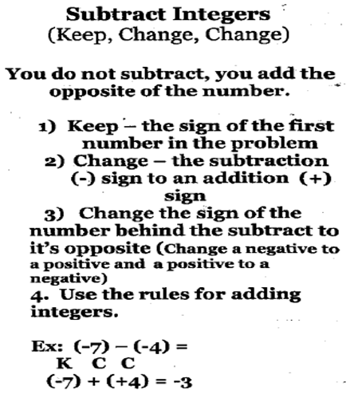

2.1 Division of Integers
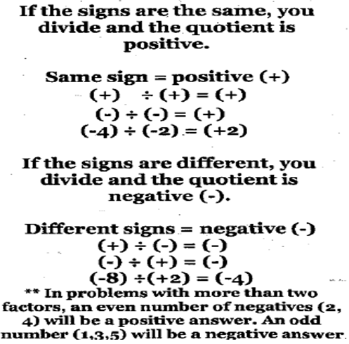

2.2 Fractions

Fraction – is a number that represents part of something.

Numerator – The top number in the fraction. Tells how many of parts of the whole are being referenced.

Denominator – The bottom number is the fraction. Tells how many equal parts are in the whole.

3<- numerator (parts you are talking about)
8<- denominator (equal parts in the whole)

2.2 Equivalent Fractions

Equivalent Fractions – are fractions that name the same amount in different proportions.

Example: In the following examples the operation that is highlighted is done to the numerator and the denominator to create the equivalent fractions. When using division this is often referred to as simplifying or reducing to lowest terms.

½ = 1/2 (x 4 to both numerator and denominator) = 4/8

2/4 = 2/4 (÷ 2 to both numerator and denominator) = ½

2.2 In-class Assignment

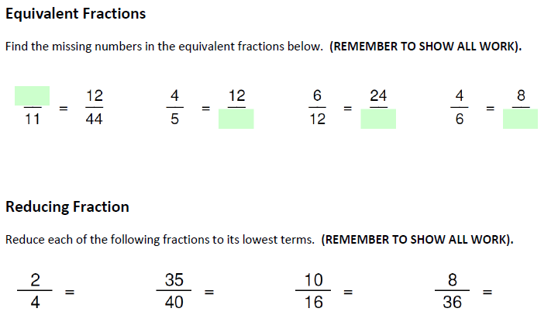

2.3 Improper Fractions and Mixed numbers.
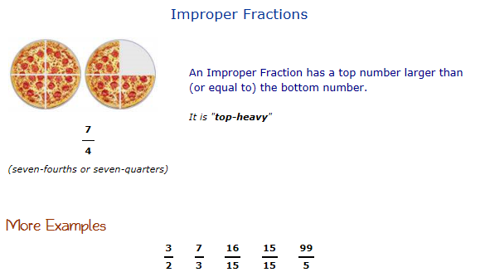
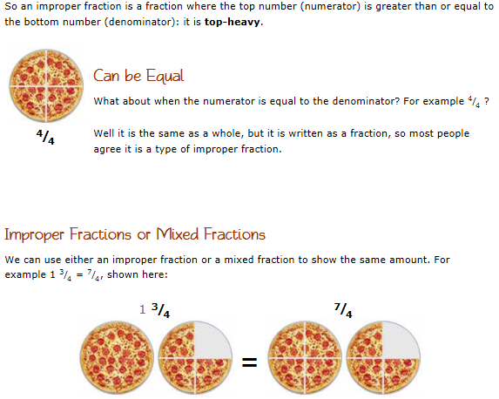
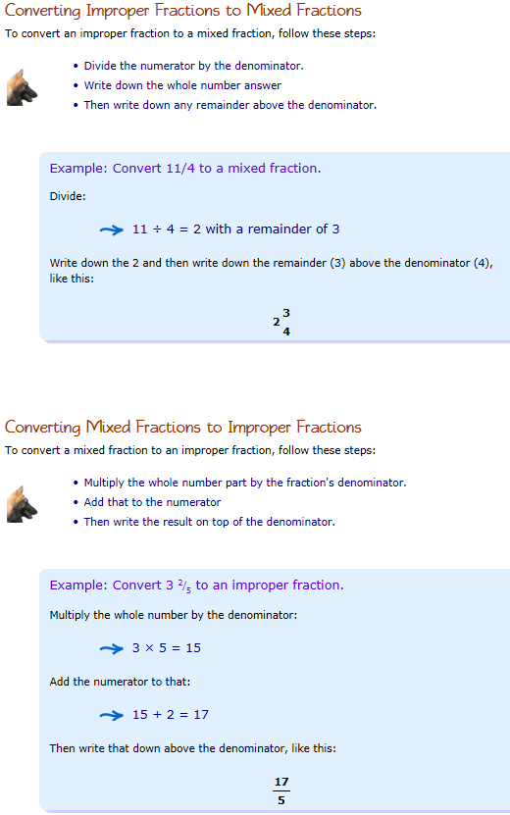
2.4 Adding Fraction
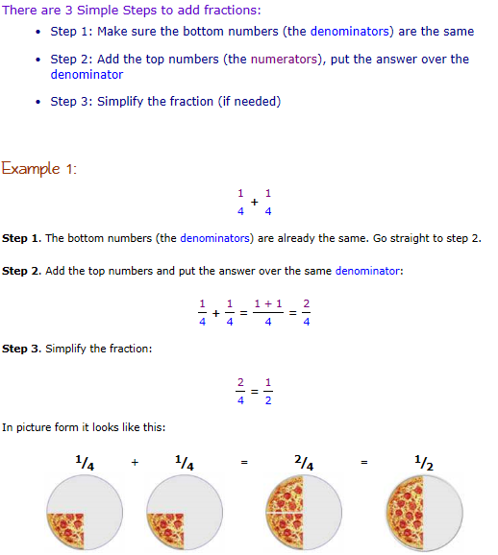
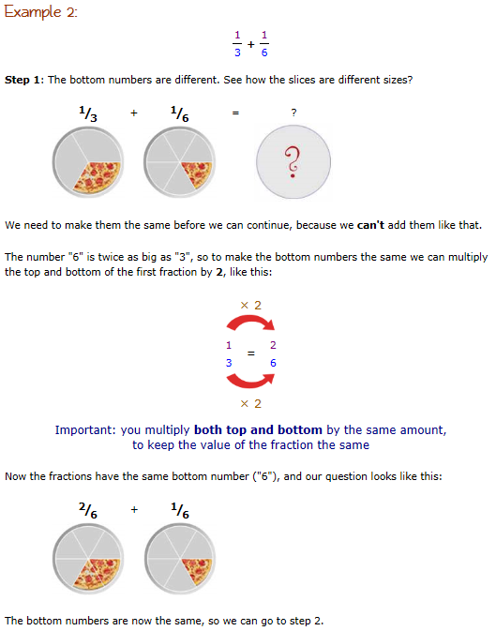
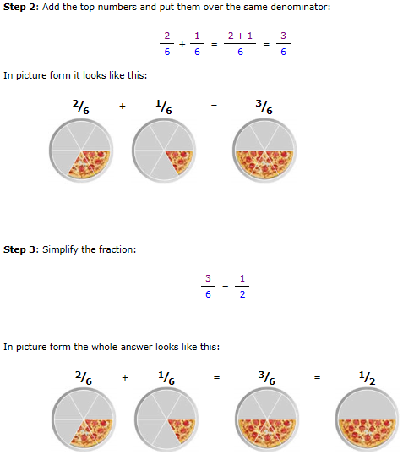

2.5 Subtracting Fractions
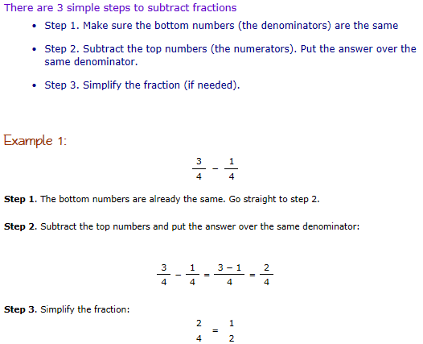
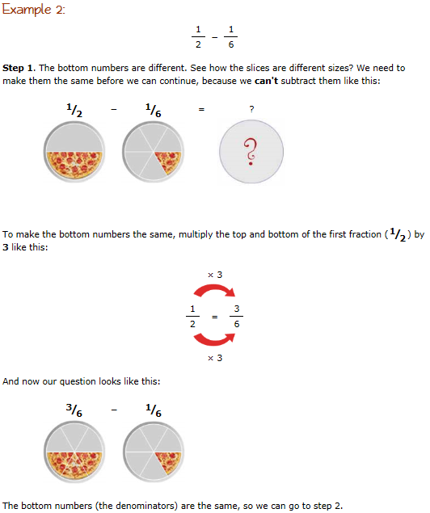
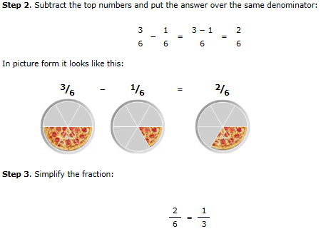

2.6 Multiplying Fractions
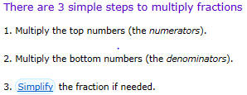
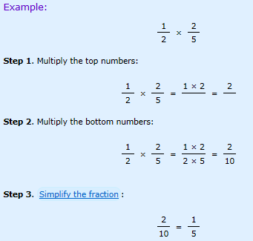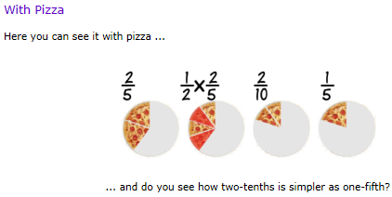

2.7 Dividing Fractions
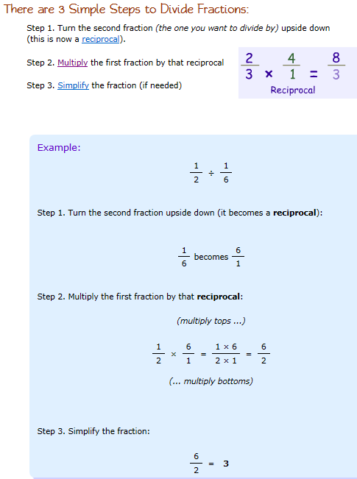

2.8 Decimals, Fractions and Percents (Equivalent)
