Grade 4 Weekly Newsletter October 16-20, 2017
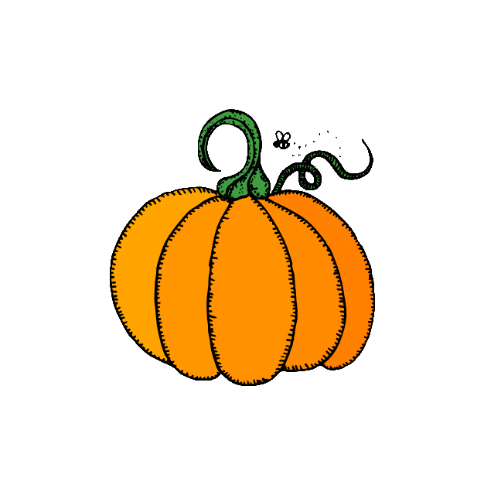
Dear Parents,
Last week we received a class pet, a guinea pig called Pipsqueak. He is on loan to us from Miss. Day. The students are very excited to have a new addition to our classroom. They are taking very good care of him and making sure all his needs are met.
Here are a few reminders:
- This is Safe Schools Week.
- Sports Club Mondays started today after school. This is every Monday. Pick up time is 4:15 PM.
- CARE Club continues after school on Thursdays. Pick up time is 4:15 PM.
- Picture Day: Monday, Oct. 23rd
- Tuesday, Oct. 24th, early dismissal due to PL for teachers.
- Halloween Spook-tacular Event: Thursday, October 26th, 6:00-7:30 PM. Loads of games to be played, prizes to be won and fun to be had by all. Remember to wear your Halloween costume. In order for the night to be successful, we are asking the grade four students to either donate a dollar or Halloween decorations-such as table cloths, Halloween bowls, wall decorations, etc. The cost is $5.00/family.
Homework:
**All homework is due this Friday, Oct. 20th.
1. In math this week we will continue to learn how to compare numbers and look for patterns. Please do the math fact practice game and telling time sheet for homework.
2. The spelling words for this week are: 1. really, 2. very, 3. friend 4. birthday 5. Halloween 6. exited 7. exciting 8. excitement.
There is a story to read called What’s a Chinese Lizard Wing? and questions to answer.
In writing the students are creating descriptive writing pieces about their pets or someone they know. Students have been learning about similes and also possessive nouns.
3.Read at least 20 minutes a night. Please use the reading log below to record what you have read. Remember grade fours for every 20 mins you read, you will earn $10 in classroom bucks!! If you would like to borrow books from me, please let me know.
Day of the Week | Title of The Book | Minutes  Read | Parent’s Initials
Monday

Tuesday
Wednesday
Thursday

In science, students are continuing to explore, discover and investigate different types of rocks.
If you have any questions or concerns, please don’t hesitate to get in contact with me.
S. Baker
sheila.baker@nbed.nb.ca

