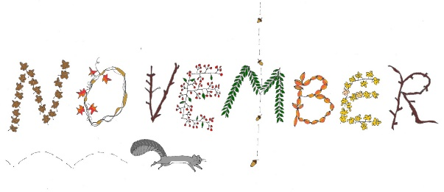
Weekly Practice and Reminders
November 6th, 2017- November 9th, 2017.
1.Jolly Phonics- This week we will review all letters in the duotang (S, A,T,I,P,N,C,K,E,H,R,M, D,G) We will work on Oo and Ll this week. We have moved into letters that will be assessed for next report. We are working on these daily and home practice really helps support this. If your child is still having difficulty with S through D, continue to focus here.
2.Numeracy – Play any game this week with a die. Have your child try to give you the number without counting. Have them touch each spot they move on the board as they count their way around the game.
3. Writing- We have started a new format and paper for writing. We are trying to continue to label our pictures but we are adding ending sounds and also trying to write our letters on the line given at the bottom of the page.
4.Show and Share – No show and share this week as it is a professional learning day for teachers.
5. Scholastic book orders- Due on Tuesday, November 14th, 2017. If you would like this as a Christmas gift, you can send a note and I will have the office call for you to pick it up when it comes in.
6 Library- Please return books each Thursday.
If you can’t find the book at home, please write a note so we can take another look around the class.
7. Students are continuing to explore their community, 5 senses and our monthly CARE quality in You and Your World. November is Compassion. We will be learning to treat others and ourselves with kindness.
8. A big thank you to anyone who sent in a treat on Halloween day. You will get another chance to send something close to Christmas as well. If you already sent something, you can leave it to another parent for next time.
9. The weather has been beautiful this Fall but we will begin to get chillier temperatures. Please be sure to dress for the weather with mittens, hats, warm jackets and outdoor footwear.
10. November 13^{th,,} - No school as well.

