SCHOOL NAME: Liverpool Street Elementary
Address: 50 Liverpool St
Parent School Support Committee
Minutes
Date: Sept 22, 2022 Time: 6:15pm
Location: Microsoft TEAMS
PSSC Members Present:  Colin Curry, Chair  Erin Wilson, Vice Chair  Keri O’Leary, Teacher Rep.  Bronwyn Mulherin-Murphy  Erica Fanjoy  Asha Noel-Hart  Amin Choroomi  PSSC Members Regrets:  Fiona Watters  Kristy Short  Sabina Thapa  Siddaiah Madadevaswamy | School/DEC Representation Present:  Kelly Parks, Principal  Vanessa Moore- Vice Principal  School/DEC Representation Regrets:  Mr. Amgad Hanafy

Call to Order: by Colin Curry

Approval of the Agenda:

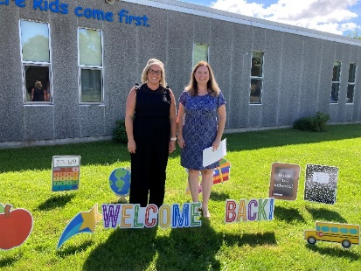
- Approval of the Minute: none

- Welcome to our new members and introductions
- Fiona Watters
- Kristy Short
- Amin Choroomi

- Vote for Chair of committee:
Colin Curry- has put his name forth – members present agree he should be chair
Nominated by Erin Wilson, Seconded by Asha Noel-Hart
If Colin for chair, vote a vice chair – Erin Wilson said she would like to do this if available
Nominated by Bronwyn Mulherin Murphy, seconded by Asha Noel-Hart
Mrs. O’Leary will continue to take on the secretary position and take minutes during meetings.
4. PSSC budget- Not available at this time
Document for what the funds can be used for by PSSC committee.
5. PSSC Documents
- Handbook
- Education Act Governance
- PSSC Declaration Form
- Training Presentation
If you did not receive this, please notify us ASAP and we will get it to you. Please return the Declaration Form as soon as you can. This signifies your commitment to the committee for the year.
6. School Plan- 2 Big Goals
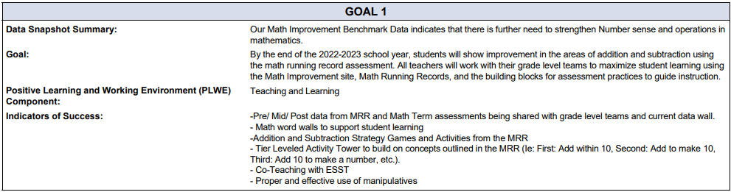
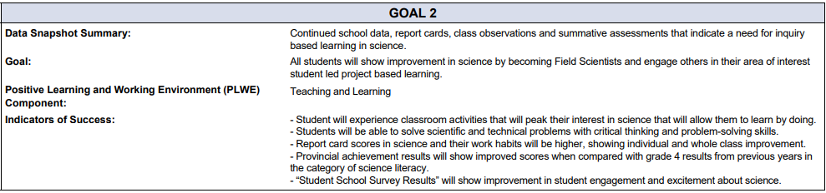
Running records in math is where we have put quite a significant push this year. These are quick snapshots that show where students are in each of the NUMBER & OPERATIONS outcomes. We have made rolling carts with drawers that are filled with games & activities that pertain to each of these outcomes to support where the students are needing assistance. ** Closer look available in principal’s report **
We’ve kept science again this year to see what further gains we can make in that subject area. Students are enjoying inquiry-based learning and the science experiments so staff are excited to continue that.
As a staff we decided to put literacy by the side for this year. It’s not that is forgotten, we just feel for now that we would like to focus on the other 2 areas and feel that gains have been made in literacy.
7. Principal Report
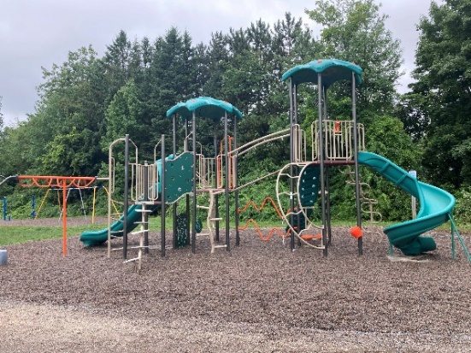
A. New Playground Equipment- This was put in by the city of Fredericton over the summer. It does belong to the city.
Erin was wondering about accessibility with the gravel
Mme. Parks will investigate the gravel with the city
Bronwyn & Erica both voiced concerned the “safety” level of it
The school had no say in the structure at all. It just arrived.
Colin wondered if there was an age rating for it.
Mme. Parks will reach out to the city and ask.
Asha asked if the old B&G structure was still being replaced?
Mme. Parks has reached out (phone, email) and hasn’t heard anything. Trying to figure out what is LSS on the playground & what belongs to the city.
B. School Plan Math Running Records- Math Running Records assess students’ basic fact fluency and increase
student achievement. Like a GPS, Math Running Records pinpoint exactly where students are in their understanding of basic math facts and then outline the next steps toward comprehensive fluency. It is research-based framework by Nikki Newton, to assess students’ thinking and move them toward becoming confident, proficient, flexible mathematicians with a very good sense of numbers.
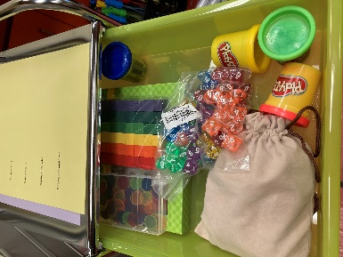
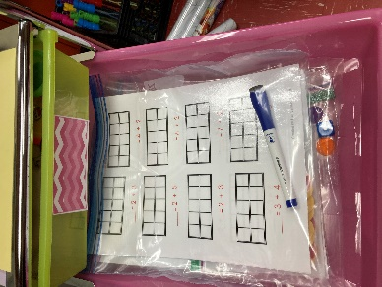
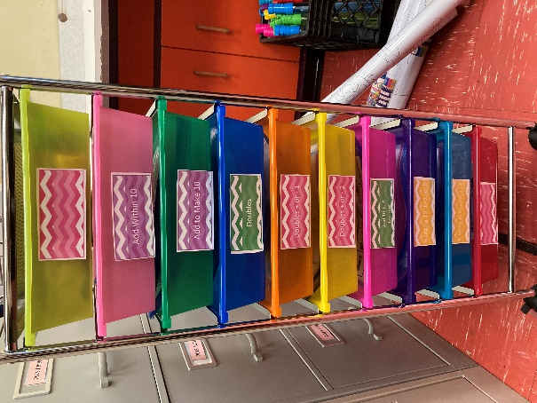

C. Sock Fundraiser- Liverpool Socks. $15.00 a pair. We will hold Liverpool sock days whether it be blue or yellow socks that students already have at home or these Liverpool Socks. School Spirit swag.
D. New Staff to Liverpool-
- Mrs. Moore- VP/Resource/Grade 2
- Ms. Fequet- Resource
- New Librarian- coming soon
- EA- Laura Greer
- EA- Julia Nason
- EA- Haru Kipp- an EA has moved to another school
- No longer have part time admin assistant- (need 300 students)
- Student Intern from UNB- Joelle Morrisette
- FHS Coop student working with Mr. Brown in Phys Ed
- Morning Music – Mme. Elder-Gomes – once a week
E. Greener Village- Highlight Liverpool in their October Spotlight series. Greener Village provides our school with brown bag lunches daily and backpack programs for families of Liverpool. (Sept. 21)
Bronwyn asked what the demand in the school is. We order 12 lunches each day and we receive 6 backpacks. This is for any child who needs food (brown bag). Will probably up the backpack number to 8-10
F. First Fire Drill has been completed. Very successful
G. DEC member sub-district 7- for our school- new as of last week. Mr. Amgad Hanafy. Mr. Hanafy is currently out of the country on vacation but, upon his return, I will advise you of his contact information so that you can communicate with him and inform him of your school PSSC meetings as well as other activities.

H. 13 classes in total.
- 7 Fi and 6 English Prime
- New class was made Sept 20- supply teacher this week, permanent teacher Sept 26 – Amanda Braman
I. Phys Ed
- Cross Country- next 4 Wednesday
- Open Gym- all mornings (grade 2/3 Tuesdays and Thursdays) Grade 4/5 (Mon, Wed, Fri)
- Noon intramurals- Tuesdays and Thursdays
J. Home and School update- first meeting was tonight. Not a large turn out, so another virtual meeting will be held next week on Thursday. Hoping to get Halloween Howl up and going for this day.
H. Found out today that Friday, September 30 is a holiday for Truth & Reconciliation Day. Movie Night planned for that evening will be rescheduled.

Questions:
- Walkers Afterschool – why are they going to the gym? After school comings & goings are very hectic. We had a lot of students wanting a meeting place for students to gather prior to walking home. Older students would jet out the back door and not cross where the crossing guard is on Canterbury. It is not safe for students to be running/walking all over the property for their own safety. They gather in the gym with Mrs. Moore, and she directs them up to the crosswalk so they can get home safely.
- Orange Shirt Day – what will the changes be in the school to honor this day on Thursday etc.? We are waiting to hear from Sarah Francis and District on the changes we can expect for next week so that we can properly recognize this day.
- How are we going to spend the PSSC budget? Can we start thinking about ways that we can use that budget and increase the communication between PSSC & the community. We can discuss at further detail in the next meeting.

Next meeting: October 20, 2022 at 6:15pm
Tentative dates for meetings:
Nov
Jan
Feb
March
May

Business from Previous Meeting: none

Business Arising from the Minutes: none

Correspondence: none

Closing Comments: See you next meeting

Date of Next Meeting: October 20, 2022

Adjournment: 7:10pm

Motioned by Colin Curry, seconded by Erin Wilson

