Welcome to
Liverpool Street Elementary School

Student Name: ______________________

STUDENT HANDBOOK 2020-21

Our School Website: http://liverpoolelem.nbed.nb.ca/


Mrs. Sandi Boles Mrs. Kelly Parks Mrs. Jennifer Kelly-Milner
Administrative Assistant Principal Vice-Principal

50 Liverpool Street
Fredericton NB, E3B 4V4
Telephone: (506) 453-5434

Fax: (506) 453-2630
District Home page: asd-w.nbed.nb.ca

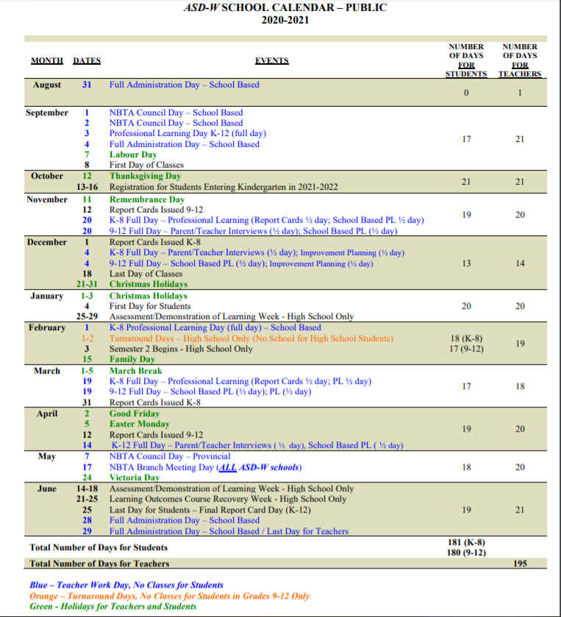

HOURS OF INSTRUCTION

Monday. Tuesday, Thursday, Friday

7:45- 810am | Bus arrival times
8:00-8:15am | Parent drop off and walker arrival times
9:45- 10:00am | Grade 2 only recess (5 designated areas. 1 area per class)
10:05-10:20am | All Grade 5, 4clow, 4 EG recess (5 designated areas. 1 area per class)
10:25-10:40am | All grade 3, 4H, 4/5 Bray recess (5 designated areas. 1 area per class)
11:30-12:00 | All Grade 2 lunch recess
12:00-12:20 | All Grade 2 Eat lunch in classrooms
12:00-12:30 | All Grade 5, 4clow, 4 EG lunch recess
12:30-12:50 | All grade 5, 4 Clow, 4EG eat lunch in classrooms
12:30-1:00 | All grade 3, 4H, 4/5 Bray lunch recess
1:00-1:20 | All Grade 3, 4H, 4/5 Bray Eat lunch in classrooms
1:45pm | Grade 2 Dismissal
3:00pm | Grades 3 to 5 Dismissal

Wednesday

11:45am | Dismissal for all grade levels at Liverpool Street Elementary

Liverpool Street Elementary School Mission/Vision
BE RESPECTFUL, BE SAFE, BE RESPONSIBLE.
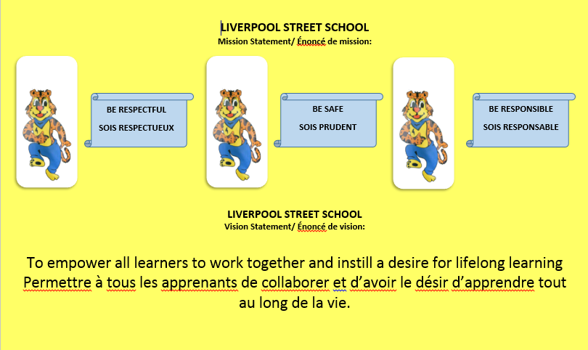

Liverpool Street Elementary School Website: http://liverpoolelem.nbed.nb.ca
Please see our website for upcoming events, newsletters, school supply lists, PSSC information, school hours, staff and important information regarding Liverpool Street Elementary. The calendar of upcoming events is updated regularly.


EDUCATION ACT
The Education Act for the Province of New Brunswick states:
Roles of Parents Duties of Pupils

13(1) In support of the learning success of
his/ her child and the learning
environment at the school, a parent is expected to:
- encourage his or her child to attend to assigned homework,
- communicate reasonably with school personnel employed at the school his or her child attends as required in the best interests of the child,
- cause his or her child to attend school as required by this act,
- ensure the basic needs of his or her child are met and,
- have due care for the conduct of his or her child at school and while on the way to and from school.

14(1) It is the duty of a pupil to
- participate in the learning
opportunities to his or her
potential,
- accept increasing responsibility for his or her learning as he or she progresses through his or her schooling,
- attend to assigned homework,
- attend school regularly and punctually,
- contribute to a safe and positive learning environment,
- be responsible for his or her conduct at school and while on the way to and from school,
- respect the rights of others, and
- comply with all school policies.

School Fee: Liverpool Street Elementary has a school Fee of $60.00. The preferred method of payment is through School Cash online. The link can be found on our school website. Our school purchases all school supplies needed for the year with the student fee and it also covers a student agenda, special supplies for projects, music consumables and Phys Ed consumables.

School Library
Students at Liverpool Street Elementary School will benefit from the school library, where they will be able to borrow books. (Due to the high cost of library books, it is necessary for the school to charge parents for replacement of lost or damaged books in accordance with their age and condition.) This may be subject to change due to Covid19.

Homework
Homework is assigned at the discretion of the classroom teacher and will vary between grade levels. If a parent has concerns regarding homework activity, it is best to contact the classroom teacher to discuss the concerns. Keep in mind that all children will benefit from reading and being read to every night!

Evaluation
Assessment is ongoing and a variety of assessments are used to monitor student achievement. Report cards during the 2020-2021 school year will be sent home 3 times. Parent-teacher interviews will be conducted 2 times in the school year by telephone. Please feel free to contact your child’s teacher at any time if you have concerns about your child’s progress. Regular communication is crucial for student success at school!

School Behavioral Expectations
Behavioral Expectations are outlined in EECD Provincial Policy 703 – Positive Learning and Working Environment and the Provincial Student Code of Conduct Guidelines.

Provincial Student Code of Conduct
As a student,
- I am responsible for my own behavior to the best of my abilities.
- I will be responsible for my own personal choices.
- I will respect others’ differences, ideas and opinions and treat everyone fairly.
- I will not tolerate bullying of any kind and I will report bullying when I have knowledge of it.
- I will do whatever I can to help those around me who may be struggling.
- I will respect the school’s rules.
- I will attend my classes, do my homework, and be prepared and on time.
- I will behave in a way that is empathetic, responsible and civil to those around me.
- I will resolve my conflicts in a constructive manner.
- I will treat school property and the property of others with respect.

I will respect myself.
I will respect others.
I will respect my environment.

Covid19 Regulations

An information bulletin will be coming home the first week of school with health and safety regulations listed for our school. Things are different and are changing daily. We are working hard to ensure our students have a safe and happy school environment.

Dear Parents/Guardians
Your children have been or will be working with a wonderful program called Zones of Regulation. This is a school wide program to help teach students self-regulation strategies. This program will empower students to recognize and communicate how they are feeling. They will learn and apply strategies or tools to help them move between zones. Below is a brief description of what each zone might look like.
Blue Zone- When children are in the blue zone their body is running slow, such as when they are tired, sick, sad or bored. This is when their body and/or brain are moving slowly or sluggishly.
Green Zone- When children are in the green zone; their body and brain are ready to learn. They may feel happy, calm, focused and ready to learn. This is the zone that students generally need to be in to complete schoolwork and for getting along with others.
Yellow Zone-When children are entering the yellow zone, they are starting to lose control. The yellow zone describes when they start to lose control such as when they are frustrated, overwhelmed, silly, wiggly, excited, nervous or surprised.
Red Zone- When children are in the red zone, they are out of control, have trouble making good choices, and may be unsafe. Children may experience anger, rage, explosive behavior, panic, or terror when in the Red Zone. Being in the Red Zone can best be explained by not being in control of one’s own body.
This program is a wonderful learning tool that can be used at home and school, and your children will be excited to share their strategies and breathing techniques with you as they learn them!
Mme. Fournier, our school Guidance Counsellor, will be visiting classes to help teach strategies (tools) for students to use.
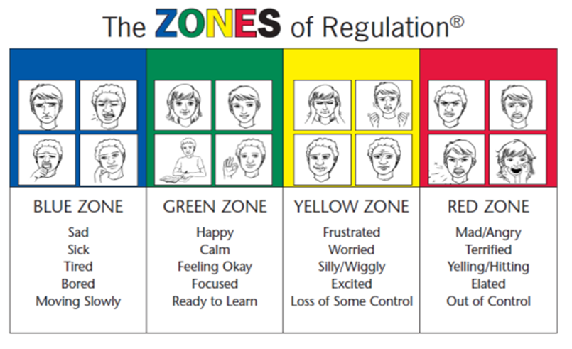

Positive Behaviour Intervention Program (PBIS)

Liverpool Street Elementary School has adopted the philosophy of Positive Behaviour Intervention Program.
It is important to note that most behaviours will be handled according to the pyramid, however there may be exceptions:
- Playground issues will be dealt with on an individual basis.
- Certain behaviours may lead to an in-school or out-of-school suspension (i.e. fighting, bullying, aggressive behavior).
- Certain unacceptable classroom behaviours (i.e. refusal to do work, defiance, continued disruption of the learning environment) will be addressed by the teacher first, then administration as required.

Communication between home and school is instrumental in helping your child to succeed emotionally, socially, and academically in school. Please feel free to contact your child’s teacher if you have any questions or concerns regarding behaviour that may be impacting your child’s learning.

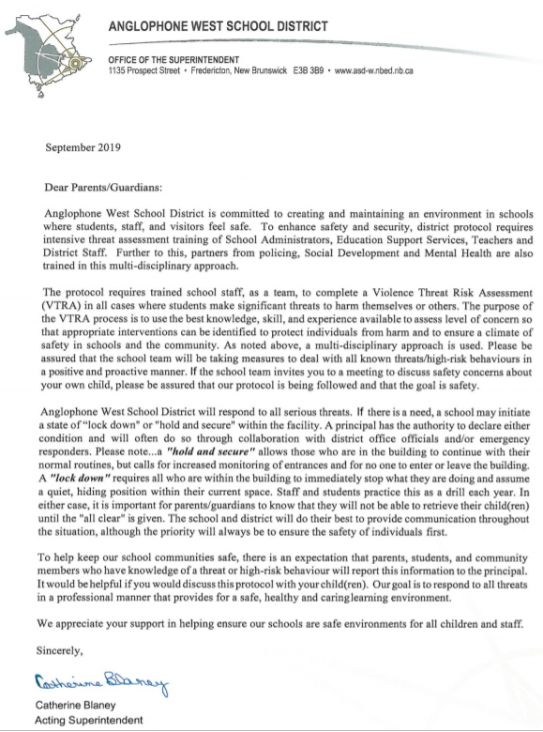

SCHOOL POLICIES AND INFORMATION

- Attendance: Regular attendance is stressed. The Education Act requires students to be at school. A written reason is required for any absence from a parent/guardian. The note should accompany the child on his or her first day back to school and may be written in the student agenda, even if you have already notified the school by telephone. Please advise the school of your child’s absence by calling 453-5434 by 8:45 AM. We operate a Safe Arrival program and will be calling to check on the well-being of students. Emails are also acceptable.

- Appointments with teachers: Due to social distancing and respecting health regulations, please arrange for phone call conferences with your child’s teachers.

- Student Arrival:
- Bus students are supervised from the time their bus arrives at school in the morning. Our first bus arrives at 7:45am.
- Walkers or students who are dropped off should not arrive until 8:00 AM
- Student Departure: In order to maintain a safe and orderly environment, parents and caregivers are to wait outside by portables for their child.
- Further information on parent pick-up, drop off during the day will be available in the Fall.

Our school thanks you in supporting us in keeping our building a safe and positive learning environment for all. We are a Closed campus. This means that the doors to our school are locked when the students are in class. Please ring the doorbell at the front door for admittance.

- Emergency Contact Numbers: It is extremely important that we have an alternate emergency phone number for your child. This is used when school is cancelled during the day because of weather, as well as in case of sickness or emergency. Emergency contact forms are sent home at the beginning of each school year.
IF THERE IS ANY CHANGE OF EMERGENCY CONTACT NUMBERS, PARENTS’ WORK NUMBER OR HOME NUMBERS DURING THE SCHOOL YEAR, PLEASE ENSURE THE SCHOOL IS NOTIFIED. We must be able to reach you at any time in case of emergency!

- School lunch program: More information will be available in the Fall.

- Allergy Alert: Some students and/or staff of Liverpool Street Elementary suffer a range of allergy triggers. Products containing nuts are not permitted school as we have some severe allergy cases. We request that you respect our attempts to provide a scent-reduced environment. Smoking is not permitted by Provincial Policy on any school property. If your child suffers from life-threatening allergies, please ensure that your child’s teacher is aware of the condition and emergency treatment, and that a medical form, as per Policy 704, is completed by school staff.
- Medication: All prescribed medication must be blister-packed by a pharmacist and delivered to the school office by an adult. A medication form needs to be completed by the parent and signed also by the doctor. It is the parent’s responsibility to fill out the medical form and have it signed by the doctor. Non-prescription medicine may be administered at the school if necessary. A note must accompany this giving the teacher or designate permission to administer this. No medication should be given directly to a child for him/her to take without adult supervision.

POLICY NO. ASD-W-550-1 AFTERNOON SCHOOL BUS STOPS (November 2013)

Anglophone West School District is committed to providing safe and reliable transportation services to all eligible students to and from school.

Grades K-12: Transportation for occasional drop-offs (e.g. birthday parties, visiting a friend, sleep-overs, or after school activities) will not be provided.

Grades K-5: Minimizing the potential for human error is paramount, therefore, there are only two afternoon bus stop options, used consistently (i.e. the same days each week), for students in Grades K-5. There is one primary address and one alternate address of the parent’s/guardian’s choice. The home address may be used as one of these two bus stop options; however, if the home address is not listed as one of these two options, students will not be taken to the home address.

On the student data collection form provided in September, parents/guardians indicate on which days students are to be dropped off at each of the two location options. For the safety of students, rotational schedules will not be accommodated.

School bus stops for primary and alternate addresses, if not the home address, must be on an existing school bus route and there must be space for the student on the bus.

When moving residence or making a permanent change for after-school childcare, notification of changes to either the primary or alternate bus stop location must be communicated to the school in writing at least 24-hours in advance of the change.

School administrators have flexibility to deal with emergency situations.

Recognizing that extenuating circumstances may exist, reasonable accommodations may be made in collaboration with the driver, transportation management and school administration. In considering these requests, written rationale must be provided by the parent with appropriate notice.

The complete Afternoon Bus Stops Policy is posted online and can be viewed at www.asd-w.nbed.nb.ca.

If you have any questions or concerns, please contact your local pupil transportation department at:
Fredericton Education Centre – 453-8143
Oromocto Education Centre – 357-4256
Woodstock Education Centre – 325-4498

If you are looking for a bus # for your area, go to the ASDW website,
choose transportation at the top of the page and follow the directions for Fredericton Area.

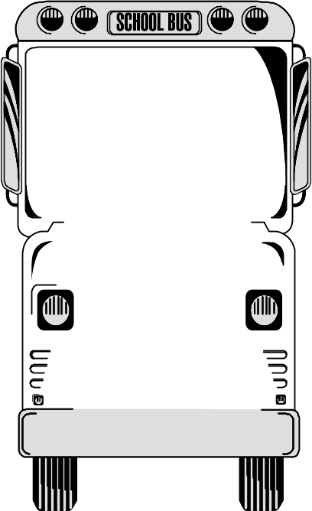

DEPARTMENT OF EDUCATION

SCHOOL BUS SAFETY GUIDELINES

1. Obey the driver promptly.
2. Avoid any unnecessary conversation with the driver while the bus is in motion.
3. Respect the driver and fellow passengers.
- Arrive on time and stand away from the roadway while waiting for the school bus.
- Wait until the bus comes to a complete stop before moving to get on.
- When crossing the road, wait for the driver’s signal and always cross at least 3 metres
in front of the bus. NEVER CROSS BEHIND THE BUS.
- Always keep a safe distance around the school bus.
- Go directly to your seat; allow others to sit with you. Remain seated.
- Sit facing forward, with your belongings on your lap or under the
seat. Keep the aisle clear.
- Obtain approval of the driver to open windows or emergency door.
Nothing must hang out or be thrown out of the windows of the bus.
- Talk quietly. Silence is required when approaching a railway crossing.
12. Eating and drinking are not allowed on the bus.
Use of tobacco is forbidden.
- Neither pets nor large objects are allowed on the bus.
- Anyone who intentionally damages the bus will be held
responsible. Financial restitution may be requested.
- Dress according to weather conditions. For safety reasons,
avoid drawstrings or loose objects on clothing and backpacks.

PUPIL TRANSPORTATION is a privilege – follow the rules.
VIOLATION may result in disciplinary action and possible loss of the privilege.

An Important Message to Parents – School Closures Because of Weather Conditions

Anglophone West School District is committed to the safe and efficient transportation of students. The District recognizes it may be necessary to cancel bus runs, close schools, or delay school opening to ensure students are not endangered by hazards brought on by poor weather and road conditions.

Approximately 22,901 students attend 69 schools in the following areas: Perth-Andover, Bath, Florenceville-Bristol, Canterbury, Centreville, Debec, Plaster Rock, Hartland, Grand Falls, Burtts Corner, Millville, Nackawic, Edmundston, Woodstock, Chipman, Coles Island, Minto, Cambridge Narrows, Gagetown, Geary, Fredericton Junction, Burton, Oromocto, Lincoln, Upper Miramichi, Doaktown, Stanley, Harvey, McAdam, New Maryland, and the greater Fredericton area.

276 school buses transport approximately 15,000 students, travelling more than six million kilometers each school year. When a decision is made to close school, delay school opening, cancel bus runs, or delay bus runs, safety is the paramount factor.

Options Considered
- Schools open as usual: no communication required
- All schools closed for the day: see “Communication” section below
- A school or schools in a particular zone of the district closed: see “Communication” section below
- All school bus routes delayed by one hour: On these occasions, all schools in the district will open at their regular time to receive walking students and drop-off students. Students arriving late will not be penalized.
- Schools may be closed early on days when it is anticipated that weather conditions may deteriorate significantly. It is important that parents have alternate arrangements for their children if they or another adult will not be at home to receive the students. Please ensure that the school has up-to-date contact numbers for parents (work numbers, cell numbers, etc.) and at least one emergency contact. It will be announced that buses will run their afternoon runs one, two, or three hours earlier than usual, whatever time is determined.

Important Notes
There may be occasions when a particular bus route is hazardous because of varying weather conditions throughout the district, In cases where the bus driver has a safety concern, he or she has the responsibility to recommend either the cancellation or delay of his/her particular bus run.
On days that the weather or road conditions are poor, parents may exercise their prerogative to keep children at home. Students will not be penalized for such absences, however, parents must provide a written excuse to the student’s teacher when the child returns to school.
There are times when school buses run late for reasons unrelated to weather. Individual school buses expected to be more than 20 minutes late will be announced whenever possible. Parents are responsible for the safety of their children at the stop until the bus comes.

School Zones - please note we are zone 6
1. Edmundston
2. Perth-Andover, Plaster Rock, Grand Falls,
3. Centreville, Florenceville-Bristol, Bath, Woodstock, Hartland, Debec
4. Canterbury, Nackawic, Burtts Corner, Millville, McAdam, Harvey
5. Stanley, Boiestown, Doaktown
6. Greater Fredericton Area (including New Maryland, Keswick Ridge, Nashwaak Valley)
7. Oromocto, Geary, Burton, Lincoln, Sunbury West
8. Chipman, Minto
9. Cambridge Narrows, Coles Island, Gagetown

Decision Process
The Superintendent of Schools makes the decision to keep open or close schools after district transportation personnel provide current information about weather and road conditions. The school district transportation department has access to current weather and road conditions throughout the district through the Department of Transportation and Infrastructure road supervisors, a contracted weather information service provider, as well as other internet sites. Inclement weather predictions are monitored closely throughout the evening and again from 5:00 a.m. onward.

Communication
It is a school-based decision to use voice-messaging, if available. Parents should not rely on this means of notification for information about school closures. Announcements will be made on local radio stations, through a recorded message that can be heard by dialing the district public information line at 1-888-388-4455 (toll free) or 453-5454 any time after 6:00 a.m., and by checking the district website at
www.asd-w.nbed.nb.ca.

The following is a list of radio stations that will be notified of a school closure/delay for announcements:
- CBD – CBC Radio One 91.3 FM Saint John  - CBZ – CBC Radio One 970 AM Fredericton  99.5 FM Fredericton  - CFAI – 101 Rock 105 101.1 FM Edmundston  - CFRK – Fred FM 92.3 FM Fredericton  - CFXY – 105 FM FOX 105.3 FM Fredericton  - CHSJ – Country 94 94.1 FM Saint John  - CHWV – The Wave 97.3 FM Saint John  - CIBX – Capital FM 106.9 FM Fredericton  - CIHI – UP 93.1 93.1 FM Fredericton | - CIKX – K93 93.5 FM Grand Falls  - CINB – NewSong FM 96.1 FM Saint John  - CIOK – K100 100.5 FM Saint John  - CIXN – Joy FM 96.5 FM Fredericton  - CJCW 590 AM Sussex  - CJCJ – CJ 104 104.1 FM Woodstock  - CJPN 90.5 FM Fredericton  - CJRI 94.7 FM Fredericton  - CJYC – 98.9 Big John 98.9 FM Saint John  - CKHJ 1260 AM Fredericton

PARENT SCHOOL SUPPORT COMMITTEE (PSSC)
The PSSC works in an advisory capacity with the school administration. This committee addresses broad issues related to the education of all children in the school, with the goal of enhancing student learning. Elections for term positions on this committee are held in September of each school year.

