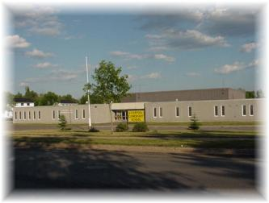
Liverpool Street School

50 Liverpool Street

Fredericton, N.B. E3B 4V4

Tel: 453-5434 Fax: 453-2630

Kelly Parks Jennifer Kelly-Milner

Principal Vice Principal

We are looking forward to seeing you in September!

Our classroom teachers will be purchasing school supplies for each student for the 2022/2023 school year.

School Fee- $57.75
This fee of $57.75 is for educational supplies and activities and other educational purposes. A $10.00 durable communication bag is purchased for grade 2, an agenda for grades 3 to 5, $5.00 music fee for Kazoo or recorder, materials such as notebooks, glue, pencils, and more.

Method of payment: The preferred method of payment is School Cash Online. Please submit payment by end of September. Our online payment method (School Cash Online) will only be available the end of August. Link for payment www.anglophonewest.schoolcashonline.com.

Items to bring for first day of school:
• Lunch Bag • Book Bag
• Indoor Sneakers
• box of Kleenex
• 1 box of Large Ziplock Bags
• 1 box of Small Ziplock Bags
• 1 water bottle

Meet And Greet for Fall 2022

All families are invited to a Meet and Greet on Thursday, September 1st at 6:00pm to 7:00pm at Liverpool St. School. We will meet in our gymnasium followed a tour around the school where families can stop in to see their child’s classroom and say hello to their new teacher.

Thank you for your continued support and have a wonderful and safe summer!

Liverpool Staff

-----------------------------------------------------------------------------------------------------------------
Please send this paper with your child on the first day of school.

Child’s name: _____________________________________________

Where does your child go afterschool?

_________________________________________________________

Walker: yes no - please circle one
Pick up: (name of person picking up child) ________________________________

Bus# __________

Phone number of where you can be reached during the day. _____________________

