April showers are here, but at least it is warmer. It will be messy coming in the school after playing on the playground. April is Poetry Month and we have partnered up with the local library to do a poetry contest. (grades 1-5).

It was great to see the AMAZING community support for our Bottle Blitz Fundraiser. It was a HUGE success and we reached the $3000 goal. A special thank you to Lawrence McIntyre who volunteered to go door to door and collect recyclables. In total, he brought in $1400! WOW!!!!

A special thank you also goes out to the local Scotiabank. They matched our Bottle Blitz Fundraiser and we are getting closer to our goal of having a multi-purpose field.

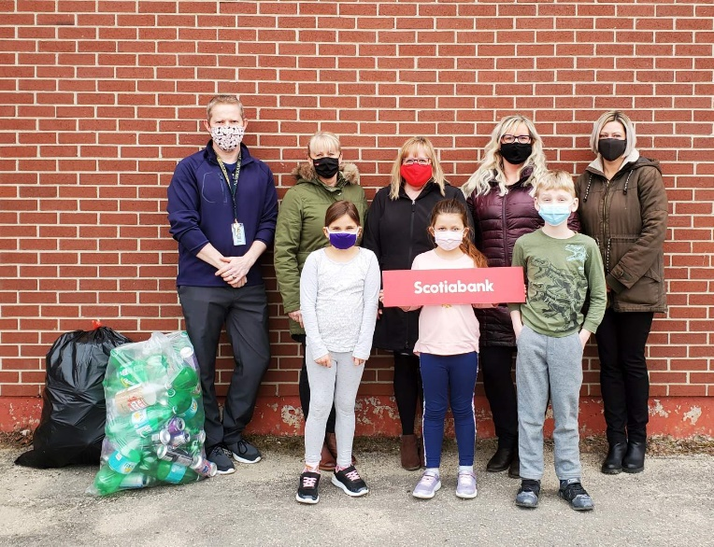

Heart Healthy Schools
The students did an amazing job with the Water Challenge. The flavoured water was a BIG hit. Now we move on to our third challenge: Encouraging students to have 2 hours or less of screen time each day.
Screen time is defined as any time spent in front of a TV, computer, tablet, iPad, gaming console, smart phone, and/or other devices equipped with a screen. Reducing screen time can help reduce the total time spent sedentary. It has been found that children and youth that spend less time being sedentary can:
- Maintain a healthy body weight
- Do better in school and learn new skills
- Improve their self confidence
- Have fun playing with friends and meeting new ones
- Improve their fitness, including a healthy heart

Home & School
The Home & School has teamed up with Railside Café to do two WAKE-UP WEDNESDAYS this month (April 7th and April 21st) ! There will be a coffee station set up in the drop off area (across the road from the school) and we will be selling coffee by donation. There will be sugar and cream there in case you need it. All proceeds will go be going towards the multi-purpose field. Everybody needs a good wake me up!

Poetry Contest
We are excited to partner up with the library to promote poetry this month. Julian Christie from the library has visited each class and let them know about the contest. We can’t wait to see what our little poets come up with.
Sun | Mon | Tues | Wed | Thurs | Fri | Sat
 |  |  |  | 1  Easter lunch provided | 2  Good Friday  No School  World Autism Day | 3
4 | 5  Easter Monday  No School | 6  Village Recycling Day | 7  World Health Day  WAKE -UP WEDNESDAY FUNDRAISER | 8 | 9  Heart & Healthy Schools January 21-25  Fruits & Vegetables Challenge!  Salad Lunch in Gym for  ALL STUDENTS Jan 23/18 | 10
11 | 12 | 13  Parent/Teacher Interviews in the evening | 14  Parent/Teacher Interviews  No school for students | 15  Talk To Your Kid About Money Day  Heart Healthy Schools Challenge #3  Screen Time Challenge – April 12th – 16th | 16 | 17
18 | 19 | 20 | 21  A rhinocero’s horn  Is madof  hair!  .  WAKE UP WEDNESDAY FUNDRAISER | 22  Happy  Earth Day | 23 | 24
25  Your text here  It is Hats, Boots & Mittens Time Again! | 26 | 27 | 28 | 29 | 30
UPCOMING EVENTS:
May 7 – No School for students
May 17 – No School for students

May 24 – Victoria Day (No School)

