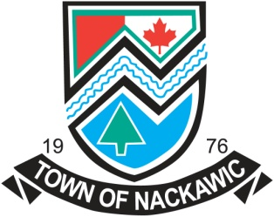

TOWN OF NACKAWIC
SAM BATES CITIZENSHIP AWARD
Sam Bates 1907-1989
The Sam Bates Citizenship Award is presented in commemoration of Mr. Bates’ contributions to the Town of Nackawic.
Mr. Bates was an integral part of the community participating in many local activities. He was the Town Hall Jailor and Janitor from January 1981 to November 29, 1987, during which time he assisted in many municipally sponsored activities including the annual Bicycle Rodeo and the Community Days Celebration. His community spirit and involvement serve to remind us of the value of kind deeds to a municipality’s existence. This scholarship is presented during the Nackawic Senior High School Graduation Ceremonies to the Nackawic student who best meets the following criteria. This is a one year scholarship. Cheques will be made payable to the educational institution in which the student is enrolled.
1. Applicants must be a graduating student pursuing higher education at a university or college.
2. Applicants must be a resident of Nackawic.
3. Applicants must provide a written dissertation alluding to his or her contribution(s) to the community.
4. Applications must be received no later than May 31st, 2020.
Interested students may apply by completing the form on the reverse side of this page.

Application Form

_____________________________________________________________________________________
Surname Given Names Initials
Mailing Address: _______________________________________________________________________
Street Address: _______________________________________________________________________
Phone Number: _______________________________________________________________________
College or University you plan to attend: ____________________________________________________
Name of course enrolled in: ______________________________________________________________
Other scholarships received: _____________________________________________________________
Contributions to the community (attach additional sheets, if required). __________________________________________________________________________________________________________________________________________________________________________________________________________________________________________________________________________________________________________________________________________________________________________________________________________________________________________________________________________________________________________________________________________________________________________________________________________________________________________________________________________________________________________________________________________________________________________________________________________________________________________________________________________________

Applicant’s signature: ___________________________ Date: __________________

To be received no later than May 31st, 2020.
Mail to: Town of Nackawic
115 Otis Drive
Nackawic, NB
E6G 2P1

