Lord of the Flies Mask Activity

Masks offer powerful avenues into the complex undercurrents that shape our sense of self and identity. As exhibited in the following passage from Lord of the Flies, Jack begins to embrace a new persona and mentality after carefully applying charcoal to his face:

He knelt, holding the shell of water. A rounded patch of sunlight fell on his face and a brightness appeared in the depths of the water. He looked on in astonishment, no longer at himself but at an awesome stranger. He split the water and leapt to his feet, laughing excitedly. Beside the pool his sinewy body held up a mask that drew their eyes and appalled them. He began to dance and his laughter became a bloodthirsty snarling… the mask was a thing on its own, behind which Jack hid, liberated from shame and self-consciousness (63-64).

Your task is to create a mask that illustrates one of the following: universal themes (evil, greed, confusion, patience, selflessness), complex ideas (id vs. the superego, the stages of life), the traits and qualities of a character from a work of literature we’ve read this year, or a mask that depicts the inner-workings of your mind and psyche. Below are three examples:
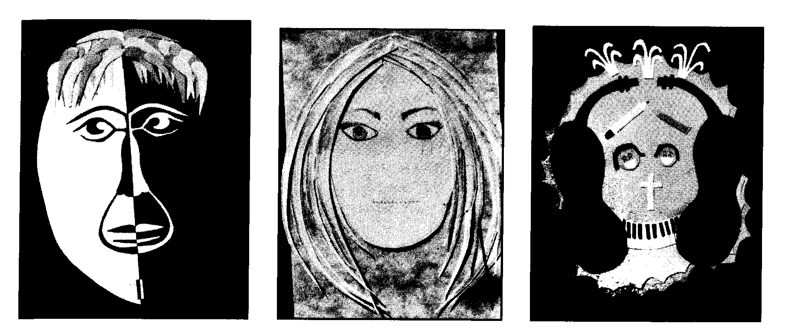
Your mask should be colorful, and should include a typed or neatly hand-written three-paragraph explanation.

In the first paragraph you should explain how you picked the topic for your mask. What was it about this topic/subject/theme that stood out to you? What personal connections or associations do you make with this mask? Were there alternative ideas you considered? How come you didn’t choose them?

Your second paragraph should contain information about the mask’s actual creation. What features did you choose to accentuate? What rationale do you have for your color choices? How did you use symbolism to make your mask dynamic and captivating? Were there any artistic devices or techniques you utilized to make your mask dramatic?

Your third paragraph should be a reflection about the way we, as humans, use masks in everyday society. Think about some of the different personas you “wear” on a regular basis. Why do you employ them? Are they necessary? Do they help or hinder you? FYI, persona is defined as “an individual's social facade or front that reflects the role in life the individual is playing; the personality that a person projects in any given environment.”

Your grade, out of 20 possible points, will be based on the following:

______ Overall quality of mask creation ______ Use of symbols & colors to make the mask dramatic & profound

_______ Depth-of-thought contained in written response _______ Grammar, spelling, and clarity of response

