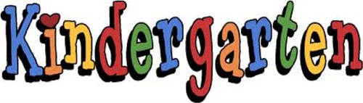

Kindergarten Supply List/Fees 2020-2021
Supplies You Are Asked to Provide
The only items you will need to provide will be:
- Indoor sneakers with Velcro (no black soles),
- lunch box
- “large” book bag (big enough for wet snow pants, lunch box, and communication bag)
- 1 box of Kleenex
- 1 box of large freezer Ziploc bags
- 1 box of medium freezer Ziploc bags
- 1 small package of band aids
- A change of clothing (2 pairs of socks, underwear, pants and shirt) in a Ziploc bag with your child’s name on it.
Kindergarten Fee
- A fee of $45.00 will be collected to purchase consumables (pencils, crayons, duo tangs, etc.) and art supplies. ASD-W’s preferred form of payment is through Cashless. You are able to register – a simple task that takes less than 2 minutes by visiting https://www.schoolcashonline.com/ or visiting our website at http://web1.nbed.nb.ca/sites/ASD-W/NMES/Pages/default.aspx and navigating your way to the School Cash Online on the right hand side of the screen. This is a one-time fee. Field trip fees will be collected separately.
Have a safe and happy summer. We’ll see you in September☺

NMES Kindergarten Teachers

